Nutrition Plus, Inc.
121 Mays Rd., Winfield, KS. 67156
Emily Roark Patti Brenn Susan Morrell
(620) 221-2777 (620) 218-1811 (785) 230-7441
roark2@cox.net pattibrenn@cox.net smorrell12@gmail.com
www.nutritionplusinc.com
November is:
2nd - National Deviled Egg Day
3rd - National Sandwich Day
6th - National Nachos Day
12th - National French Dip Day
17th - National Homemade Bread Day
23rd - National Cashew Day
25th – National Parfait Day
26th – Thanksgiving Day

Important dates

November 24th - Checks/direct deposits go out
November 26th – Thanksgiving Day

Grain-Based Desserts
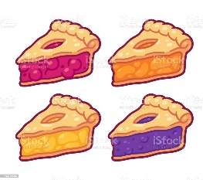
Grain-based desserts contain added sugars, saturated fats and very few nutrients. In hopes of decreasing health problems like type 2 diabetes and obesity, the CACFP has eliminated grain-based desserts from the creditable food list. There is no set amount of sugar or fat that labels a product a grain-based dessert. The CACFP has labeled grain-based desserts as the following: Cookies (including vanilla wafers), pie crusts (dessert pies, cobbler, fruit turnovers), Doughnuts (cake and yeast raised), Cereal bars, breakfast bars, granola bars or bites, Sweet roll (cinnamon rolls), Toaster pastry (Pop-Tarts®), cake, coffee cake, brownies,
November 2020
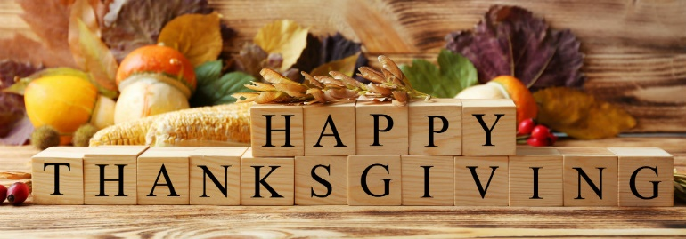

marshmallow cereal treats, sweet bread puddings, sweet rice puddings.

It doesn’t matter whether these items are made from scratch or store bought. It’s less about the recipe and how much of what goes into it, and all about how the food item is classified in the grain requirement section of the CACFP’s handbook. This is intended to make it easier to keep straight, although it does seem to leave questions. I can always ask Child Nutrition and Wellness if any of you have questions about a certain food.
I know this seems like an exhaustive list of “No-No’s”, but there are plenty of delicious alternatives to grain-based desserts.
- Banana bread, pumpkin bread and other quick breads
- Cornbread
- Animal crackers, graham crackers
- French toast
- Muffins
- Pancakes
- Pie crusts for savory pies like pot pies or quiche
- Croissants
- Biscotti make with cheese, veggies or herbs
- Savory rice puddings made with cheese, veggies, etc.
- Savory bread puddings made with cheese, veggies, herbs, etc.
- Savory scones made with cheese, veggies or herbs, etc.
- Teething biscuits, crackers, toasts
- Tortillas and tortilla chips
- Waffles
- Cereals that meet the sugar limit and are whole grain-rich, enriched and/or fortified.
- Crackers, all types
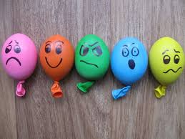
Stress Balls
Fill party balloons with rice and draw on spooky, scary, or cute faces with a black Sharpie. Once you tie them off, give 'em a squeeze for stress relief.
Some other ideas are below. I’m sure you could use brown balloons for turkeys. You can also use flour or cornstarch, but you can play with the consistency to see which you like best. With the home schooling and remote learning going on, you and your kiddos may all like to use when things get intense. They probably miss their friends and the school experience as much as you miss them being there.

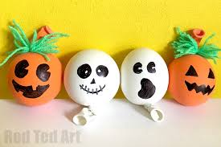

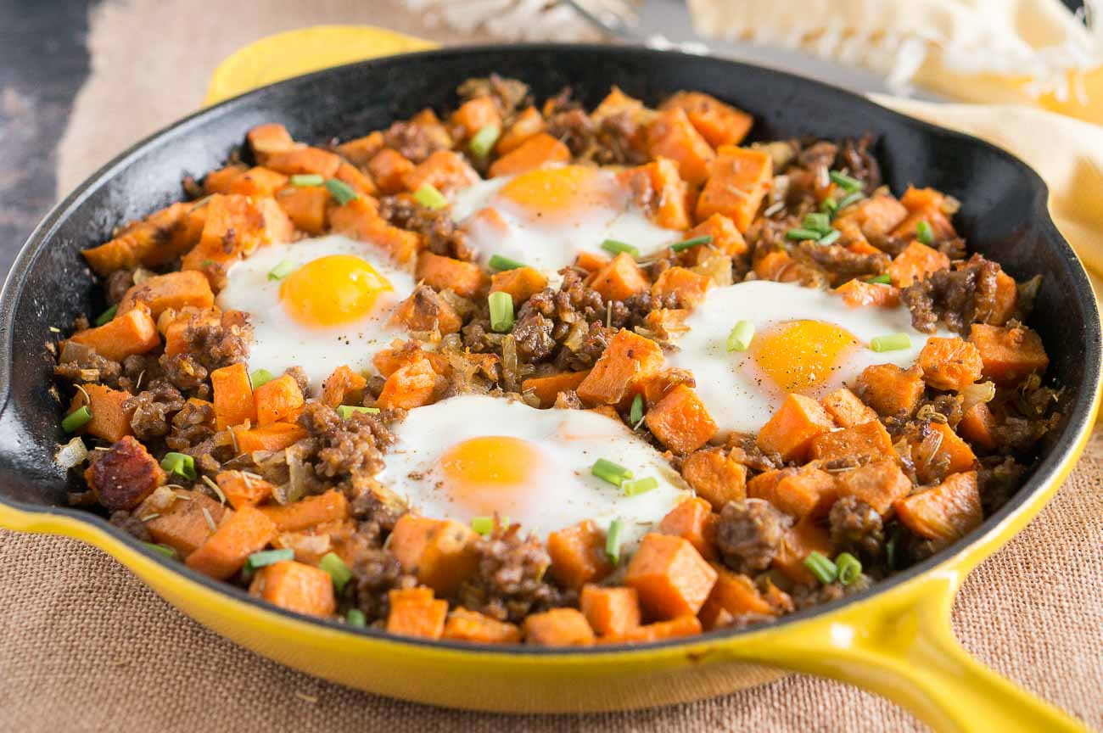

Sweet Potato Hash

Ingredients:
- 1 tablespoon olive oil
- 1/2 sweet onion, diced
- 2 lbs. sweet potatoes, peeled and diced petitely
- 2 tablespoons water
- 3 large eggs

Directions:
- Sautee the onion in oil until thoroughly softened and then stir in the sweet potato and water.
- Cover pot and cook on medium-high heat for 10-15 minutes until the potatoes are cooked.
- Make three cavities with the back of a spoon and crack in the eggs.
- Cover again, cook 5 minutes until the eggs have set, and scrambled them into the potatoes.
- Serve immediately.

Breakfast/Snack Crediting: 9 Servings for ages 1-5 (counts for vegetable and meat alternate). Serve with milk at breakfast.

"Childhood means simplicity. Look at the world with the child's eye — it is very beautiful." - Kailash Satyarthi

Thanks for being the best part of Nutrition Plus! Emily, Patti & Susan

