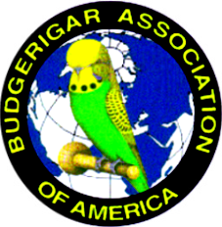
New Orleans budgerigar society
2019 annual show

July 20th and 21st
Saturday judge: Robert ferguson Sunday judge: dewayne Weldon
Judging starts at 10:00AM Judging starts at 9:00am

Show Location & Hotel Reservations
Pearl RIver Lions Club Microtel Inn & Suites
65062 Calhoun St. 63537 Hwy 1090
Pearl River, LA 70452 Pearl River, La 70452
985-863-7310

Show hall will open at 1pm Friday, July 19, 2019 and will be locked up at 9pm. You are welcomed to bring your birds and set up on Friday.
All birds must be checked in and tagged by 8:30 Saturday morning. If possible please send show forms to Connie Lovell as soon as possible to cvigil@riverlandmedical.com. Show form attached.

Lunch and Supper will be provided by the Club. Snacks and Desserts would be appreciated.
Bird auction will be held Saturday night after Supper. All bird donations are appreciated!!!!

JOIN US FOR GREAT FUN SOUTHERN STYLE
“Laissez les bon temps rouler.”

