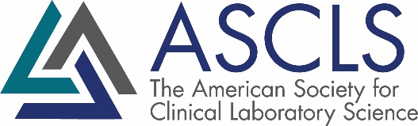

April 21, 2021

Dear ASCLS-ND Online Meeting Continuing Education Attendee:

Welcome to the ASCLS ND 2021 State Meeting continuing education sessions. With the online meeting format we will use the online ASCLS CE Organizer program to document your attendance. Both ASCLS members and non-members can prepare a certificate with CE Organizer.

At the end of each session, the moderator via Zoom will announce a unique session code for that particular session. Record the session code number. You will need this number to get credit for attending the session. You will need to access the CE Organizer by 2 months after the live Zoom sessions to claim your PACE certificate. If the sessions were April 29, 2021, you would have to access by June 29, 2021 and for the following quarterly zoom sessions, 2 months after the live zoom sessions.

If you do have questions or comments, about CE Organizer, contact ASCLS at 571-748-3770 or ascls@ascls.org.

Here is a brief summary describing how to use the ASCLS CE Organizer:
- Go to http://ceorganizer.ascls.org/.
- Select either the Member or Non-Member log-in box.
  - ASCLS members will log in using the same username and password used to enter the Members Section of the ASCLS website.
  - If you are not an ASCLS member, and do not have an account in CE Organizer already, click the “Register Here” link to create a username and password.
- Once logged in, click on Claim Certificates.
- In the list of ASCLS State & Regional Events, click on “View North Dakota” next to the event you attended.
- On the next screen, check the boxes of every session you attended and click “Next” at the bottom of the page. If you cannot see the checkboxes, you may need to use the scroll bar at the bottom of the page.
- On the following screen enter the unique session code for each session and click “Next”. Once again, depending on your computer set-up, you may need to use the scroll bar.
- We will also be using a CE organizer survey that you will need to complete in order to obtain the certificate. If you have problems with the survey, email Mary Coleman.
- If you entered everything correctly, a button will appear on the screen that says "download certificate now". Click this button to view, print, or save your certificate.

CE Organizer data is automatically transferred to the BOC Certification Maintenance Program (CMP) form for re-certification purposes for all ASCLS members if your correct ASCP customer ID number is listed in CE Organizer.

Mary Coleman
ASCLS-ND P.A.C.E.® Coordinator
mary.coleman@und.edu

