Uploading Prequal Letters

Step 1:
Please create a prequalification letter to upload. This is used for compliance examinations, to prove you made your decision, and informed the borrower.

Next Steps: See the Screen Shots below to Upload your Prequal Letters to MBOT:

Step 2:
Go to Imaging and select Upload Document:
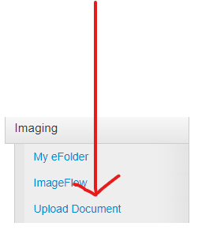

CONTINUE TO NEXT PAGE

Step 3:
Click the File to Upload Button:

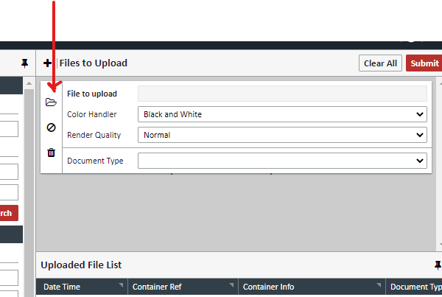

CONTINUE TO NEXT PAGE

Step 4:
Slecect Preqalification Letter from the Document Type Dropdown listing:

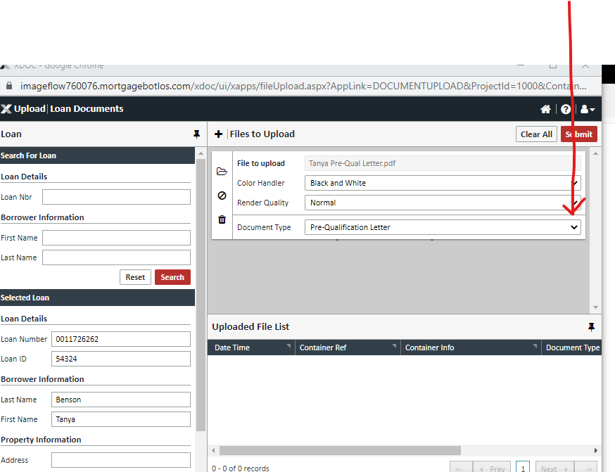

CONTINUE TO NEXT PAGE

Step 5:
Slecect the submit button to finish the upload process:

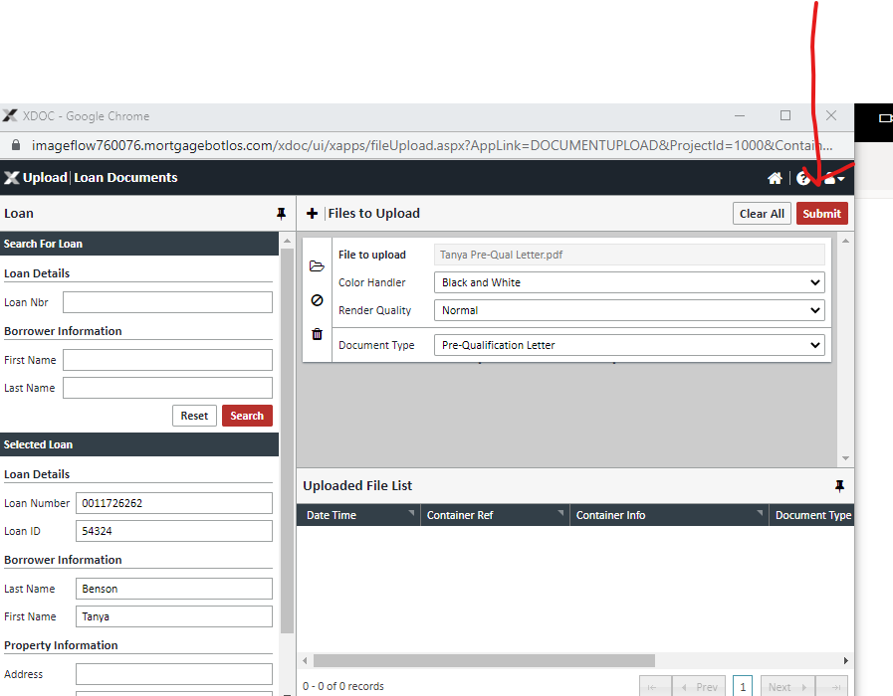

CONTINUE TO NEXT PAGE

Step 6:
Now check to make sure your letter is in IMAGE FLOW in MBOT. Go to Imaging again, and click on Image Flow.

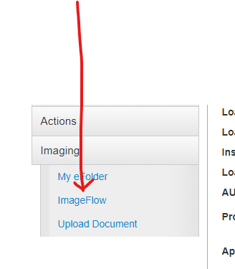

CONTINUE TO NEXT PAGE

Step 7: - LAST STEP
View the letter in Image flow to make sure it uploaded properly.

