TRINITY UNITED METHODIST CHURCH
Pastor Doug Benton ___ Minister
July 11, 2021 Color: Green
SEVENTH SUNDAY AFTER PENTECOST
"We welcome you to our service this morning and pray that your time with us will be a blessing to you"
THE ORDER FOR WORSHIP
Prelude Eddie Welborn
Let us silently prepare our hearts and minds for worship.
Welcome and Announcements Grady Senn
Chiming of the Hour Eddie Welborn
Candle Lighting and Processional
“Stool Time with Pastor doug”
Call to Worship Pastor Benton
Opening Prayer Pastor Benton
Children’s Time Pastor Benton
Hymn of Adoration: “To god Be the Glory” Page 98
*Apostles Creed Page 881
*Gloria Patri: “Glory Be to the Father”
Praises, Concerns and Prayers Grady Senn
Pastoral Prayer/Lord’s Prayer Pastor Benton
Tithes and Offering Ushers / Grady Senn
*Doxology: “Praise God From Whom All Blessings Flow”
*Hymn of Preparation: “Blessed Assurance” Page 369
First Reading: 2 Samuel 6:1-5, 12-19 Kelly Morris
Second Reading: Psalm 24 Kelly Morris
Sermon Scripture: Ephesians 1:3-14 Pastor Benton
Transitional Music
Sermon: “A Father’s Blessing” Pastor Benton
*Hymn of Service: “Faith of Our Fathers” Page 710
*Returning of the Light

*The Benediction Pastor Benton

*Three-Fold Amen Eddie Welborn
*Going Forth Eddie Welborn
*Stand if able. God’s altar is open to you following the sermon.
Technician: Josh Pitts

The Altar Flowers are given by John Pollard
in memory of my daughter Kim and to the Glory of God.

Next Sunday – July 18

Altar Flowers: Open; Scripture Reader: Sharon Baughman; Technician: Bryan Waldrop

Our Faithfulness

Worship Attendance for July 4, 2021: 57
Total Budget for 2021: $ 149,647.00
Weekly Offering Needed: $ 2,877.83
Offering Received June 27, 2021: $ 2,067.00
Offering Received July 4, 2021: $ 2,287.00
2021 Average Weekly Offering YTD: $ 2,286 .00

The Concerns of Trinity
Our Known Hospitalized:
Recent Hospitalizations and/or Surgeries:
Nursing Home: Gloria Brehmer (Springfield Place)
Continued Prayers: Robert Pollard, James and Jeanette Poag, Cheryl Longshore, Shirley Berry, Rebecca Bundrick,, Frieda Kesler, Wayne Black, Mary Forrest, Ashley Wilson

Family and Friends of Trinity: Blake Hendrix, Phillip Sanders, Wilson Bowles, Charlotte Berry, Megan Wainwright, Diane Merchant, Neil Thomas, Francis Leopard,
Sal Welborn, Thomas Gallman

Available in the Narthex:

Please be advised that a 2021 Altar Flower calendar can be found
on the wall closest to the choir robes. Please notify Peggy Bogart
with the wording you wish to have printed.

Also in the Narthex on a table , you can find a monthly flyer
that shows the scripture list and sermon title for each Sunday
of the month. Also available is a flyer containing the Sunday
scriptures printed for easy reading.

WELCOME VISITORS

Thank you for coming today! We are delighted you are here! We hope
you will join us again as we continue to discover the difference God’s love makes in our lives. If you have questions or desire to become a member of Trinity UMC, please speak to pastor. We are blessed because you’re here.

Trinity United Methodist Church Please visit our website for bulletins & newsletters:
1160 Trinity Church Road www.trinityumcnewberry.net
Newberry, SC 29108
Rev. doug benton, Pastor
Upcoming Events at Trinity

July 12: Administrative Council meeting – 6:30 pm
July 20 & 21: VBS - Barnyard Roundup - Please see information sheet in Narthex.

803-276-1245 (Church Office)
803-768-7687 (Church’s cellphone)
803-543-0082 (Pastor’s Cell)
dobenton@umcsc.net
Trinity
United
Methodist
Church

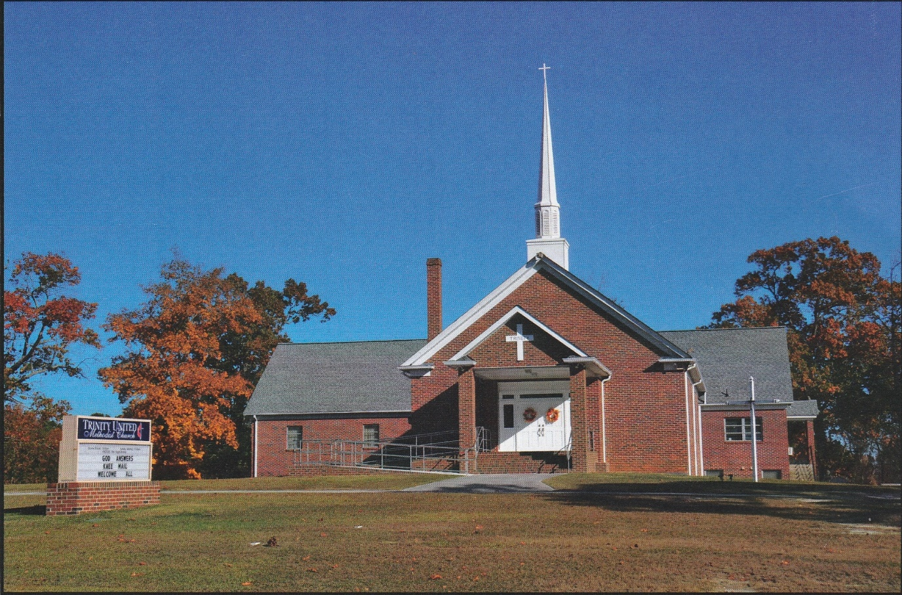

1160 Trinity Church Road
Newberry, SC 29108
Trinityumcnewberry@gmail.com

