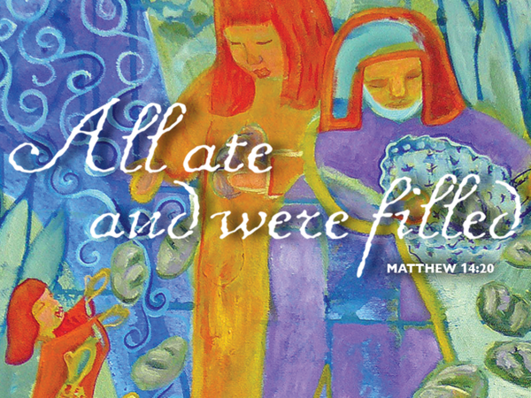
Real Food for Real People
August 6, 2017
Matthew 14:13-21
Grace and peace to you from God Our Father and from the One who feeds us with his own real Body and real Blood, Jesus Christ, Our Lord, amen.
Our Gospel for today is the account of Jesus feeding the 5,000. Now today, there are some people who claim this didn’t happen. They say it’s impossible to feed 5,000 people and more from just 5 loaves of bread and 2 small fish. They claim this was all made up by the apostles. Or another popular theory is that when Jesus began to share the bread and the fish it brought out the generosity in the people and they all began to share food they had secretly been hoarding until then. I believe they’re wrong. This is a true story, it is real and it was real food for real people.
Five thousand people: that’s a lot of people. I looked up the numbers for the Great Darke County Fair and according to their website the fair hosts just shy of 200,000 people each year. Now that’s a lot of people! When we go to the fair, we always walk around looking for the best food to eat. My favorites are the Wisconsin fried cheese curds. PJ likes the fancy caramel covered apples. As we walk around, it always seems to me almost every other food booth has Texas Tenderloins. I’ll bet there’s more tenderloin sandwiches at the Great Darke County Fair than there are people… At the fair, there’s lots of real food for lots real people. In the Gospel today Jesus wasn’t just making fish sandwiches – bread and fish—for a crowd. If that’s all it was, it wouldn’t do any good for you or me, because we weren’t there. No, this gospel is about more than fish sandwiches. So then, what is this story about and why is it relevant for us today?
The story begins, “Now when Jesus heard [about the beheading of John the Baptist], he withdrew from there in a boat to a deserted place by himself.” John the Baptist had been executed, by King Herod. His disciples had been there. They had the funeral for John. In the verses just before our text, it reads, “And his disciples came and took the body and buried it, and they went and told Jesus.” Jesus and the disciples were looking for a retreat in a quite place so they could grieve their loss.
It’s not surprising, when they heard about the death of John the Baptist, the people turned to Jesus. Whether or not they knew or were ready to believe Jesus was the Messiah, we don’t know. We know Jesus is the Christ, the Lord and Savior, but at that time He had not yet been crucified, he had not spent three days in the grave, and he had not yet risen from the dead. Nor had the Holy Spirit been sent. So, they are in a different time, a different situation, and saw things from a different point of view than we, who benefit from 2000 years of hind sight. It would be natural for them to turn to Jesus, who they knew as another teacher, for an explanation about what had happened to John. So, in light of this tragic news, they are following after Jesus's boat.
Jesus arrived at shore, and there they are. He has compassion on them. In the same story in Mark’s Gospel it says Jesus had compassion on them because they were like sheep without a shepherd. These are the people who had followed John the Baptist and their leader was now dead. In his compassion, Jesus heals the sick among them. He wanted to be alone to grieve, but his compassion led him to serve these people instead.
As the day begins to turn to evening, the disciples have a plan. Their plan is to send the people away, and let them find food on their own. Have you noticed that the disciples’ plans always make logical sense, that they are quite practical and rational, but their plans are never the Lord’s way? Our God is neither illogical nor irrational. God isn’t crazy, but His ways are not our ways, nor His thoughts our thoughts. He calls us to see people and situations through eyes enlightened by faith and trust in God, to see the unseen, to see as He sees.
Jesus makes it clear the people are not to be sent away. Jesus doesn’t send anyone who is honestly seeking him away. He doesn’t reject us either, sinners though we are. I think what happens next is both instructive and revealing. Jesus could have just made the bread and fish turn into fish sandwiches for everyone, but that’s not what he did. Perhaps if he had made Texas Tenderloins for everyone there wouldn’t have been 12 baskets left over… What Jesus does is tell the disciples to feed the people. Why do you suppose Jesus telling the disciples to give the people something to eat? Is it because He secretly knows they really are able to do it and He just wants to shore up their self-confidence? No, precisely because everyone knows they can’t do it. Jesus wants then – and us to know how dependent we are on Him. That’s a truth we so often forget as we tend to believe everything we have, we’ve earned from the sweat of our brow. Not so, says the Lord of Hosts. It all comes from God, every last morsel. So, the disciples find some bread and some fish. Clearly this is not enough. What does Jesus do? Does He say to the people, “Look, here is some bread and some fish. It can remind you of the meal you had before. Think about that, and it’ll will fix your hunger.” No. He multiplies the food, so there will be real food for real people.
Having done that, does He multiply it so that everyone has only a taste, but not enough to really feed them? Does He say, “Eat this bite of bread, and a smidgen of fish, because it represents the meal you can have later, when you get home?” No, He multiples the food, the disciples hand it out, and there is plenty, plenty, for everyone. Everyone eats, everyone is full. And to prove that everyone is full, and want no more, Jesus makes enough so there are leftovers – 12 baskets. The other night PJ and I walked around downtown Greenville for First Friday. One of the restaurants had an all you can eat fish special so, that’s where we ate. When the waitress came around asking if we wanted seconds, both of us were already quite full, but thanked her anyway. She told us some folks had come in earlier and eaten 5 plates full of fish and shrimp with all the fixings. There were probably some in the crowd of 5000 who were that hungry and Jesus fed them all!
In doing this, Jesus shows the people, and you and me, that He is the Lord. For the One who made the everything out of nothing, it is nothing to make much out of little. If, in the beginning, Christ can create bread and fish, and He did, He surely can multiply bread and fish. This is something more than a teacher or rabbi, can do. This is stuff only God can do!
Look carefully at what Jesus does. First, He has compassion on the people, even as He has compassion on you and me. Then, He provides for the people, in a real and tangible way. Listen to the text, “he looked up to heaven and said a blessing. Then he broke the loaves and gave them to the disciples.” That sounds familiar, doesn’t it? I hope so, because on the night when He was betrayed, our Lord took bread, and when He had given thanks, He broke it and gave it to them.
Our Savior Jesus Christ, in this miraculous feeding, is making a picture of the Great High Feast He will give to His Church in in heaven. The even greater miracle is that Jesus has been giving a meal of Himself, one that gives life because it is He who is Life who gives it. Jesus has been multiplying that meal for 2,000 years, feeding millions of saints, and continues to do so to this very day!
See, our Savior, who became a human being, just as you and me, knows that we need real food. We don’t need just a reminder of what He did on Calvary. Nor is it enough to give us a meal which only represents the feast we will have in the world to come, something for then, but not really for now. No, Christ gives us real food for real people, now, today, in His holy supper. He doesn’t send us away to buy food He knows we can’t buy. As Isaiah wrote, so invites our Savior, “He who has no money, come and eat.”
Although He Himself was sinless, He took all sin into His body on the cross. He knows how is it, how it feels, when our feet have walked where they should not go, our hands done things they must not do, our tongues said things they ought not say, our eyes have soaked in what they best not see. He knows we don’t just need our sins forgiven, our spirits renewed. We need our whole bodies cleansed and redeemed. So, He gives us His real body and His real blood: Real food for real people. He feeds us because He loves us. He loves us. He doesn’t give us only a reminder of His death and resurrection. He doesn’t give us only a representation, a spiritual meal. No, He gives us Himself and being joined to Him, Who died, rose, and lives, we will also die, rise, and live with Him.
He doesn’t send us away. He satisfies our deepest needs. He fills us ‘til we want no more. He is here with us, in His supper, and we are with Him. It’s Lord’s Supper – it’s real food for real people. Amen, Come Lord Jesus!

