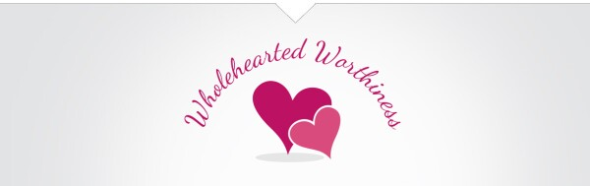
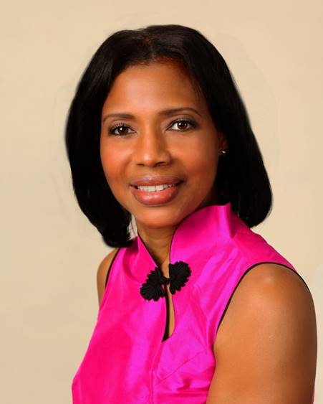
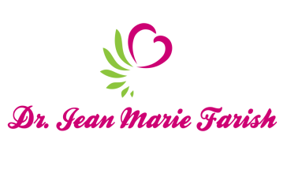

LOVE LIGHT NewsLetter

I am excited to host my VoiceAmerica Empowerment Show-LOVE LIGHT with amazing Guests to cultivate a lifestyle of love and wholehearted connections through worthiness. My show is aligned with my mission to live an altruistic and heart centered life.

MEET LOVE LIGHT GUEST

LYNDA DYER
Certified NLP Trainer & Master Trainer of Matrix Therapies
Registered Trainer Member of the NLPAA

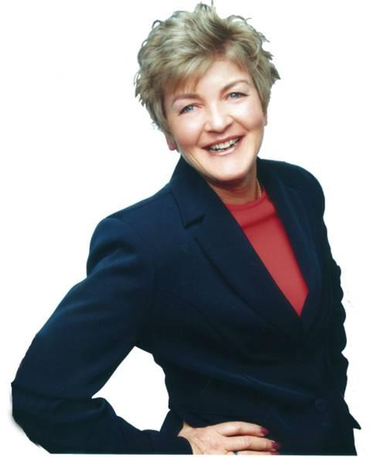

Be, Do, Have….
Love Yourself and You Could Change the World

APRIL 24, 2020

ABOUT LYNDA DYER

Lynda Dyer is one of 58 people filmed for ‘The Secret’ movie because she applies her material to her own life and has cured herself of the debilitating disease of Lupus. She is a Certified Professional Trainer of NLP and a Master Trainer of Matrix Therapies. She is an International Speaker, Transformational Coach, TedX Speaker ‘Happiness is a Choice’, Cast Member of Living Consciously TV Show, and International Best Selling and Award- Winning Author of 12 books.

Lynda’s humanitarian efforts include: Assisting the earthquake victims in China; sponsoring a village in Uganda, Africa; and currently works with an Australian/Vietnamese Association AVVRG, to bring better humanitarian services to others. She lives with the motto “You Can Make it Happen Now’ while she writes, trains, coaches and shares her material every day.

lynda@mindpowerglobal.com.au
www.mindpowerglobal.com.au

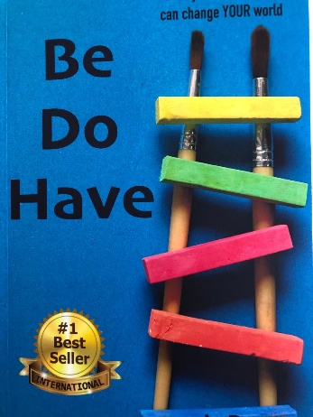
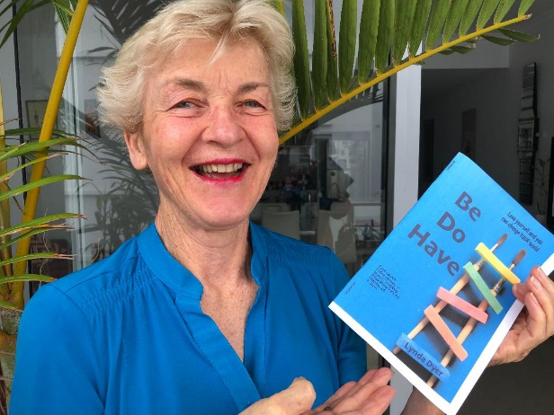

“An empowered self is a loving self and keep your love light shining”

