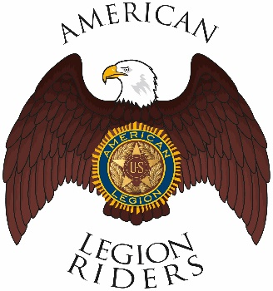

American Legion Riders Chapter 3, Hanford, CA
Minutes for April 12, 2022
Meeting called to order: The meeting was called to order @ 6:34pm. Prayer, Pledge of Allegiance and Preamble was said.
Officers Present: Director James Landolt, Asst-Director Frank Pightling, Treasurer Geni Lefler, Secretary David Darrow, Judge Advocate Pat O'Brien, Sgt-At-Arms Jack Alford, Road Captain Robert Stover, Chaplain Filly Reynolds Excused:

Members Present: Gustie Compton, Jon Bailey, Scott Day, Kathleen McClary, Dan Rushing
Guests Present: Alex Anderson
Review of Minutes: Motion to accept minutes for March 8, 2022, was proposed by Pat O’Brien and 2nd by Robert Stover and ratified by members.
Committee Reports: None
Treasurer's Report: $1000 outstanding for scooter purchase, $500 for cycle gear gift certificate and Hotels for the convention
Chaplain Report: Frank Silva’s recover is not going well, pray for him.
Unfinished/Old Business:
Robert Stover made a motion to buy 10 tickets for the raffle at the convention 2nd by Gustie Compton and ratified by the members for a total of $100.oo

Friday KSU at Legion Hall for ride to convention

This Saturday’s ride is to the Penny Bar in McKittrick KSU at 9am

30th of April it the Western Regions Vietnam Wall Memorial opening in Dinuba. KSU at Veterans Hall at 8am

New Business:

First Nominations for officers are as follows:
Director, Kathleen McClary
Vice Director, Frank Pightling
Sgt-At-Arms, Gustie Compton and Jack Alford
Treasurer, Geni Lefler
10th Thru 12th Jun is the Legacy Run, details will be posted on alrhanford.com
Good of the Riders:

Secretary will update website (www.alrhanford.com) first Saturday after monthly meeting and again the Saturday prior to the next meeting.

Remember to Ride Safe

Meeting adjourned at 7:43pm

