Amelia-Nottoway Technical Center News 2/5/2021
ANTC STUDENT SPOTLIGHT!
Jacob Banton, NHS Junior
Auto Body II
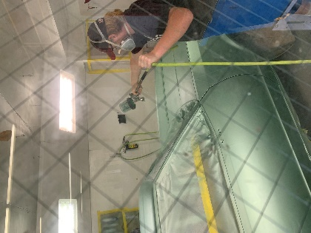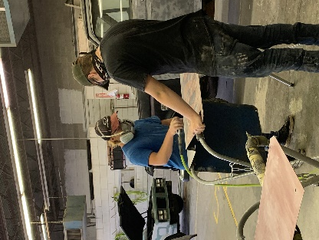

What brought you to ANTC? I like to work on cars; it has always been my passion.
What is your dream job? I would like to do HVAC.
What is your favorite class that you have taken so far? Why? Auto Body, I feel like I get more hands on and it is fun to me.
What is the best advice you have been given by your instructor at ANTC? Mr. Spradlin always tells us to use our head.
What is your favorite memory at ANTC? My favorite memory is when we were fixing the white Caprice for the Christmas parade.
What was the first feeling you had when you attended ANTC? I was excited.
What words of wisdom do you have for other students? I would tell other students to, “Do what you want to do and follow your dreams.”
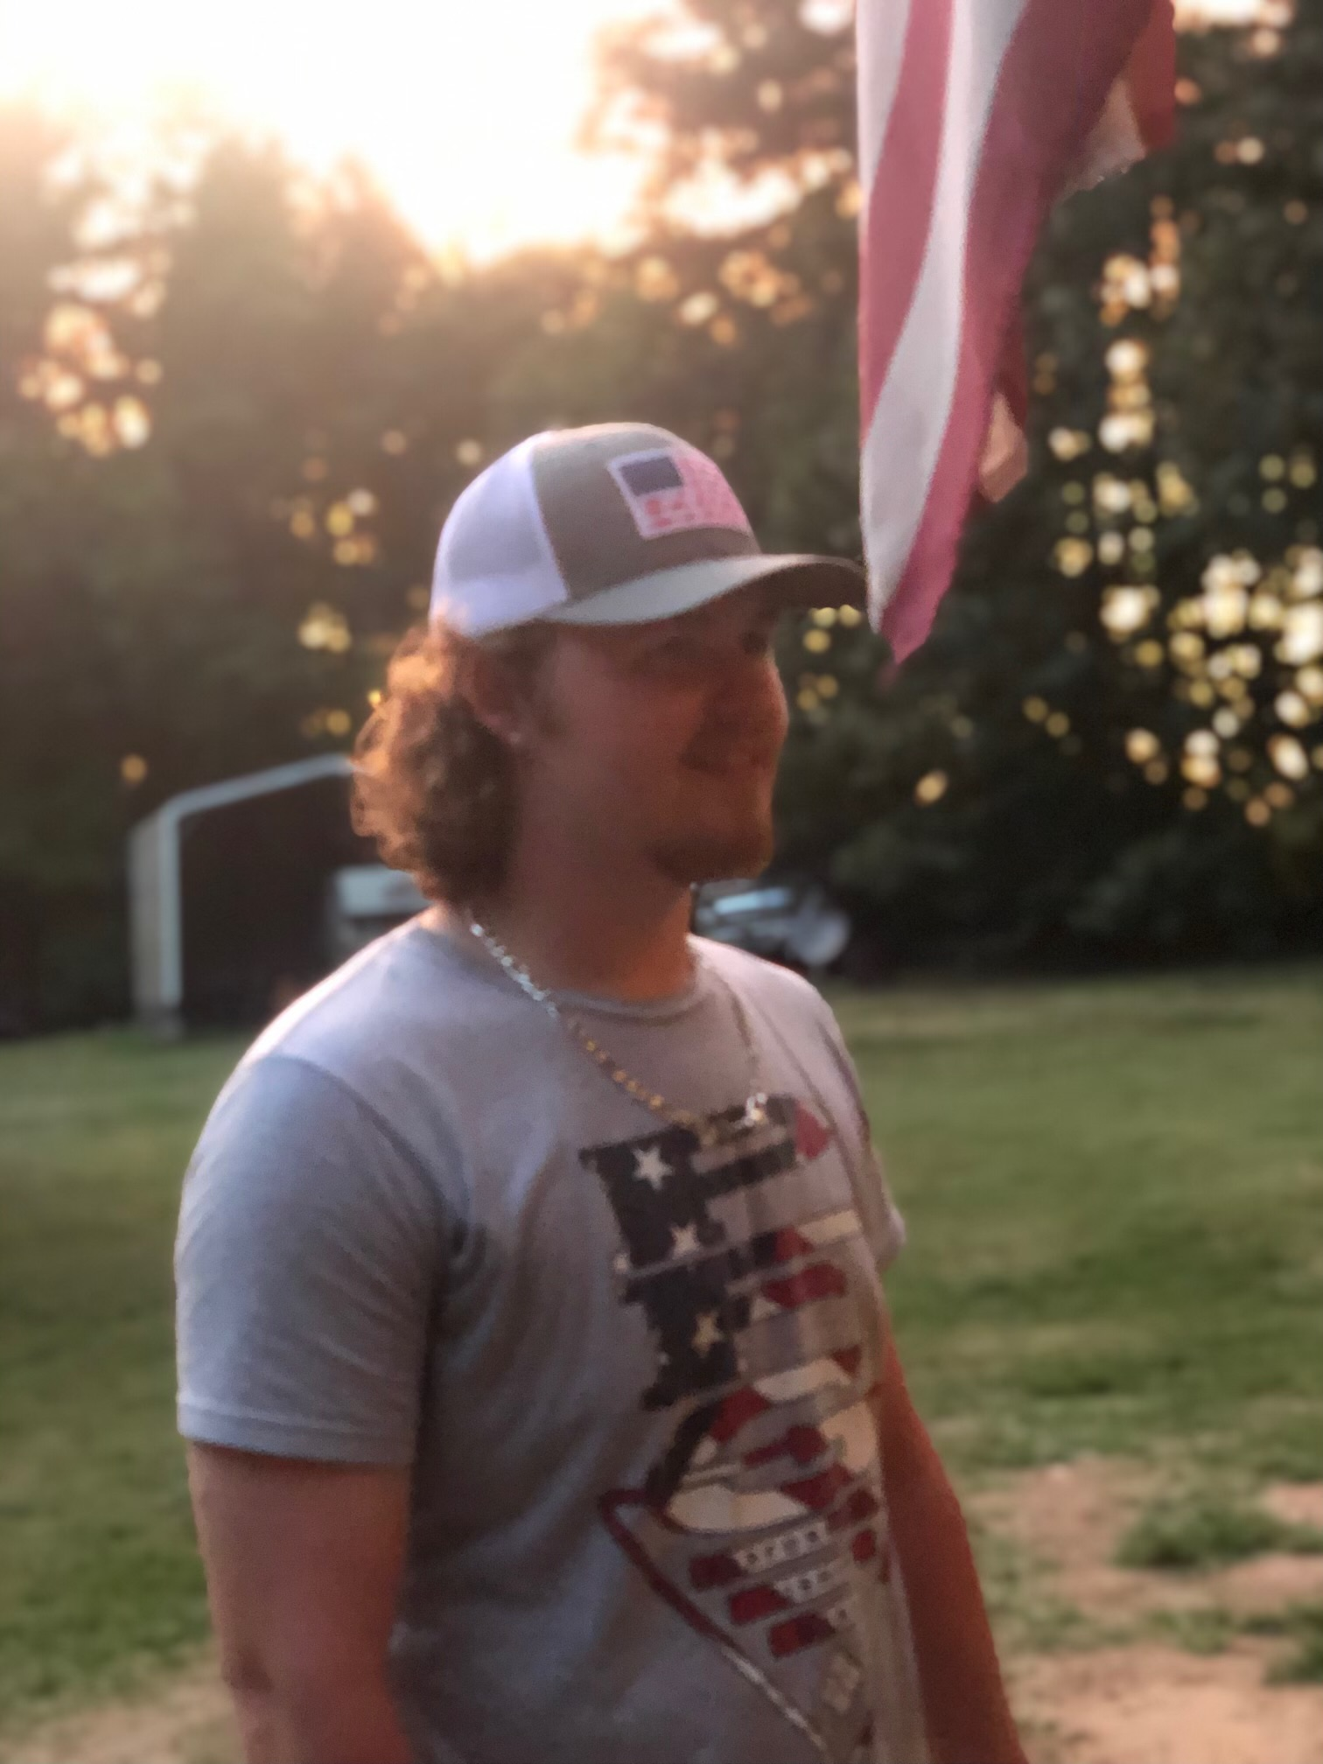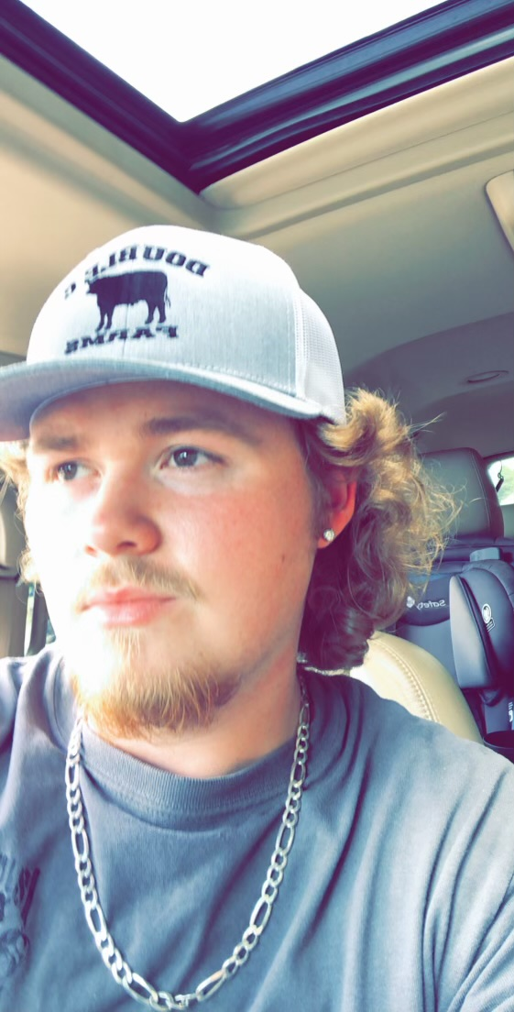
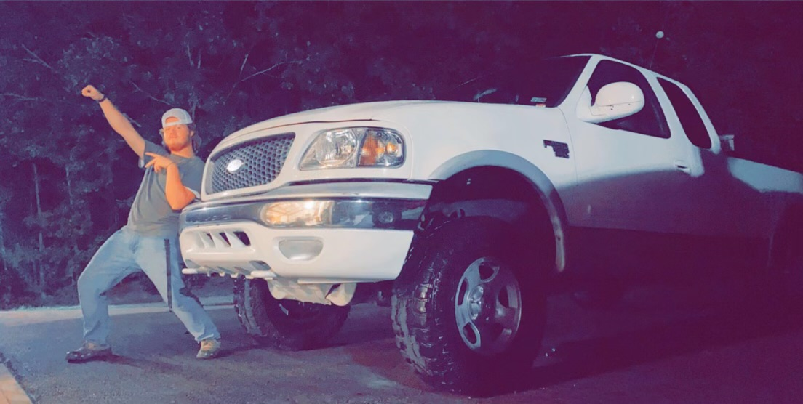
ANTC ALUMNI HIGHLIGHT!
Hunter Tolbert
High School: Nottoway High School
ANTC Program: Auto Body
Career: Commercial Refrigeration

DID YOU KNOW?
ANTC Transportation
ACHS Bus Driver, Mrs. Martin NHS Bus Driver, Ms. Streppone
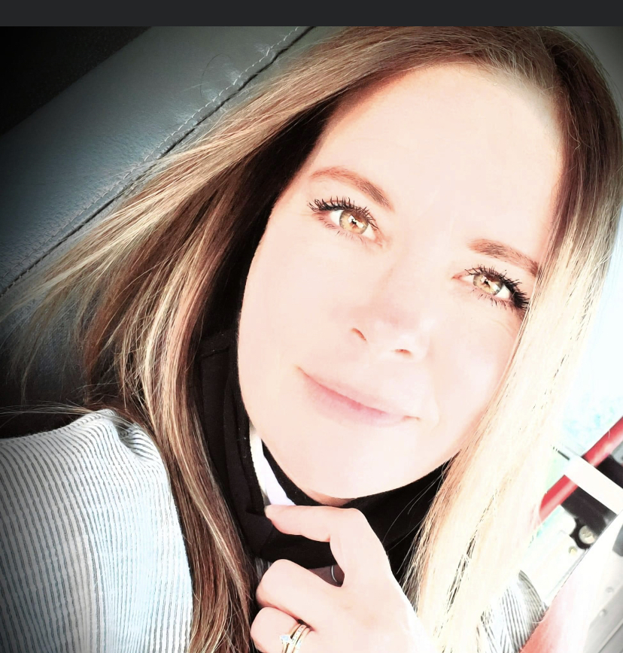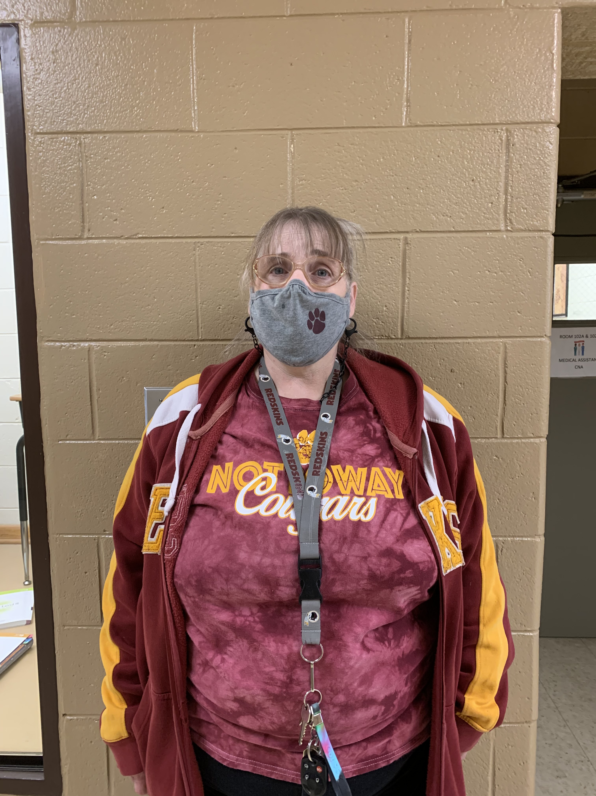

ANTC serving our Alumni!

Black History & Career and Technical Education
During the month of February, we celebrate Black History Month. This is an annual recognition of the contributions and achievements of Black Americans/African Americans. Initially, the celebration began as Negro History Week and was initiated by historian Carter G. Woodson. February is also recognized as Career and Technical Education Month. During February, educators raise awareness and highlight best practices in CTE.
However, CTE has a mixed history when it comes to the education of African Americans. In what is commonly known as the “Great Debate,” Booker T. Washington and W.E.B. DuBois openly disagreed about the role of education in the advancement of African Americans. Washington was a proponent of industrial education, contending that it was the pathway to economic independence and mobility. DuBois contended Black youth should aspire to the highest levels of education and that support of the Washington doctrine as opposed to liberal education would limit Blacks from charting their own course and being independent.
Today the question of whether it is better to pursue career-oriented education versus liberal arts continues. However, it is not an either/or consideration, as each contributes to equipping students with the requisite knowledge (i.e., academic and technical skills) to enhance lives through gainful employment that can lead to greater mobility and a productive career. Hence, CTE has the ability to transform life chances but still has room to grow relative to increasing diversity in the CTE pipeline and subsequently bolstering opportunity for all.
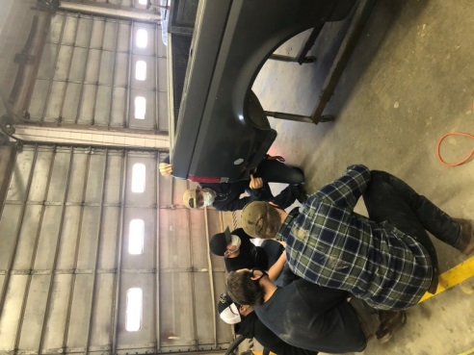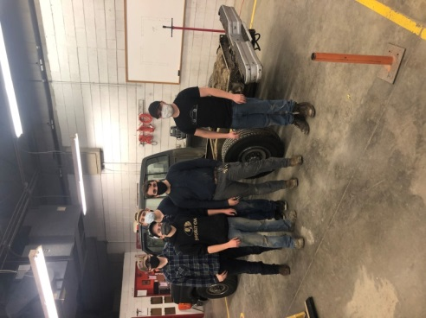
Program: Auto Body l & II; Amelia and Nottoway

Auto Body Repair Services may include: Auto Dent and Scratch Repair, Auto Dent Removal, Fender Repair,
Bumper Repair, Auto Painting, Auto Paint Repair, Paintless Dent Repair (PDR), Frame Straightening…

Auto Body II
Amelia County High School
Nottoway High School

Auto Body I
Nottoway High School
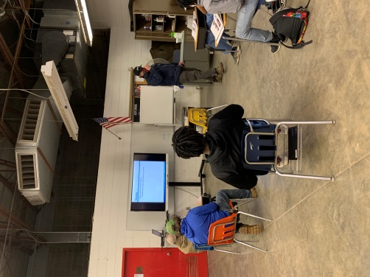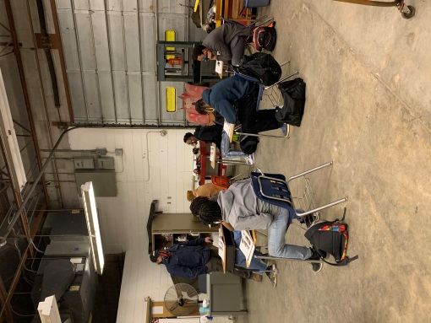
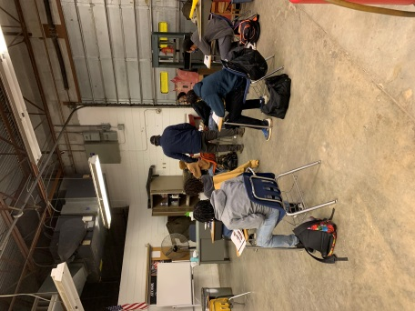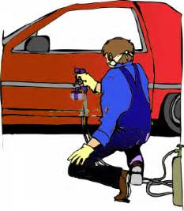

Program: Cosmetology l & II; Amelia, Cumberland and Nottoway

Skills: Sculpting Hair

Selecting the right mannequin is essential!

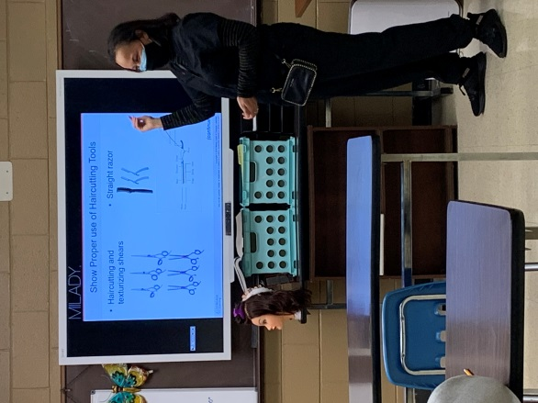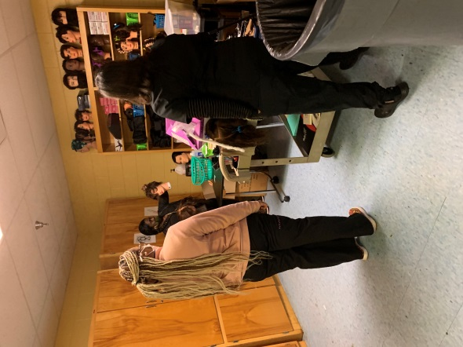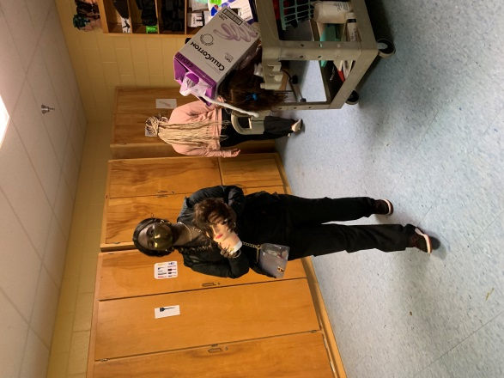
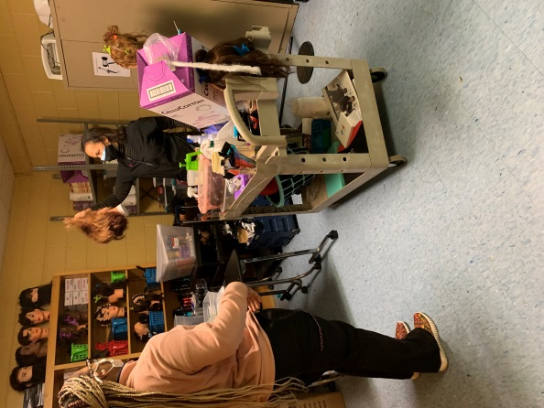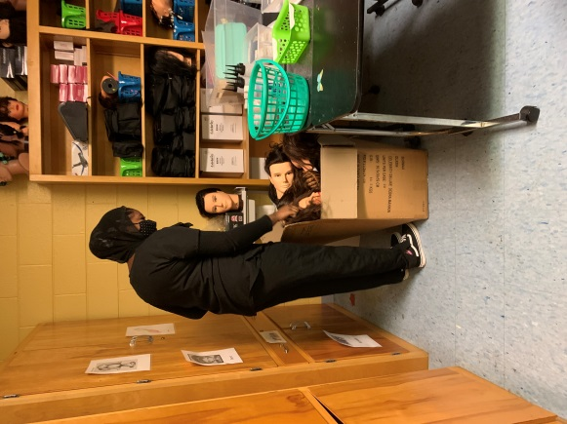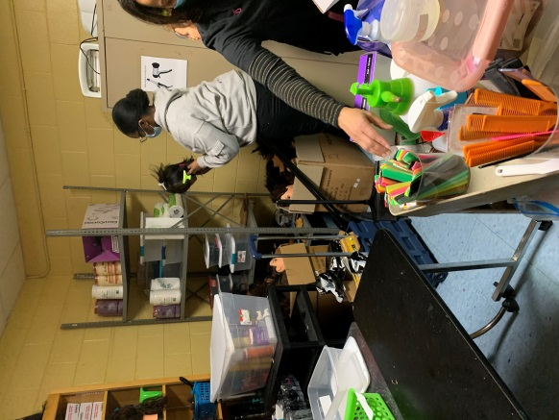
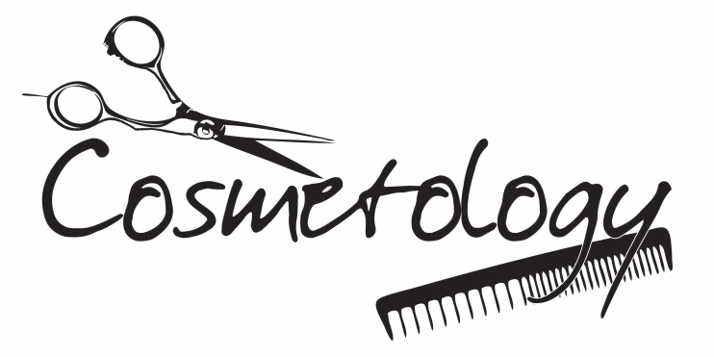
Program: Medical Assistant I & II; Amelia and Nottoway

Skills: Medical Coding and New Equipment

Translating diagnosis and treatment into standardized codes!

