“I was especially edified by the example of
HARRISBURG DIOCESAN
COUNCIL OF CATHOLIC WOMEN
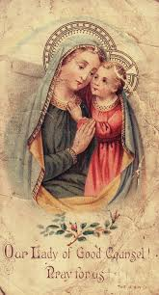

Prayer to Our Lady of Good Counsel

God of heavenly wisdom, You have given us Mary, Mother of Jesus to be our guide and counselor. Grant that
we may always seek her Motherly help in this life, and so enjoy Her blessed presence in the life to come.

O Mother of Good Counsel, Patroness of the National Council of Catholic Women, intercede for us that we may be wise, courageous and loving leaders
of the Church. Help us, dear Mother, to know the mind of Jesus, your Son.

May the Holy Spirit fill us with reverence for God’s creation and compassion for all God’s children.

May our labors of love on earth enhance the reign of God and may God’s gifts of faith and living hope prepare us for the fullness of the world to come.

Amen.

your deep faith and love of the Eucharist. I am
greatly impressed by the breadth and depth of
the work of the Council, at the parish level, the
diocesan level and world-wide.”
~ Most Reverend Ronald W. Gainer
Bishop of Harrisburg
Harrisburg Diocesan
Council of Catholic Women

Website: hdccw.webs.com
Follow us on Facebook:
Harrisburg Diocesan Council of Catholic Women
SPIRITUALITY COMMISSION
Membership is open to all women of the Harrisburg Diocese 18 years & older. It provides a network of support through affiliated parish Council of Catholic Women organizations. The Council offers opportunities for personal faith growth, and promotes Catholic values through the Spiritual and Corporal Works of Mercy.

District Councils of Catholic Women representing the 44 parishes of the Diocese of Harrisburg:

CONEWAGO- Annunciation BVM, Immaculate Heart of Mary, St. Francis Xavier, St. Joseph, St. Joseph the Worker, St. Vincent de Paul
CUMBERLAND‐PERRY- Good Shepherd, Our Lady of Lourdes, St. Bernadette, St. Joseph, St. Katherine Drexel, St. Patrick, St. Theresa of the Infant Jesus
DAUPHIN- Holy Name of Jesus, Prince of Peace, Seven Sorrows BVM, St. Catherine Laboure, St. Margaret Mary Alacoque
LANCASTER- Mary Mother of the Church, St. Peter, Columbia, St. Peter, Elizabethtown
LEBANON- Assumption of the Blessed Virgin Mary, Mary Gate of Heaven, Sacred Heart, St. Joan of Arc, St. Paul the Apostle
NORTHERN- Immaculate Conception, Sacred Heart of Jesus, St. Columba, St. Joseph, Berwick, St. Joseph, Milton
NORTHUMBERLAND- Divine Redeemer, Our Lady Help of Christians, Our Lady of Hope, Our Lady of Mt. Carmel, Sacred Heart of Jesus Mission
SETON- Corpus Christi, Immaculate Conception of the Blessed Virgin Mary, St. Andrew the Apostle, St. Ignatius Loyola
YORK- Holy Infant, St. Joseph, St. Mary’s
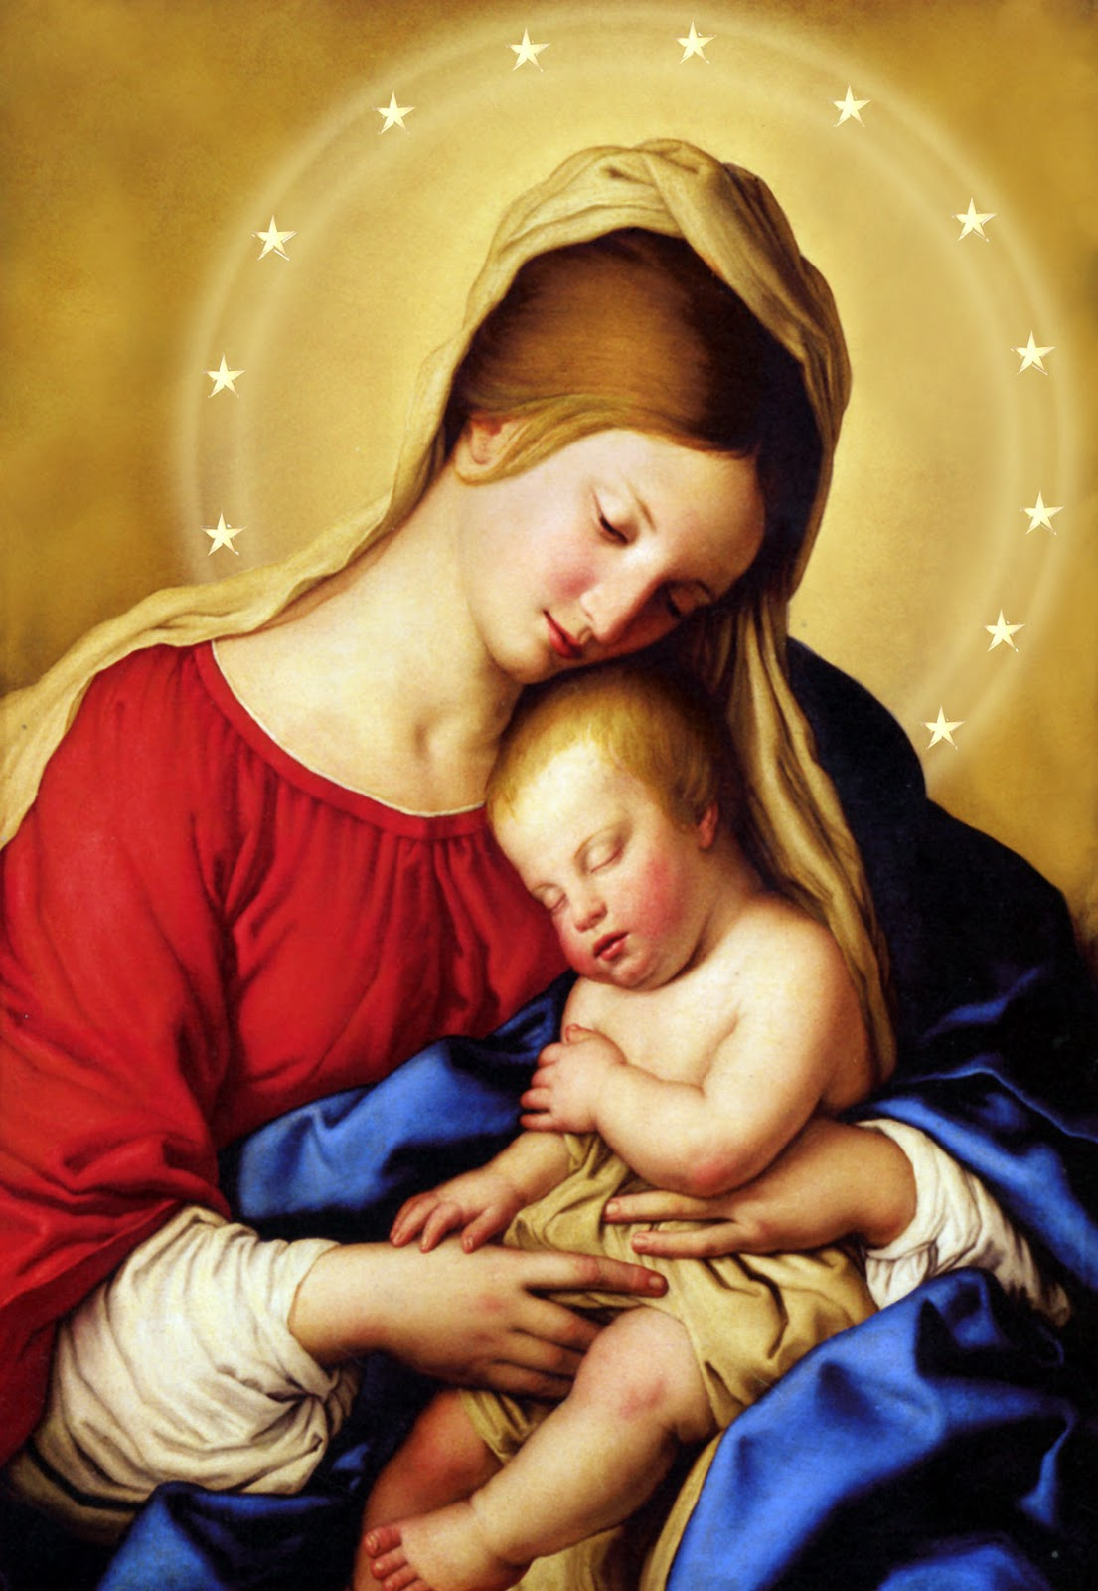

Church
Assist women on their journey to greater faith, hope and charity as they strive to imitate Jesus Christ and Our Blessed Mother Mary in their daily lives

Annual Weekend Retreat
June
Mount Saint Mary’s
Emmitsburg, Maryland

Annual Convention
Cardinal Keeler Center
Union Deposit, Pennsylvania

SERVICE COMMISSION
Community Concerns
family life within the Church and society; preserve and protect the sanctity of marriage; promote vocations
Hispanic Apostolate / Migrant Ministry provide funding through our Hispanic Apostolate/Migrant Ministry collection
International Concerns
promote and support works of peace and justice globally; educate Council on worldwide issues Catholic Relief Services, Water for Life, Madonna Plan, Help-A-Child

LEADERSHIP COMMISSION
Legislation / Respect Life
Addressing issues such as Dignity and Sanctity of
Life; Integrity of the Environment; Immigration Reform; and Health Care
Organization
Supporting the Council in our Parish and District
providing resources in order to fulfill our goals
Public Relations promoting the Council of Catholic Women organization – events and programs
Special Diocesan Activities Fund (SDA)

Mission Statement

“To support, empower and educate all Catholic
women in spirituality, leadership and service;
to inspire while promoting Gospel values in a constantly changing world.”

