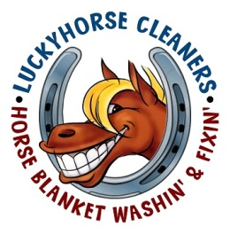LUCKYHORSE CLEANERS
HORSE BLANKET PICKUP/PACKING PROCEDURES
- PRINT THE “FOLLOW ME CARD” FROM THE WEBPAGE: LUCKYHORSECLEANERS.COM, OR USE THE ONE PACKAGED WITH YOUR BLANKET LAST YEAR.

- GIVE US AT LEAST YOUR NAME, ADDRESS OR BARN NAME AND YOUR PHONE NUMBER

- TELL US WHAT YOU WANT DONE TO YOUR BLANKETS IN THE “WANT YOU WANT DONE” SECTION

- PUT YOUR BLANKETS IN A TRASH BAG, AS MANY AS YOU CAN STUFF FULL. IF YOU HAVE MULTIPLE BAGS, USE DUCT TAPE AND WRITE YOUR NAME ON THE OUTSIDE OF THE BAG AND HOW MANY BAGS YOU HAVE i.e. 1 OF 2 AND 2 OF 2, etc.etc.

- PUT THE COMPLETED “FOLLOW ME CARD” FOR THOSE BLANKETS IN THAT BAG, NOT ON THE OUTSIDE.

- CALL STEPHANIE OR JIMMY @ 804-271-0000 FOR QUESTIONS

THEN….YOUR DONE
THANKS’ AND WE REALLY APPRECIATE YOUR BUSINESS
BLANKET PICKUP REQUIREMENTS: 12 BLANKETS MINIMUM WITHIN 12 MILES FROM OUR SHOP, THEN 1 BLANKET PER MILE, i.e.: WE’LL GO 20 MILES FOR 20 BLANKETS, etc.
YOUR NEXT PICKUP DATE IS:

