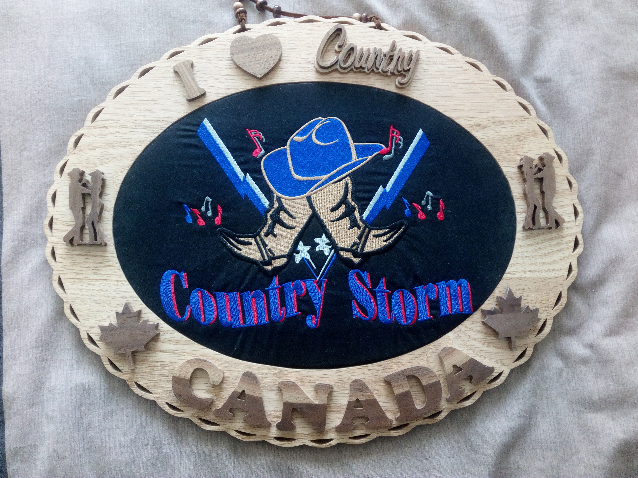 Country Storm

Description:- 64 Count Partner Dance, Same Footwork Throughout, unless stated. Start dance on Lt Foot.
Start dance facing OLOD, Indian Position, Man Behind Lady, Rt Hands on Ladys Rt Hip, Lt Arms Held Out to Lt Side Waist Height
Choreographed by :- Alan & Sonia Cole. ( alan.sonia@btinternet.com )
Website:- http://alan-and-sonia.webs.com
Music:- Country Storm by Aly Cook. Start Dance On Vocals
Video Link:- https://www.youtube.com/watch?v=ldgtKLcqsJ8
Dance Written For Rachel & Roy and The Country Storm Dancers, Gatineau, Quebec, Canada.

Step Lt Side, Touch Rt, Step Rt Side Touch Lt, StepLt Side, Bring Rt up to Lt, Step fwd on Lt, Touch Rt next to Lt
1 – 8 Step Lt to Lt Side, Touch Rt next To Lt, Step Rt to Rt Side, Touch Lt next to Rt, Step Lt to Lt Side, Bring Rt up to Lt
Step Fwd on Lt, Touch Rt next To Lt
Step Rt Side, Touch Lt, Step Lt Side, Touch Rt, Step Rt Side, Bring Lt up to Rt, Turn ¼ turn Lt
9 – 16 Step Rt to Rt Side, Touch Lt next To Rt, Step Lt to Lt side, Touch Rt next To Left, Step Rt to Rt Side, Bring Lt up to Rt
Keeping hold of both sets of hands turn ¼ turn Rt stepping Fwd on Rt ( Keeping Lt Hands behind Ladys Back )
( N.B. When doing the side & touch moves give a gentle body sway as you step to each side )

BOTH Step, ½ turn Step, GENT Walk Fwd on Rt, Lt, Rt, LADY Full Turn Rt into Indian Position
17 – 20 Step Fwd on Left Pivot ½ turn rt taking Wt on Rt, Step Fwd on Lt
( Release Lt Hands on Turn, take Rt Hands over Gents head, Picking Back up in VW position Rt Hands on Top )
21 – 24 GENT Walk Fwd on RT, Lt, Rt,
LADY ( taking both Arms over Head ) Turn Full Turn Rt on Rt Lt, Rt. Ending in Indian Position Man Behind Lady

GENT Walk Fwd X3, LADY ½ Turn Rt into Double Hand Hold, BOTH Back Mambo
25 – 28 GENT Walk Fwd on Lt, Rt, Lt,
LADY Turn ½ turn Rt on Lt, Rt, Lt, ( taking both arms over Head and change into Double Hand Hold facing each other )
29 – 32 BOTH Rock back on Rt, Recover on Lt, Step Fwd on Rt.

BOTH Cross Rock, Recover, Step to Side, GENT Walk ½ turn Rt, LADY Turn ½ Turn Lt, Changing Sides
33 – 36 BOTH Rock Lt over Rt, Recover on Rt, Step to Lt Side on Lt ( End Rt Shoulder to Rt Shoulder )
37 – 40 GENT Walk ½ turn Rt round back of Lady on Rt, Lt, Rt, to face RLOD
( taking Gent’s Rt, Lady’s Lt over her head as she turns under )
LADY Turn ½ turn Lt on Rt, Lt, Rt, to end facing LOD ( end face to face picking up Double Hand Hold after turn )

BOTH Cross Rock, Recover, Step to Side, GENT Walk ½ turn Rt, LADY Turn ½ Turn Lt, Changing Sides
41 – 44 BOTH Rock Lt over Rt, Recover on Rt, Step to Lt Side on Lt ( End Rt Shoulder to Rt Shoulder )
45 - 48 GENT Walk ½ turn Rt round back of Lady on Rt, Lt, Rt, to face LOD
( taking Gent’s Rt, Lady’s Lt over her head as she turns under )
LADY Turn ½ turn Lt on Rt, Lt, Rt, to end facing LOD ( end face to face picking up Double Hand Hold after turn )

BOTH Back Mambo into Bow Position, Pinwheel ½ Turn Rt Sliding Inside Arms down Into Inside Hand Hold
49 – 52 BOTH Rock Back on Lt, Recover on Rt, Step Fwd on Lt, ending Rt Shoulder to Rt Shoulder
( As you come Rt shoulder to Rt shoulder take Arms over heads and to behind knecks to end in Bow Position )
53 – 56 BOTH Pinwheel ½ Turn Rt on Rt, Lt, Rt, ( Gent is now facing RLOD on OLOD Lady is facing LOD on ILOD)
( Releasing Lt Hands as you turn and slide Rt Hands down Arms to end in inside hand hold )

GENT Walk ½ turn Rt round back of Lady to ILOD, LADY Walk across front of Gent to OLOD
56 – 60 GENT Walk ½ turn Rt round back of Lady on Lt, Rt, Lt to ILOD ( Keep hold of Rt Hands as you pass behind Lady )
LADY Walk diag Rt on Lt, Rt, Lt to OLOD ( Keep Rt Hands held behind Ladies Back and pick up Lt hands in Skaters )

BOTH Cross Rock Rt over Lt, Recover on Lt, turn ¼ Turn Rt stepping on Rt , Touch Lt next to Rt.
61 – 64 BOTH Cross Rock Rt over Lt, Recover on Lt, Turn ¼ Turn Rt Stepping on Rt to face OLOD, Touch Lt Next To Rt.

START AGAIN
Happy Dancing Alan & Sonia

