Trinity Times

Volume 10, Issue 9/10
September & October 2021

Dear friends,
Our bible is very specific about what God requires when we pick a leader or how we conduct our lives. As Christians we cannot pick or choose which of these things we can give ourselves or others a pass on. God requires a higher standard for us, our leaders, and others, if our world, nation, and society are to survive. Let us pick up our bibles daily and genuinely seek God’s word. And remember when it comes to God’s word, no-one gets a pass.

What God Requires of leaders and all his children.
-A person who seeks first the Kingdom of God and his righteousness.
-A person who loves God with all their heart, mind, strength, and soul.
-A person who loves all of God’s children and treats them with dignity.
-A person who is above reproach.
-A person of peace, love, and understanding who seeks to unite and not divide.
-A person who prays for and forgives both friend and enemy.
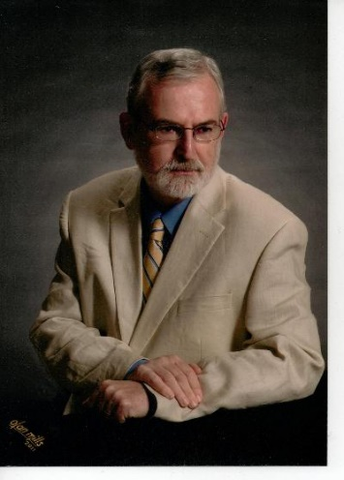
-A person who attends church, reads, studies, knows, teaches, and lives by God’s words.
-A person who is faithful to their spouse, and family.
-A person who when necessary will defend the word of God over the laws of man.
-A person who does not seek to build up their own name, or brag or gloat about themselves but rather seeks to glorify God and considers all others greater than their selves.

-A person who will always admit when they are wrong and seek forgiveness from God and from others.
-A person who is honest in all things and does not lie.
-A person who does not judge others or seek to make himself look better than others.
-A person who does not try to hurt, cause pain, disgrace, or get even with others and will work toward the good of all.
-A person who is quick to hear, slow to speak or to anger.
-A person whose speech is always gracious.
-A person who does not love to argue, but rather seek ways to find common ground and understanding.
-A person who is not a lover of money or power.
-A person who seeks to share all that they have with others.
-A person who welcomes the stranger, feeds the hungry, clothes the naked, and visits the sick, lonely, and imprisoned.
-A person who can put aside all bitterness, wrath, anger, and malice.
-A person who chooses to defend, honor, and protect not just his family or nation but all of God’s children as well as all that God created on this earth.

Love and Peace in Christ,

doug

Pastor Douglas Benton

Trinity United Methodist Church

1160 Trinity Church Road
Newberry, SC 29108
803-276-1245 Office
www.trinityumcnewberry.net

Pastor Douglas Benton
803-543-0082 Pastor Cell
dobenton@umcsc.org

www.trinityumcnewberry.net
PLEASE VISIT OUR WEBSITE
AS OFTEN AS YOU CAN!

Peggy Bogart, Church Secretary
Head Usher: Harry Longshore
Choir Director: Jane Pollard
Organist: Eddie Welborn
Substitute Organist: Phyllis Sanders
Video Board: Josh Pitts, Caroline Senn,
Foster Senn, Bryan Waldrop
Acolytes/Cross Bearers Coordinator: N/A
Newsletter Editor: Harriet Stevenson

SPAGHETTI FUNDRAISER!!

SUNDAY, SEPT. 26

MYF FUNDRAISER AFTER
CHURCH SERVICE IN
FELLOWSHIP HALL.
EAT IN OR TAKE OUT
FREE – JUST MAKE A DONATION
TO MYF

MONEY WILL BE USED FOR MYF ACTIVITIES

We are a caring church and want to share your concerns. Let us know if you or someone you know would like to share a prayer request with us. We will be happy to pray for you. Contact Peggy Bogart, Church Secretary, or Harriet Stevenson, Communications Chairperson, to add or remove names from the Church Prayer List.

Nursing Home: Gloria Brehmer, Springfield Place.
James Poag, White Oak
Trinity Member Prayers: Shirley Berry, Rebecca Bundrick, Jeannette Poag, Robert Pollard, family of Ronnie Davenport
Family and friends of Trinity: Blake Hendrix, Wilson Bowles, Megan Wainwright, Neil Thomas, Francis Leopard, Harriet Connelly, Kinsley Bouknight, family of Sal Welborn, Janna Longshore

We have made some changes to our website. Go to www.newberryumcnewberry.net and let us know what you think. We have added the weekly bulletin and monthly scripture readings.

Sept. and October Readers and Greeters
Readers Greeters
Sept. 5 Harry L. Watkins M.
Sept. 12 Josh P. Phyllis S.
Sept. 19 Dixie W. Debbie Lipscomb
Sept. 26 Crystal W. Clarissa H.
Oct. 3 Frieda K Linda L.
Oct. 10 Foster S. Clarissa H..
Oct. 17 Kelly M. John P.
Oct. 24 Harriet S. Myrtle L.
Oct. 31 Sharon B. Bridget B.

Please contact Phyllis (803-924-3228) or Peggy (803-944-1769) if you are unable to serve or need to switch. Readers will receive a bulletin in the mail with scripture included. Greeters need to be in the Narthex by 10:40 a.m.

THANK YOU FOR YOUR SERVICE!

13 – Ruthie Jane Spicer 4 - Robert Pollard
22 – Andrew Morris 7 – Jed Daniel Brehmer
24 – Colton Poag 14 - Marie Somers
24 - John Pollard 17 – Laura Mohler
26 – William “Boo” Johnson 21 - John Longshore
22 - Barbara Carter
25 - Rebecca Bundrick
26 - Bryan Waldrop
30 - Frieda Kesler
30 - Johnnie Pitts Jr

The Trinity Women’s Mission Group packed Starting Over Boxes for the Newberry County Probation and Parole Office to give to individuals who have recently returned to Newberry County after incarceration. Our boxes were packed with toiletry items. They also received a box of food items from the O’Neal Street UMC Food Pantry. The Trinity Men’s Club will take over this task for the remainder of the year. These boxes are a blessing to those who receive them as these individuals enter back into society with very little. Harriet Stevenson is shown delivering one of three boxes to Brenda DeWalt with the NCPP. The Trinity Women’s Group has made a goal of reaching out to our community to help others. This is in line with the United Methodist goal of Mission InSite. If you know of a local community project, please reach out to Harriet.

Trinity’s VBS, Barnyard Roundup, presented the children an opportunity to help others. Through donations, they raised $165.00 to purchase chickens, goats, honeybees, and a beehive from Heifer International. These animal donations will provide milk, eggs, and honey as well as giving families a hand up, increasing access to medicine, school, food, and a sustainable livelihood.
They also donated $165.00 to The Boys Farm in Newberry. These donations were given in honor of April Wilson, long time VBS director, who was unable to head up VBS this year.

**************************************
Kruz Bouknight and Wyatt Pitts attended this year’s Newberry Youth Space Camp. WLTX and their Street Squad came to Newberry to report on the Camp. Kruz was chosen as one of the students interviewed about being able to watch the live video of Jeff Bezos’s flight. Kruz stated that it was very interesting to watch and he was glad he got to see it live.
**************************************
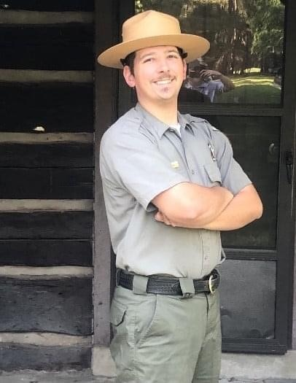
Derek Senn, grandson of Wayne and Betsy Black, was recently highlighted in “A Day in the Life of a Park Ranger” on the S. C. State Park Service website. Derek is employed by the S. C. State Park Service and is stationed at Cheraw State Park. Derek is a graduate of Piedmont Technical College. Derek previously was stationed at Dreher Island State Park. Thank you, Ranger Derek, for all you do to help protect our natural resources and to welcome park visitors to Cheraw State Park.

***************************************

Congratulations to Mr. and Mrs. Douglas Benton
Joined in Holy Matrimony - August 7, 2021

VBS 2021 – A Blessing to All
Trinity held a 2-day VBS on August 21 and 22nd with 15 children and 1 student assistant, along with a host of volunteers who helped to make VBS a great success. Our theme of Barnyard Roundup, Jesus Gathers Us Together was everywhere you looked in the Fellowship Hall. Jesus did indeed gather us together. The children learned new songs, memorized the 23rd Psalm, told everyone that Jesus loved them and put on a great show on Wednesday evening at the VBS Program. Thanks to all who helped with VBS and to all who attended. We were very excited to have 9 children out of 16 who were not members of Trinity and who we now consider a part of our “church family”. We hope to see everyone again next year when we go on a completely different journey!
Special Thanks

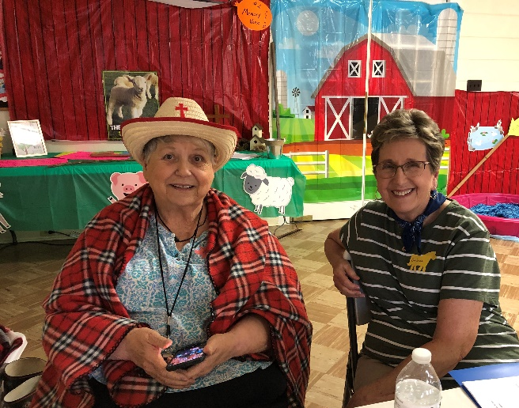
Event Coordinators
Betsy Black
Clarissa Hendrix
Phyllis Sanders
Harriet Stevenson

Volunteers
Pastor doug (P Dougie) Glynda Meadows
Bridget Bouknight Joan Morris
Taylor Bouknight Jane Pollard
Holly Hendrix Barbara Rogers
Shelbie Johnson Dixie Waldrop
Debbie Lipscomb Jane Woodward
Myrtle Longshore
Susan Longshore
Betsy and Barbara at Registration

Special thanks to Pastor doug and Holly Myers for performing our skit, Lynn Mohler for making our barn backdrop, Craig Kesler for providing our hay bales, Wayne Black for the loan of his miniature carriage, Jane and Terry Woodward for obtaining a $250 grant from Thrivent Financial to defray the cost of VBS, Senn Freight Lines and Trinity Women’s Club for lunch each day and the Trinity Men’s Club for the Cookout on Wednesday evening. Thanks to ALL who provided other props for decorating. Trinity has so many creative and kind people who are always willing to help
.
Learning the 23rd Psalm Charlie the Horse Recreation – Shelbie J.

VBS Picture Gallery
Dalton, Student Asst. CJ Wyatt
Kella Anna Grace Kathryn and Charliegh

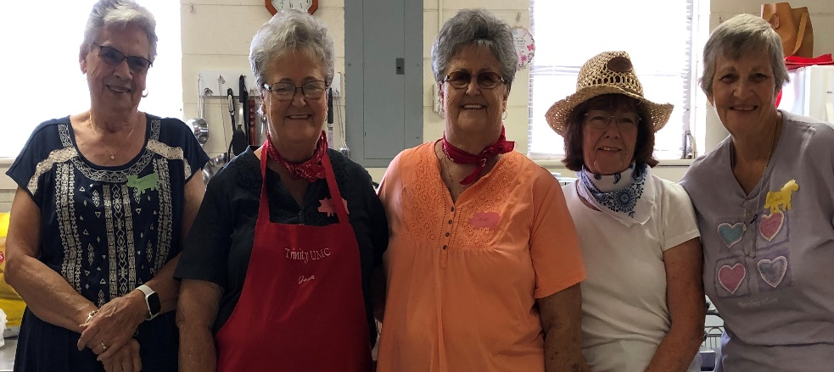
The Oink Oink Grill – Myrtle, Joan, Jane P., Dixie, and Jane W. Music – Cowgirl Taylor B.
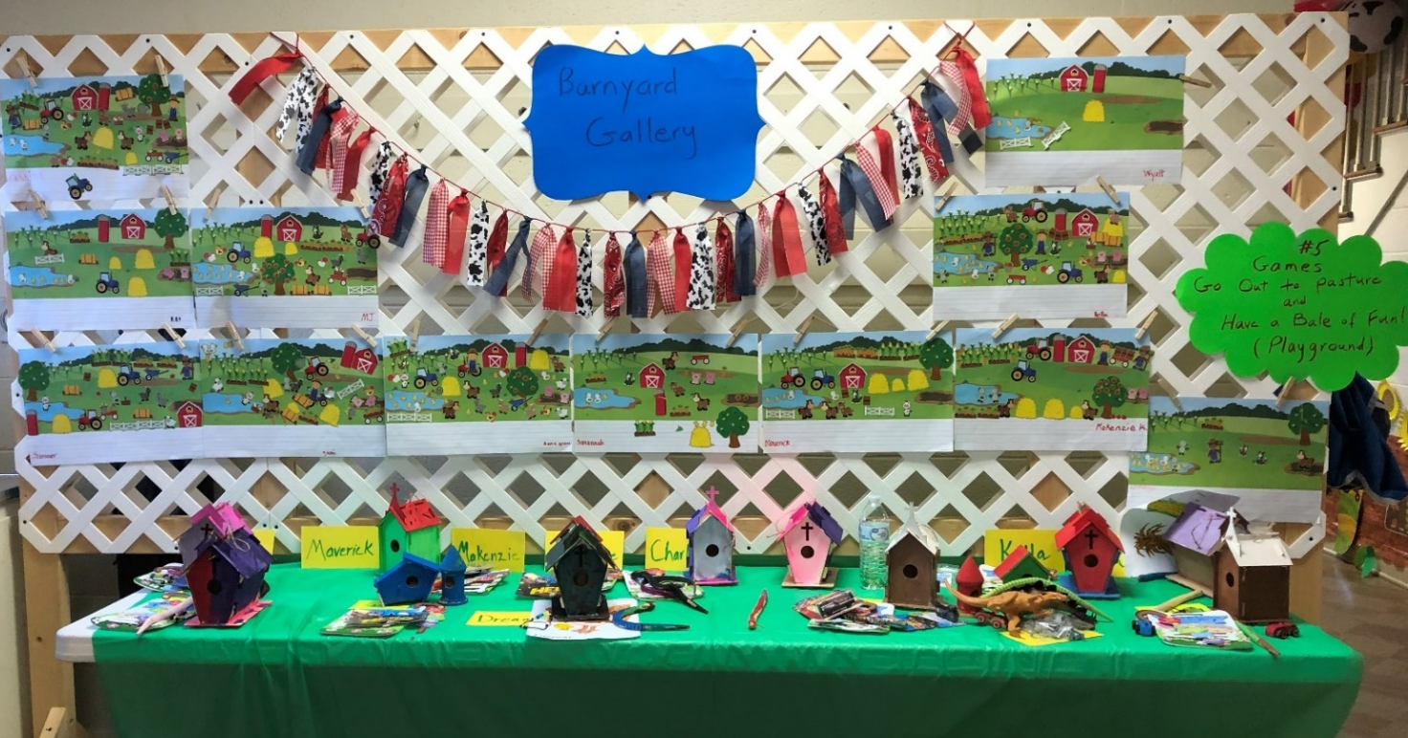
Lots of Crafts made by students in just two days.
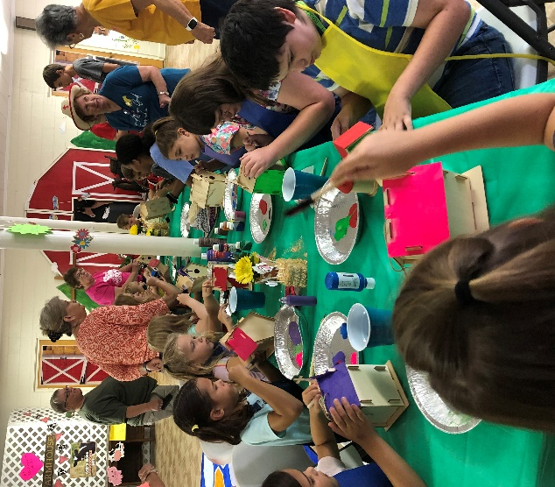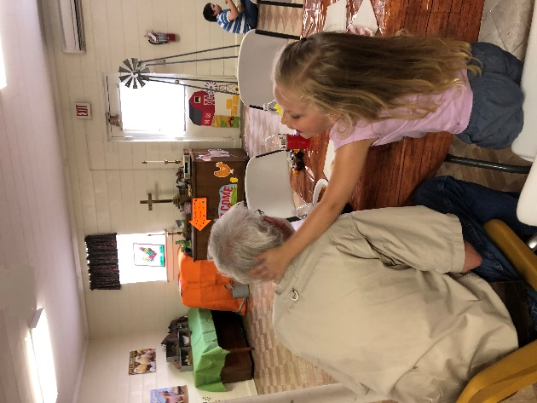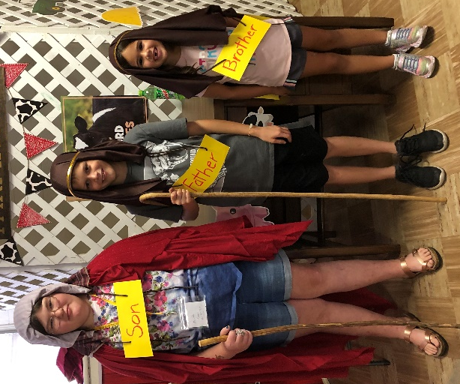
Crafts Playing with Pastor’s hair! The Prodigal Son Skit.
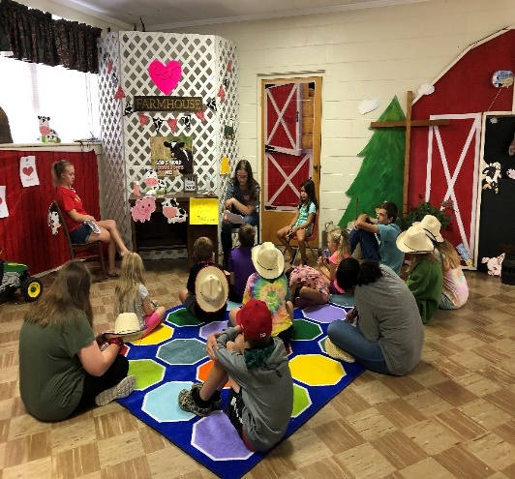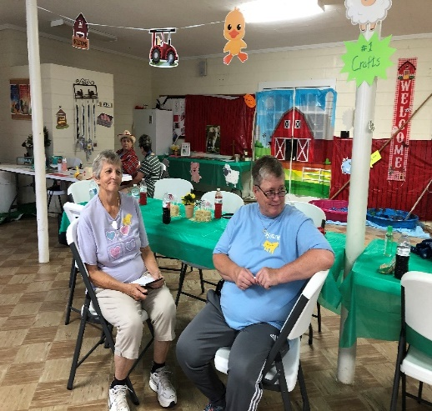
Bible Story Time Volunteers Jane W. and Glynda M. Music-Farmer Phyllis
September 12 - Grandparents’ Day – Children/Adults, invite your grandparents to church OR grandparents, invite your grandchild(ren) to church. This is our day to celebrate you! We will take your photo together after church and the following Sunday, deliver a beautiful 5 x 7 photo, one for you and one for your grandchild(ren) that will be cherished forever. Absolutely FREE! This is our way of saying WE LOVE YOU!
The MYF enjoyed their trip to Carowinds in July. The Youth also did a wonderful job with Youth Sunday by helping with the service on August 8. The sermon was a skit entitled, “Wake up, Wake Up, The Harvest is Ready”. Participants were Kruz Bouknight, CJ Griffin, Noah Mohler, Wyatt Pitts and Kella Battiste. A beautiful solo entitled “Oceans” was performed by Kella Battiste. Others helped with acolyte, offering, scripture readings, and benediction.
MYF meeting - September 12 from 5:00-6:30 p.m. for lesson, games and dinner. MYF Leaders - Josh and Erin Pitts
October 31

September 1 Trinity Men’s Club – 7:30 p.m.
September 6 Labor Day
September 7 Trinity Wo men’s Club – 6:00 p.m.
September 12 Grandparents Day - Photos taken after the church service
September 12 MYF meeting at church at 5:00 p.m.
September 13 Administrative Council – 6:30 p.m.
September 22 First Day of Fall
September 26 MYF Annual Spaghetti Fundraiser after church (eat it or take out)

October Breast Cancer Awareness Month
October Pastor Appreciation Month
October 4 Trinity Women’s Club 6:00 p.m.
October 6 Trinity Men’s Club
October 11 Administrative Council – 6:30 p.m.
October 17 Wear Pink to church in support of Breast Cancer victims and survivors
October 31 Pastor Appreciation Sunday

We`re working on having a Drive-By Trunk or Treat. We don`t yet have all the details as we navigate the safest way to proceed. Stay tuned for more information!

July 3 Boston Butt and Hash Fundraiser – AS ALWAYS A GREAT SUCCESS!
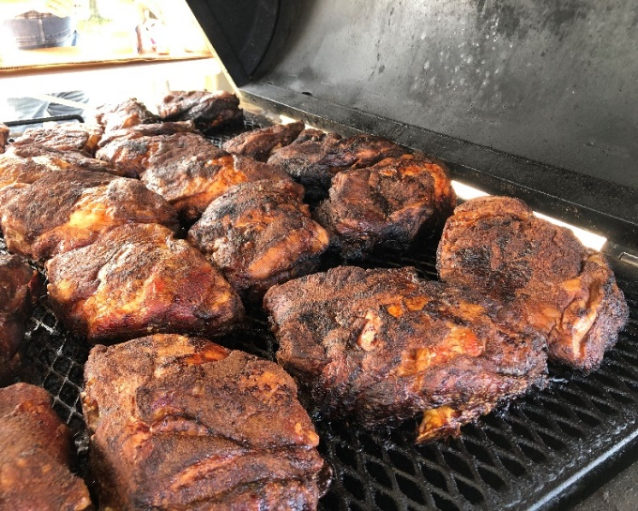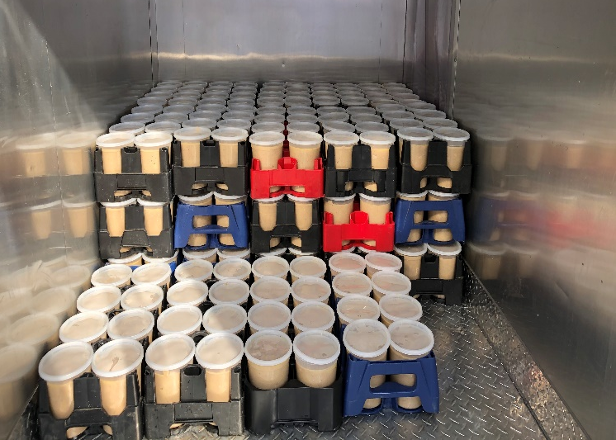
Butts Hash
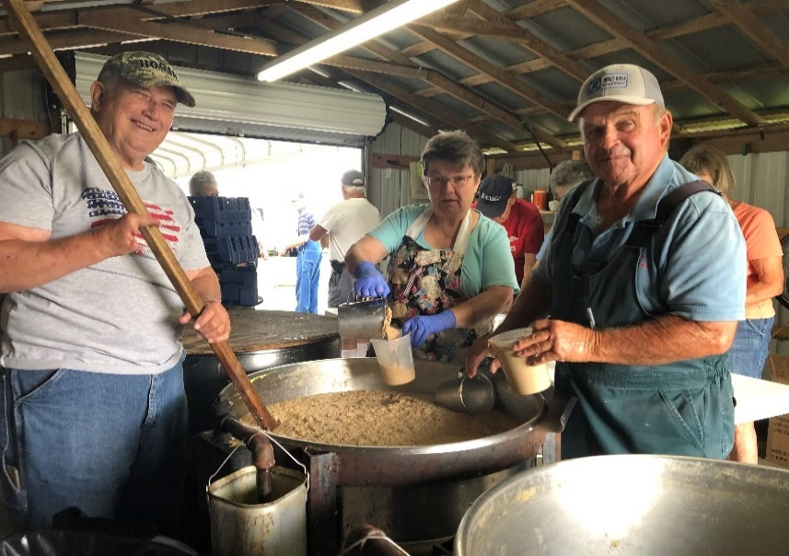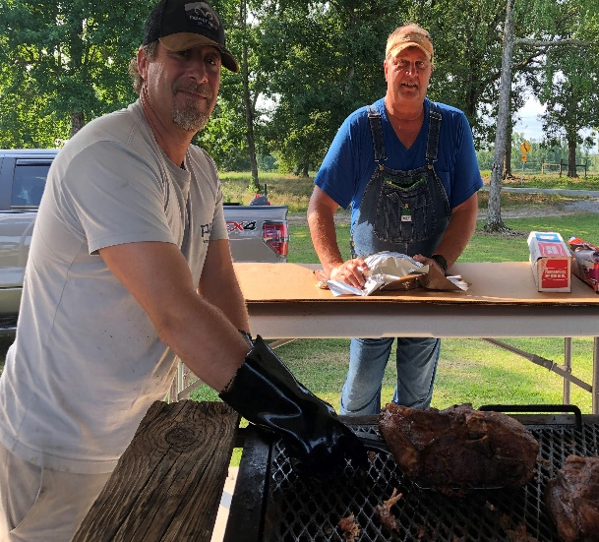
David Stirring; Marie & Johnnie Dipping Michael B. and Craig K. Wrapping Butts

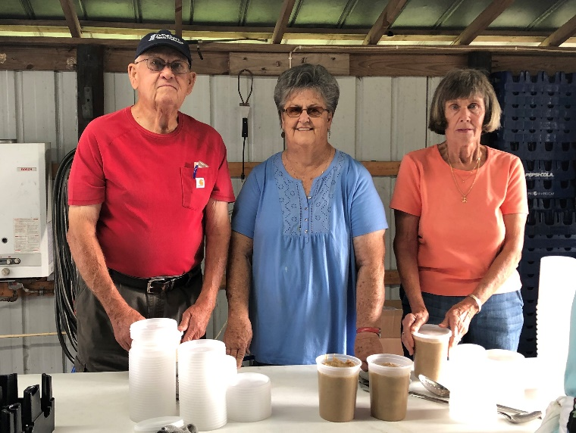
Watkins, Jane, and Joyce Topping Off the Hash
THANKS TO ALL WHO HELPED IN ANY WAY!!!

Trinity United Methodist Church
1160 Trinity Church Road
Newberry, SC 29108

