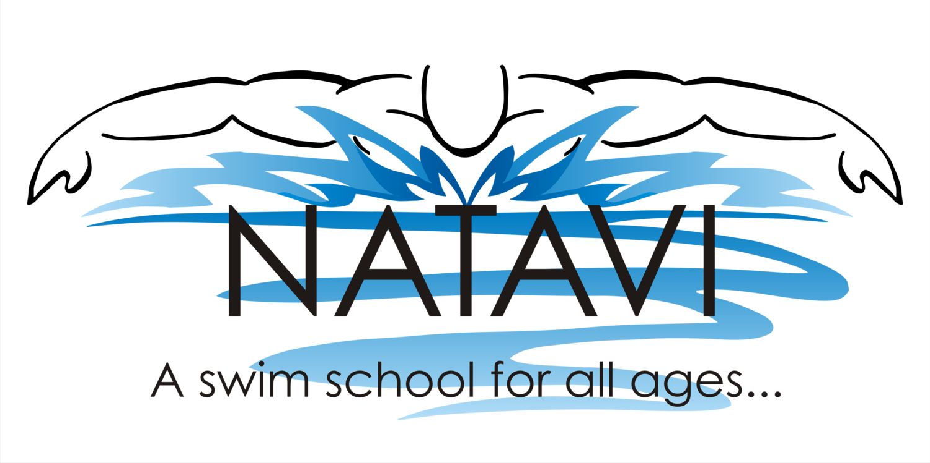
Monday | Tuesday | Wednesday | Thursday | Friday | Saturday
Water Aerobics:  9:00-9:50am  Water Walking/ Lap swimming:  10:00-11:00am  12:30-1:30pm  Family Swim:  2:00-3:00pm  Swim Lessons:  3:30-6:40pm  BOGA PILATES  7:00-7:50pm | Swim Lessons:  9:30am-12:00pm  Express Aerobics:  12:00-12:30pm  Water Walking/ Lap swimming:  1:00-2:00pm  Family Swim:  2:00-3:00pm  Swim Lessons:  3:30-6:40pm  Water Aerobics:  7:00-7:50pm | Water Aerobics:  9:00-9:50am  Water Walking/ Lap swimming:  10:00-11:00  12:30-1:30pm  In Water Pilates  1:30-2:20p  Family Swim:  2:30-3:30p  Swim Lessons:  3:30-6:40pm  Yoga – class varies: *  7:00-7:40pm  Aqua Meditari™ **  8:00-8:45pm | Swim Lessons:  9:30am-12:00pm  Express Aerobics:  12:00-12:30pm  Water Walking/ Lap swimming:  1:00-2:00pm  Family Swim:  2:00-3:00pm  Swim Lessons:  3:30-6:40pm  Water Aerobics:  7:00-7:50pm | Water Aerobics:  9:00-9:50am  Water Walking/ Lap swimming:  10:00-11:00 | Swim Lessons:  10:00-12:30p  Family Swim:  12:45-1:45pm
Summer 2021 - Effective June 1st 2021 – September 6th 2021

**Check Facebook for events and dates

