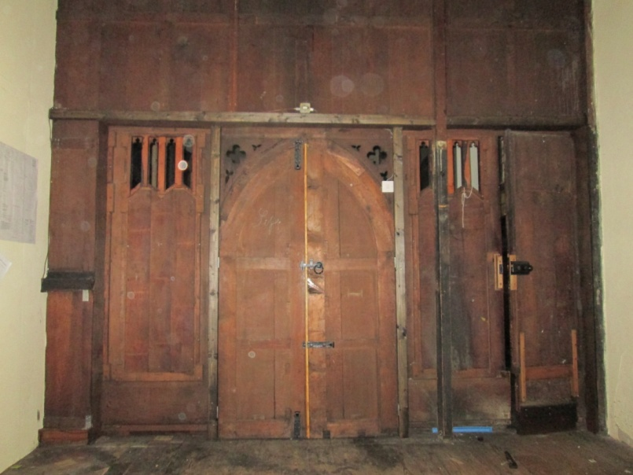
Meanwhile back inside do you remember the screen dividing the Church Office from the North aisle – well of course you do – viewed from the office side it wasn’t particularly attractive but it has undergone a transformation and now looks very smart.
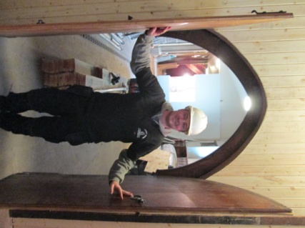

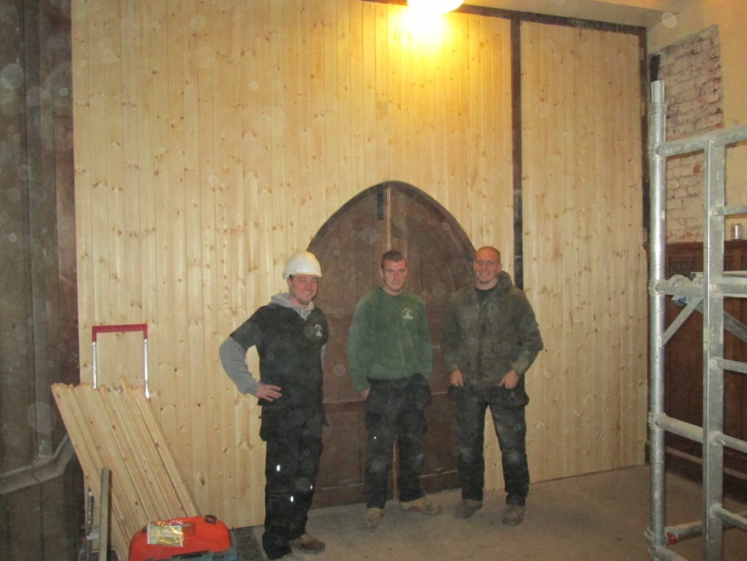

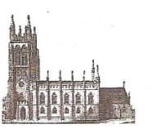
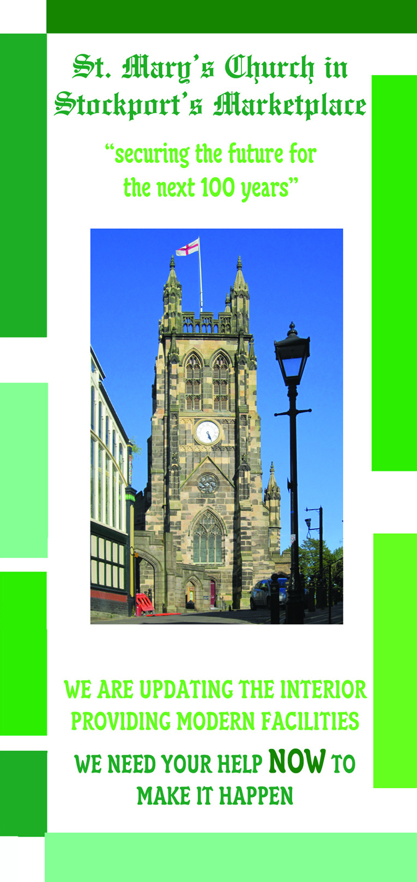
St Mary’s in the Marketplace.
Issue No 13 (14th October 2012))

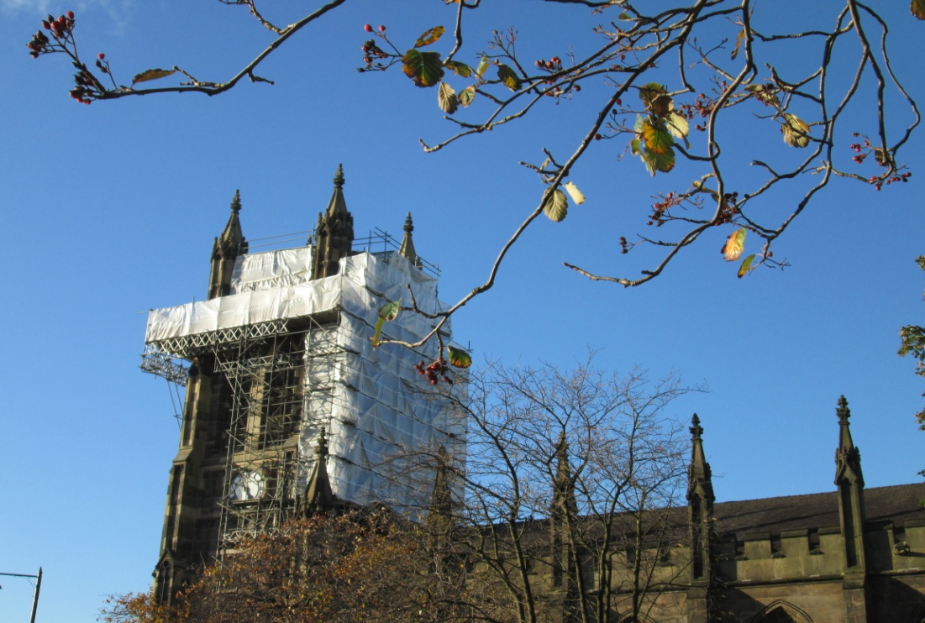
“Securing the future for the next 100 years”

Lambert Walker continue to work on Phase 5 with most the activity taking place on the Tower Roof. Our Rector has been up there to view progress as well as to take photographs for the archives and to bring the rest of us “ up-to-date” on developments.
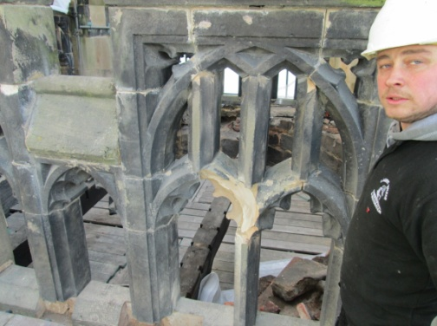
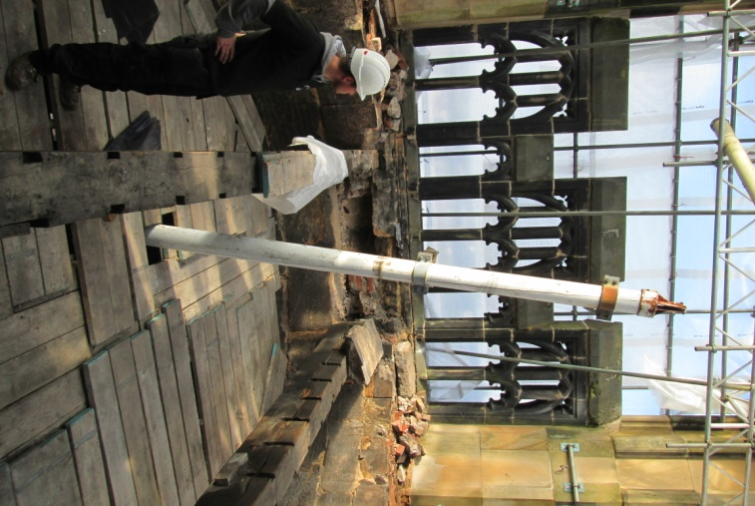
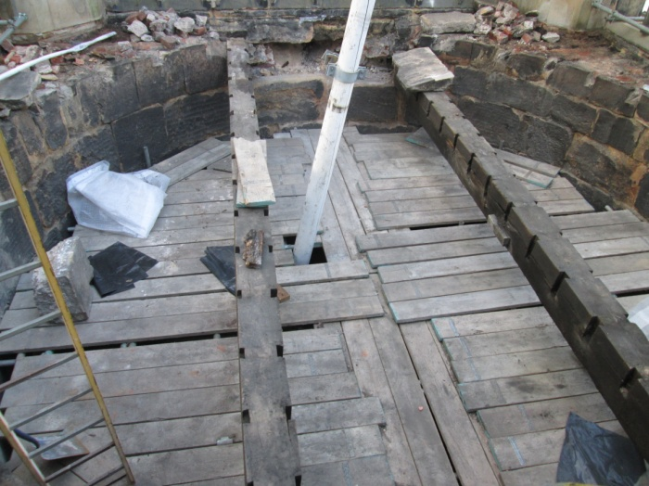

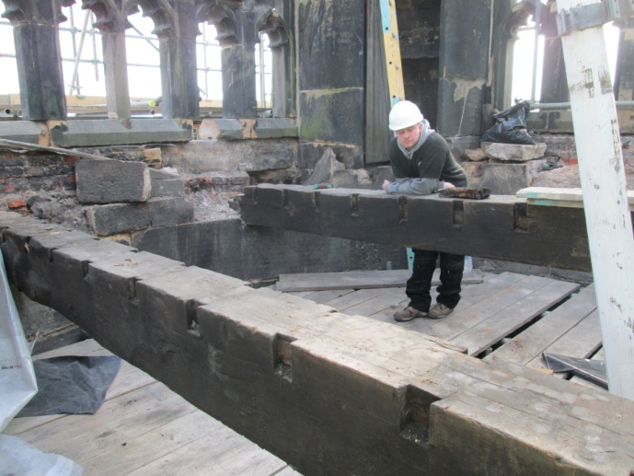
The photographs largely speak for themselves as we can view the heavy timber beams and areas of crumbling stonework on and around the Tower Roof. Comforting to know that we have experts up there sorting it all out for us.

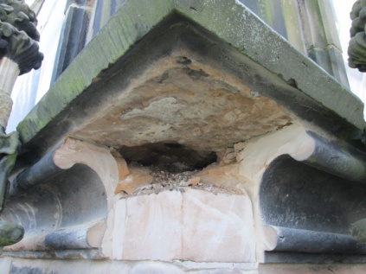
We are of course reminded as to the extent of
the work required to sort the problems on the
stonework – restoration and conservation is no
easy business!
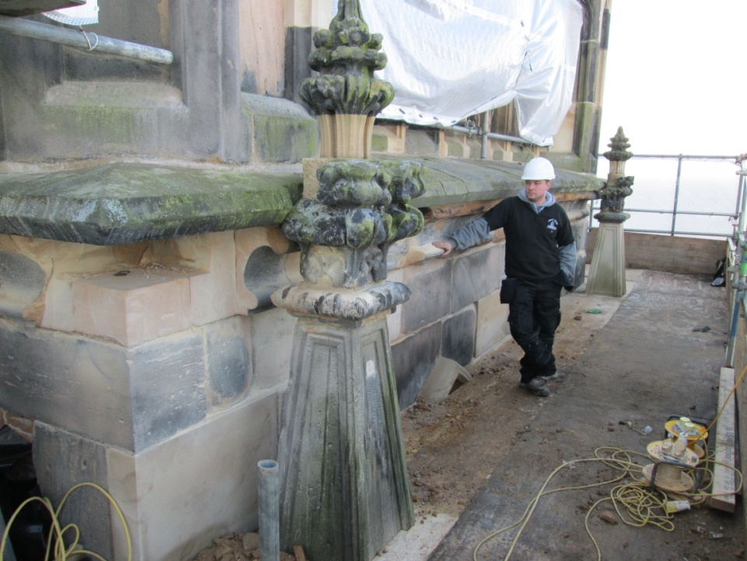

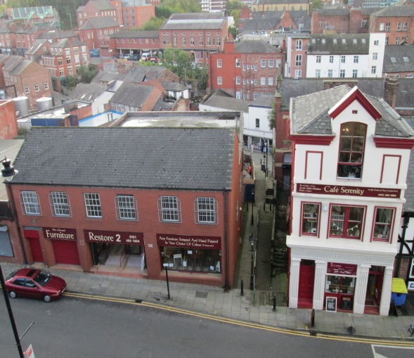
And the views from the scaffolding are somewhat different from our normal view of Churchgate.
