May/June 2022  Holiday Programme |  |  | www.wildaboutplayridgewood.co.uk
May | Mon 30th | Tues 31st | Weds 1st June | Thurs 2nd | Fri 3rd
Open 8am | Play | Creative Challenges  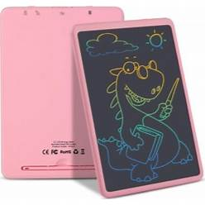 | Card Games | Club Closed  Bank Holiday | Club Closed  Bank Holiday
9:30am  10:30am | Coding for Kids |  |  | Holidays, Activities & Food Programme (HAF)  We may be able to offer you some free sessions if you are on benefit related free school meals or if you child has additional needs | Children’s Mental Health  We are planning a new ‘Worries’ board, mental health advice displays & sharing website links with our children – some of whom are experiencing difficulties such as anxiety or negative thought patterns.  Please do reach out to us should you need signposting to these websites or if you need a friendly face to face about any issues you are experiencing with your child’s mental health – we will be happy to run a few workshops to help.  Guide to Managing Anxiety –successfullymanaginganxiety informationfor adultandcarers_611.pdf (southglos.gov.uk)
12:00pm |  |  | Healthy packed lunch with ice pack for 12pm dinner each day please
 | Parachute Games | Yoga | Skipping Fun | You can find healthier swaps for next time you shop
1:00pm
2:30pm | Fruit Salad Bowl Making  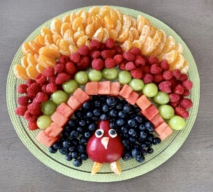 | Balloon Tennis
4:00pm  Close 6pm |  |  | Stress Balloon Making | As part of our Healthy Eating, we are providing healthy meal choices for Holidays, Activities & Food Programme (HAF) funded children.  Is your lunch box deemed healthy? …  School food standards - School Food Plan
Texts only: Sian (Club Owner) 07531 344 549 The booking deadline is Friday 13th May - Don’t miss it! Onsite Mobile (Staff team) Tel: 07784 48 10 32

May/June 2022 Holiday Programme
Date  Please tick your selected sessions | Morning Session  (8am-1pm)  £15.15 |  |  | Afternoon Session  (1pm-6pm)  £15.15 |  |  | All Day Care  (8am-6pm)  £23.10
Mon 30th May
Tues 31st
Weds 1st June
Thurs 2nd | Thurs 2nd & Fri 3rd June - Club Closed – Bank Holidays
Fri 3rd | Thurs 2nd & Fri 3rd June - Club Closed – Bank Holidays
Please note that trips are compulsory and there will not be an option of staying at Club.
We welcome suggestions for competitively priced trips and visitors to continue to keep fees low.

By booking certain dates, you are giving your consent for Wild About Play staff to take your child/children off Club premises, to the stated trip destination or take part in a particular activity by foot or by transport/public transport.
Name/s of Children: |  |  |  |  | Age/s during the May/June Holidays:
Name of parent/carer: |  |  |  |  | Telephone number:
Are you requesting booked dates that are funded by the Holiday, Activities & Food programme? If so, would your child like: A healthy packed lunch box containing fruit & veg, a cheese / or ham sandwich, a fruit yogurt/fromage frais, breadsticks and raisins, , beans on toast , cheese on toast , jacket potato with cheese and or beans
Email address: |  |  |  |  | School:
Please circle payment type: |  | BACS | Childcare Vouchers |  | Cash no longer accepted |  |  | Cheques no longer accepted
Signature: |  |  |  |  | Date:

The booking deadline is Friday 13th May - Don’t miss it!
Please send your completed form to wapridgewood@yahoo.co.uk

