- Help with this request form
This information is to support families, children and young people and those working with them to find out about the Social Communication Resource. This request form is how to ask if a child or young person can be supported by the Provision.
The request can be filled out in partnership between parents and carers, young people and the school where they might be on roll. Schools and other professionals are also able to make the request, with parent/carer consent
If you are a child or young person with a special educational need or a disability (SEND), or the parent of a child or young person with SEND, and you want help with this information or to fill in the request form you can call the Amaze SENDIASS helpline.
Amaze SENDIASS is the Special Educational Needs and Disability Information, Advice and Support Service for Brighton and Hove.
Tel:01273 772289
Email:sendiass@amazesussex.org.uk
Web page: https://amazesussex.org.uk/

- Introduction and Information

The Social Communication Resource is a Brighton & Hove resource, serving the whole city, for primary and secondary aged children who are not attending school at all and/or significantly struggling to attend school on a full-time basis due to their identified social communication difficulties (including autism) and associated social and emotional mental health.

- Essential eligibility criteria

These are required factors for children and young people when requesting access to the resource.

The child/young person:
- Is school age
- Is a Brighton and Hove resident
- Has identified social communication difficulties which have, significantly impacted on their access to learning.
- Has not made adequate progress despite a range of individualised interventions.
- They are on roll at a mainstream school or seeking to re-access a formal educational setting.
- Has not been on roll at a special school and/or identified as requiring special school through the Educational Health Care Needs Assessment and/or annual review process.
- Does not have a Risk Assessment identifying that it would not be considered safe for them to access the facilities.
- Parents and carers are seeking to work in partnership with the provision.
- Is consulted about this request for accessing the provision.

- Identification process

- The information submitted will be reviewed by a panel with a range of stakeholders present (e.g. Provision Coordinators, School, SEN Team, Health representatives, Brighton and Hove Inclusion Support Service BHISS, PaCC, Amaze).
- The panel meets termly.
- The panel will review progress, consider transition and moving on planning, as well as identifying new children and young people who might access the provision.
- Once a year a steering group meeting will take place to inform the provision development.
- The panel members use a set of criteria to help establish who is offered support from the provision
- Provision Coordinators may seek further information about eligibility through contact with families and the child young person.

- Accessible Formats
This form and introduction information can be made available in a range of languages and accessible formats. BHISS will arrange this where needed.

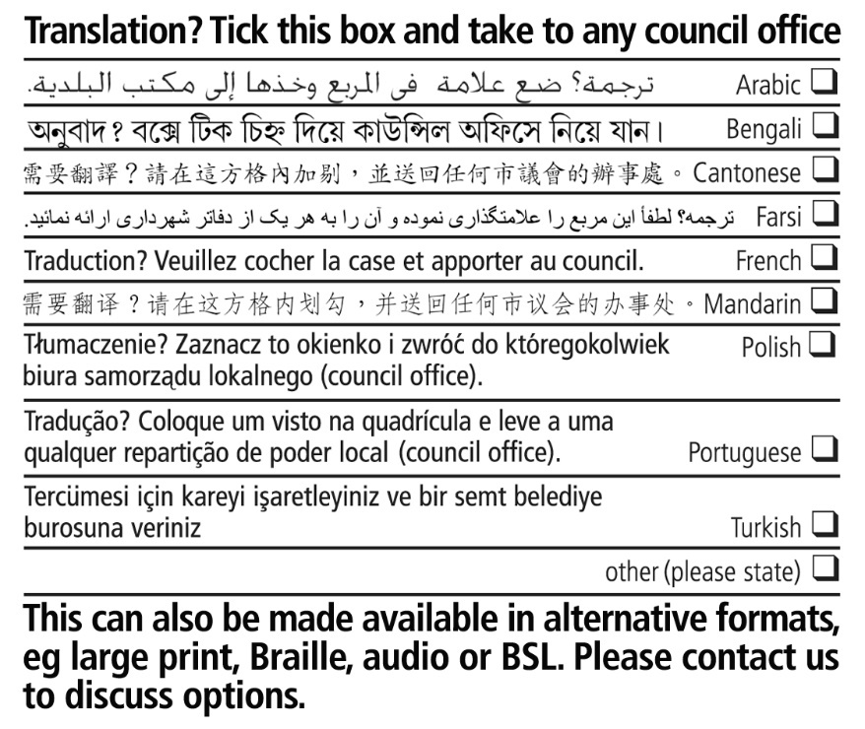

Local Offer page: Get help for children and young people who have social communication difficulties (brighton-hove.gov.uk)

Date of referral:
Name & role of referrer:
Child/Young Person’s name (Also Known As)
Date of Birth |  |  | Age
Preferred pronouns
Ethnic origin
Language used at home
Interpreter needed? | YES/NO | If yes - language required
Child/Young person’s address
Educational setting /
Not on roll
If not on roll, when last at a school and where
Current Year group
Current attendance percentage, if on roll and known
Education, Health and Care Plan in place | YES/NO | If yes, SEN Team have access to statutory paperwork
Child in Care | YES/NO
Child Protection Plan in place | YES/NO
Who has parental responsibility?
Parental contact telephone number and email address
Parent’s names
Parent’s address (if different from child/ young person’s)
Foster carer’s name
Social worker acting as parent
Other (please specify)

- Please attach most relevant and recent professional reports detailing the child/young person’s areas of need. Please also share any relevant historical reports.
e.g. Paediatrician or Consultant Nurse, Occupational Therapist, Speech and Language Therapist, CAMHS Psychiatrist, Clinical Psychologist, Therapist or Practitioner, GPs, Integrated Team for Families Worker (Front Door for Families), Education Other Than At School tutors (EOTAS), BHISS Educational Psychologist, BHISS Specialist Teacher, BHISS Schools Wellbeing Service Practitioner, ATTEND profile to outline factors affecting school attendance, school reports, and any other relevant reports.
- Please complete the sections below about the child / young person
You can reference attached reports rather than repeating the content.

- Describe the child/young person’s social communication difficulties
e.g. initiating (starting), maintaining interactions, conversation skills, reciprocity (turn taking)

- Describe how the child/young person’s social communication difficulties have impacted on their access to learning, wellbeing and development in school and at home
e.g. with indicators such as impact on attendance, lack of progression, social isolation, mental health deterioration, behaviour across settings

- Describe the child/young person’s attendance history
e.g. giving a timeline of when difficulties started, percentage of attendance, difficulties transitioning into school each morning

- Describe factors and issues that have impacted on attendance
e.g. evidence of using the ATTEND form where available

- If on roll at a school, give details of individualised intervention in support plans and monitoring of effectiveness over time
If not on roll please share any information on support given at home and how it helps

e.g. SEND Support Plans, Wellbeing plans, ATTEND support plan with evidence of regular reviews, Just Right profiles, Speech and language therapy plans

- Detail of support service involvement with dates
e.g. Team Around the Family TAF Plans, BHISS (please state which support team), Speech and Language Therapy, Occupational Therapy, Seaside View Child Development Centre, Child and Mental Health Service CAMHS

- Parent/ carer’s views

Some questions to consider:
- What is going well?
- What are the current challenges?
- How much access to home learning is there?
- What are your best hopes for your child?
- What is a typical day like at home for the child/young person and the rest of the family?

- Child/ Young Person’s Views
Please gather the child / young person’s views. This can be done in varied ways to match their age and communication preference, using a person-centred approach.

Videos, audio recordings can be shared as well as drawings, their own written words, or scribed answers to questions shared.

There are no set questions to ask; below is a guide of the areas to explore with the child young person:

- What is going well at home / at school / other areas?
- What do you enjoy doing? What would you like to do more of? What is getting in the way of you doing these things?
- What are you best at? What have you done that makes you feel proud?
- What do you find difficult? What challenges do you have?
- What learning do you do at home? How do you organise this learning? Who helps you?
- What do you hope working with the provision will help you with?

- Declaration by Parent/Carer, Young Person
I give consent for this request and attached reports to be used by the panel when making placement decisions. YES /NO
I agree that relevant information can be shared with other professionals as appropriate. YES/NO
Print name:

Relationship to child / young person:

Signed:

Date:

Data Protection Statement: Brighton & Hove Council will use the information provided in this form for the purpose of deciding whether or not the above-named child/young person be offered support from the Social Communication Provision Resource. The Council will only process your personal information for the purpose for which it was collected unless additional processing is required by law or in circumstances where the relevant conditions within the General Data Protection Regulation (GDPR) and Data Protection Act (2018) are satisfied. The Council maintains and uses information collected from children and families for whom it provides services to enable it to carry out functions for which it is responsible. Your personal information, including sensitive personal information (as defined by the Data Protection Act) will be shared between internal departments or with external partners and agencies involved in delivering statutory and other services.

l) Please send this form and all relevant reports and information as requested by post or email to:

Social Communication Resource Request

Brighton and Hove Inclusion Support Service BHISS
County Oak Avenue
Brighton
BN1 8DJ

BHISS@brighton-hove.gov.uk

