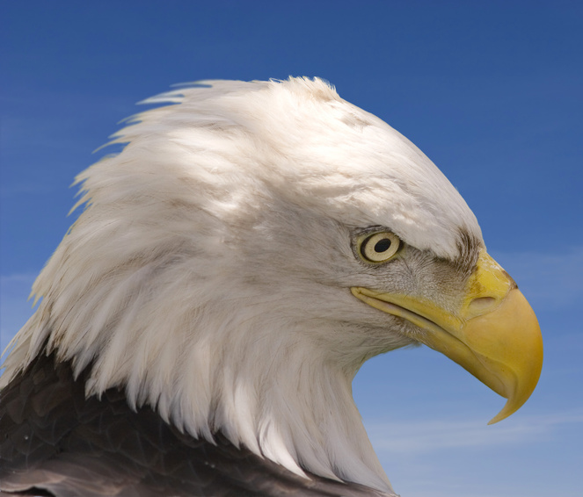
KENTUCKY VETERANS HALL OF FAME FOUNDATION, INC
KVHOFF, Inc..

The Covington, KY campus of Daymar College played host on July 28, 2012 to the Veterans Appreciation Day event.

Many Veterans and their families were honored for their dedicated service to our country.
Members of the Kentucky Veterans Hall of Fame Foundation, Blue Star Mothers of Northern KY, Blue Star Dads of Northern KY, US Marine Riders Association, Inc., Patriotic Guard Riders from Northern KY and Boone Post 4 American Legion as well as several other military support groups were in attendance. A large group of the Northern Kentucky Young Marines, under the leadership of YM/Sgt Dakota Richter, were in attendance for the Call for Posting of the Colors as well as the Alert to retire colors.
The staff from Daymar College did an outstanding job with the red, white and blue patriotic decorations and also served a very nice catered lunch and beverages.

KY State Representative, Dennis Keene from Wilder, KY was the guest speaker and spoke very much in favor of the newly established KY Veterans Hall of Fame Foundation, Inc. and what it would mean to so many Kentucky Veterans and their families as well as to our Commonwealth of Kentucky.

Tina Barnes, Daymar Campus President, presented Appreciation Awards to the two guest speakers, Dean Gosney and H.B. Deatherage, for their service to the armed forces and also to our communities, our state and our nation.
Both gentlemen are from Florence, KY and graduated from Boone County High School.

Mr. Deatherage as always, gave a very informative speech in enlightening many veterans of the future hopes and plans of the KVHOFF.

Many thanks to Tina, Dianna and the entire staff of Daymar College for making so many feel so very welcome.

Respectfully,

Lorene

