WINTER NEWSLETTER 2021
Dear Carer and Service User
We are into December again and Christmas is almost around the corner. We have had a very busy autumn period adjusting to life at Crossroads without Olivia. As you can imagine she is a huge miss in the office here. Her days are now filled with looking after her grandchildren and she most likely wonders when she ever had time to work! A tremendous amount of money came in to commemorate Olivia’s retirement and she chose a Tim Wooten picture of 3 highland coos, with the remaining money going towards an electric bike.
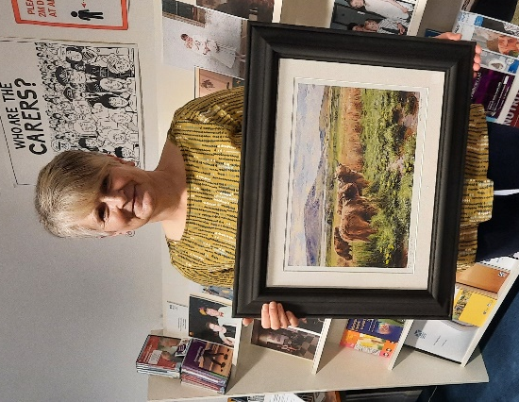
As we approach the festive season again I would like to inform you of the office closure dates. The office will close on Friday the 24th of December 2021 at 5pm until Monday the 3rd of January 2022 at 9am. Care Attendants do not normally work on the 25th and 26th of December and the 1st and 2nd of January unless the care is essential. If you have not been informed of, or are unsure of your care provision over the festive please give us a ring on 87 0500. If you need to contact someone when the office is closed over the festive period please call Arlene on 0792 748 7517.
Staffing update- Arlene Montgomery took over from Olivia on 22nd September. Catherine Tullock has now taken on the role of full time Coordinator, keeping her training role also. Karen Laughton has very recently taken on the post of 25-hour Coordinator. We look forward to working together as a team, moving forward to support you and continue the good work that Crossroads has done for many years now.
Tea Afternoon- Unfortunately the tea afternoon was cancelled due to the increasing numbers of covid circulating within the community at the time. The raffle was still drawn and for the sale of raffle tickets the amazing total of £1830 was raised. Many Thanks to all who sold and bought tickets, it was greatly appreciated as always.
Carers Assessments- We can do Carer’s Assessments here at the Orkney Carer’s Centre, looking at the tasks you do for the person you care for and looking at services and aids that could help you in your caring role. Orkney Health and Care also do Adult Support Plans for unpaid Carers and they can give you your options under Self Directed Support, if you meet the criteria for help. They can be contacted on 873535, ask to speak to the Duty Social Worker for Adults. The Young Carers equivalent is a Young Carer’s Statement. Our Young Carer’s Support Worker can also assess Young Carers for our service.
Scotspirit Holiday Voucher Scheme- Crossroads Care Orkney are working in partnership with Visit Scotland and Shared Care Scotland to deliver the ScotSpirit Scheme. This scheme is open to unpaid Carers who do a significant amount of caring to apply to for funding for a short break. The Carer can take their family with them too. We now have access to the Visit Scotland directory of places available and on completion of application we then book it for you. The amount allocated is up to £400 for an individual to take a break or up to £500 for a family, there will also be the option of a day trip and there is an allocation of £200 for that. Breaks must be taken by December 2022 but all bookings must be in place by the end of March 2022. If you are interested in finding out more about this please get in touch ASAP and I can also post or e mail out an application form. It would be great to see people benefiting from the scheme so please get in touch at the earliest opportunity.
Time to live fund- We have again been successful in getting more Time to Live Funding for the coming year. This fund is more flexible in that you can purchase anything that gives you a break such as a craft magazine subscription, music lessons, gym membership, garden bench, the list is endless. Please get in touch if you are interested or would like to have a chat about this fund or to request an application form.
Covid Boosters- You should all receive an appointment for your Covid booster through the post if you haven’t had it already. Should you have any queries regarding this give the Kirkwall vaccination centre a call on 0300 303 5313
Carers Support group- The group is underway again, meeting in the office on the second Wednesday of each month from 12-2pm. We are keen to see folk at this group and have been thinking of ways we could enhance it. Would you be interested in a craft session? A talk? A demonstration of some sort? Would a different time work better? Please let me know your thoughts so we can make it work for you. All ideas welcome.
Reviews- Just a reminder that you can request a review of your care at any time. Please give us a call and we can arrange that no problem at all, should you have any thing you wish to discuss or any changes that may need to be made.
It has again been a year like no other. Covid has had such an impact on our day to lives but please remember we are here to support you in whatever way we can, and if we don’t know the answer we will find out! Thank you also for supporting us, and helping us to help you.
Wishing you a peaceful time over the festive and all the best for the coming new year.
Take care and stay safe.

Yours sincerely
Arlene Montgomery
Manager

Email arlene@crossroadsorkney.co.uk
Registered Charity Number SC022786 Co. No. 16342

