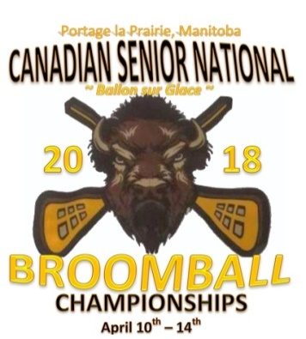
2018 CANADIAN SENIOR BROOMBALL CHAMPIONSHIPS
PORTAGE LA PRAIRIE, MB
APRIL 10 - 14, 2018

To All Provincial Delegates & Teams
This event is scheduled for April 10-14, 2018 at the Facility Stride Place (former PCU Centre) in Portage la Prairie, MB. Portage la Prairie is home to many top notch hotels and excellent restaurants. The Winnipeg James A. Richardson International Airport in Winnipeg is located only 90 km from Portage la Prairie (~70 minutes).

Please check the Manitoba Amateur Broomball Association web site for up to date information: http://www.manitobabroomball.com. Contact Raymond Massinon at rmassinon@hotmail.com, broomballmb@shaw.ca or Cell # 204-745-8775.

Vehicle Rentals
Enterprise (Winnipeg Airport) – quote promo code: LC64371

Host Hotel, Registration & Meeting Location

CanadInns Destination Centre Portage la Prairie

(www.canadinns.com/stay/portage-la-prairie)
2401 Saskatchewan Ave. W
Portage la Prairie, MB
1-204-857-9745

Driving Directions from Canadinns to Stride Place (7 minutes)
Head east on Saskatchewan Ave. W toward Elm Street.
Turn right onto Royal Rd. S

Practice Ice
For those teams wanting practice ice times, please contact Shelley (Stride Place) at 204-857-7772 ext. 2237 or email at ssmith@prra.ca. Dressing room keys will be available at the arena.

Team Registration
Tuesday, April 10th– times to be determined based on team arrival times.
Note: Coaches are required to bring all players certificates of proof for the on-line Anti-Doping course to Registration.

Team Photos
MAROHN IMAGES Is offering action photos (& Team photos) by pre-arranged request only. Please book in advance by phone/text 204-476-4025. Further information will be available shortly.

Coaches Meeting
Tuesday, April 10th @ 9:00 pm – CanadInns (Ambassador D)

Opening Ceremonies
Wednesday, April 11th @ 7:30 pm
NOTE: Teams – please wear your team home jerseys.

Awards Banquet & Dinner
Saturday, April 14th @ CanadInns
Banquet tickets are to be purchased during registration on April 10th @ $50.00 each. Extra tickets will be available until Wednesday, April 11th @ 6:00pm – CASH/CHEQUE ONLY PLEASE – There will be no tickets sold at the door.

Banquet Tickets
Number of tickets for the banquet (players / coaches / spectators): _______________________
Please indicate if any Player/team official has any food allergies:

Name: __________________________________ Type of allergy: ___________________________
__________________________________ ___________________________

TEAM CONTACT:
Name:__________________________________________________________________
Phone #: ________________________________________________________________
Email: __________________________________________________________________
Arrival Information: ______________________________________________________
What Hotel is your team staying at: __________________________________________

National Clothing Merchandise:
- Hoodies - Performance Sweat pants
- T-shirts - Long sleeve t-shirts - Performance Vests
- Toque - Baseball caps
We would like to have orders placed in advance so if you could please provide us with your order PRIOR to March 6/18 to ensure it’s available at registration for pick up (cash/cheque/money order or e-transfer payment options available). Order forms will be sent in a separate email.
NOTE: we will have a limited number of quantities and sizes at the main arena sold on a first come first serve basis.

