Kingston Single Malt Society
A social club for the appreciation of Single Malt Whisky since 1998
OCTOBER 26, 2009 VOLUME 3; NUMBER 2

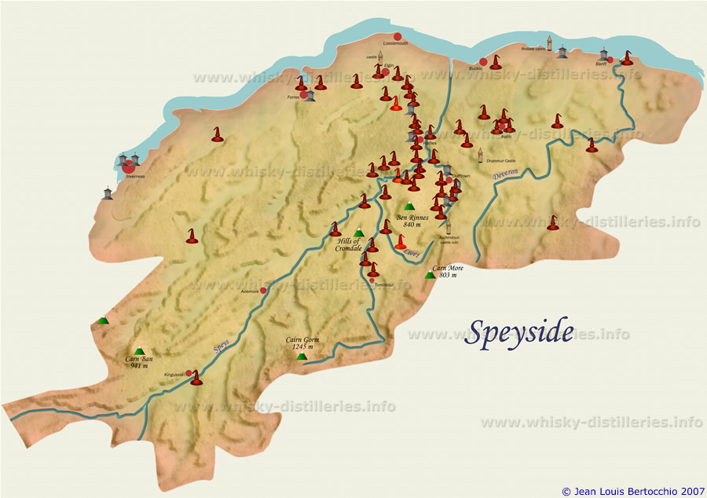
----------------------------
This evening's menu features a vertical tasting of BenRiach Single Malts from SPEYSIDE
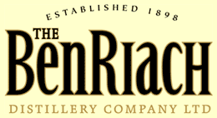
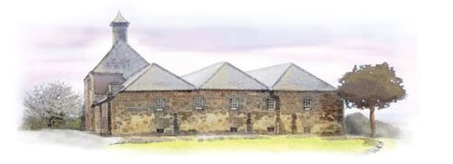

A Warm Welcome from BenRiach
It’s not often a long kept secret is revealed in the world of Single Malt Scotch Whisky – but here is a true discovery! Since 1898, the BenRiach distillery has very quietly been producing quality Single Malt Scotch Whisky, which has only ever been enjoyed in very small quantities, by a few discerning individuals who have been fortunate enough to come by a bottle. In April of 2004 the distillery, which was previously under the ownership of Chivas Brothers, was acquired by 3 entrepreneurs, led by Scotch Whisky industry veteran Billy Walker, and The BenRiach Distillery Company was born. Now BenRiach, located in the 'Heart of Speyside' just south of Elgin, is once again producing its very special Single Malt Whiskies ... as an independent distiller.

----------------------------

Soup: Curried Pumpkin Bisque

1st Nosing: CURIOSITAS PEATED OVER 10 YO
(introduced by: Christine Wasson)

Salad: Two Sprout and Spinach
Dressing: Toasted Sesame

2nd Nosing: 15Year Old PEDRO XIMINEZ SHERRY FINISH
(introduced by: Conrad Falkson)

Entree: Stuffed Pork Loin with Cranberry Dressing
Vegetables: Seasonal
Potato: Saffron Flavored Rice

3rd Nosing: 15Year Old TAWNY PORT FINISH
(introduced by: Drew Webster)

Dessert: Chocolate Carrot Craze

----------------------------

COST OF THE MALTS
I know members are always interested in the cost of the single malts we taste. Plus the $75 Special Occasion Permit and the 16% levy charged by the LCBO for all alcohol served at the dinner.

- CURIOSITAS PEATED OVER 10 YO (THE BENRIACH DISTILLERY VINTAGES 93500 | 700 mL bottle Price: $64.95 Spirits, 46.0% Alcohol/Vol.

- 15 YO PEDRO XIMINEZ FINISH SGL MALT (BENRIACH DIST) VINTAGES 93492 | 700 mL bottle Price: $94.95 Spirits, 46.0% Alcohol/Vol.

- 15YO SINGLE MALT AGED TAWNY FINISH (BENRIACH DIST) VINTAGES 93518 | 700 mL bottle Price: $94.95 Spirits, 46.0% Alcohol/Vol.

----------------------------
Dinner dates for KSMS 2009-2010
November 23, 2009 – Speyside
January 25, 2010 – Robbie Burns Night
February 22, 2010 – Highland
March 22, 2010 – St.Patrick's (Irish)
April 26, 2010 – Island
May 17, 2010 – Islay
June 21, 2010 – BBQ (Final Exam)
----------------------------
----------------------------

Membership and Dinner prices for 2009-2010
Membership Fees: $40 (singles)
$60 (couples)
One Time Initiation Fee $15
Standard Dinner Fee: $50 (member)
$60 (non-member)
Dinner only - No Single Malt: $45 (member)
$55 (non-member)
Robbie Burns Dinner Fee: $60 (member)
$70 (non-member)
(includes $5 donation per attendee to RMC Pipes &
Drums with Highland Dancers)
June BBQ Dinner Fee: $60 (member)
$70 (non-member)

----------------------------

SEPTEMBER - KSMS Financial Statement
(Money raised by September attendees) = $2590.00
September dinner 50 persons = $35.00/ea = $1750.00
Special Occasion Permit @ LCBO = $75.00
(Money remaining for buying Single Malt) = $765.00
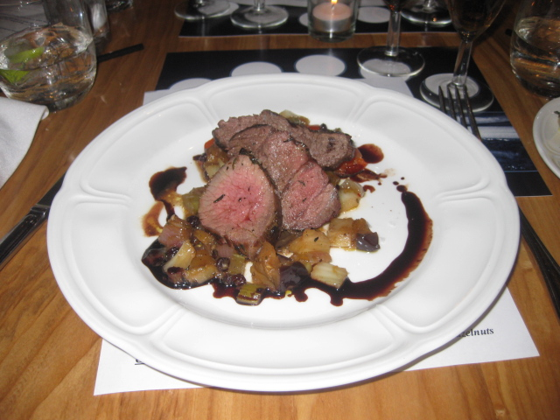
Cost of Single Malts September: = $842.14
KSMS Monthly operational balance = <-$77.14>
Cost per person (All inclusive) = $53.34

----------------------------
Interesting Websites

http://www.connosr.com/

http://www.forpeatsake.com/

http://www.maltmadness.com/

http://www.whisky-distilleries.info/

----------------------------
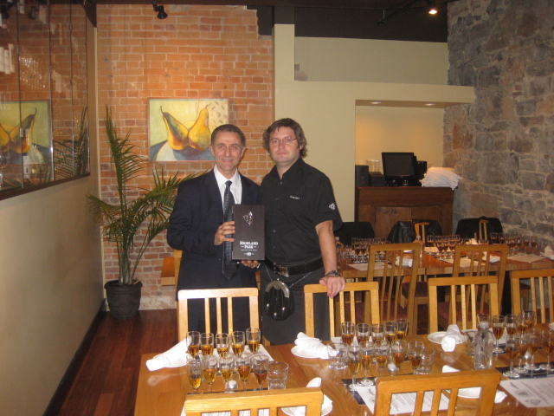
Kingston Single Malt Society hosted a vertical tasting of Highland Park Single Malts @ Olivea Restaurant
Saturday October 24th, 2009
Twenty-six attendees enjoyed a fine meal and a range of Highland Park. The evening was led by special guest Gerry Tosh, Highland Park, Head of Brand Education & Global Ambassador who made his way from the Highland Park distillery in Orkney, Scotland for the occasion.

MENU
Blind pouring: Famous Grouse Black

Cocktail: Old Fashioned Highland Park
(featuring Highland Park 12 year old)

Hors d’oeuvres: Rosemary roasted almonds
Panelle (Sicilian chickpea fritters) with lemon salt
Crostini with sopressata Veneta and fontina

1st Nosing: Highland Park 16 year old
Soup: Celery root puree with truffle oil drizzle

2nd Nosing: Highland Park 18 year old
Salad: Smoked salmon with fingerling potato salad & lemon caper vinaigrette

3rd Nosing: Highland Park 21 year old
Meat: Venison sirloin with squash caponata and fig vincotto

4th Nosing: Highland Park 25 year old
Dessert: Chocolate Valpolicella Crema
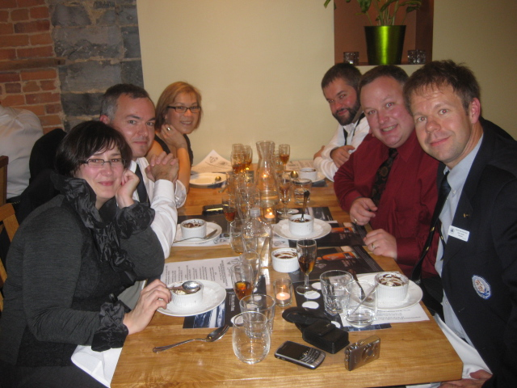
Enjoying dessert and the Highland Park 25.

5th Nosing: Highland Park 40 year old
Cheese: Aged pecorino cheese with truffled honey and toasted hazelnuts

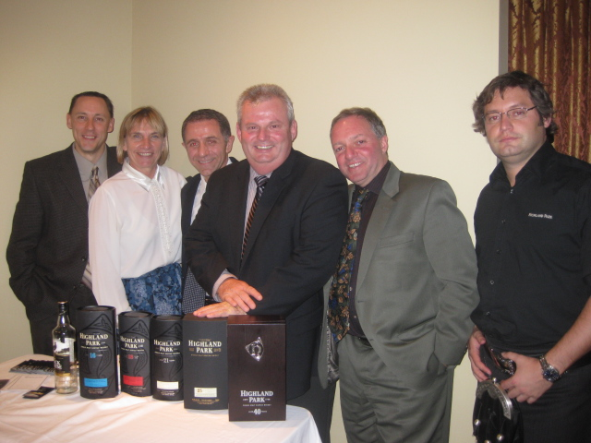
Gerry Tosh and some guests.

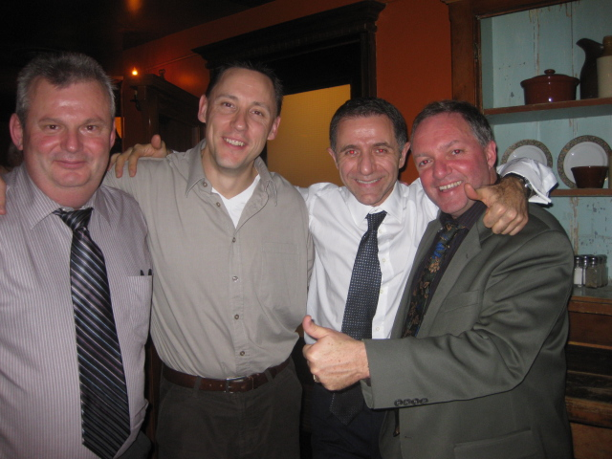
Signing off after a great night

----------------------------

The world’s greatest celebration of the whiskies of the world. Whisky Live Toronto, now in its fourth year, is Canada’s whisky tasting event of the year, bringing the celebration of whisky to Toronto.
Held this year in two halls, Halls F & G of the Metro Toronto Convention Centre, Whisky Live Toronto brings all the very best whiskies from around the world under one roof. Appealing to both the enthusiast and the novice Whisky Live Toronto has expert advice on hand as well as the opportunity to learn about the whisky basics. It is the ultimate whisky experience with such a stunning range of whiskies, delicious food, Masterclasses, live music and regular nose-off competitions. And with more room for more whiskies and more food, this should be the best whisky event ever.

On hand at this years edition were (L-R)
Sylvain Bouffard, Bill Gorham, Michael Hartzman, Roberto Di Fazio, Mike Patchett, and Ken Goodland.

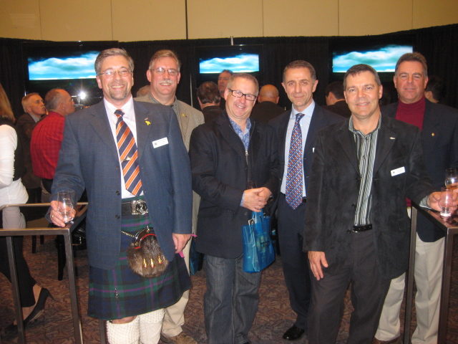
----------------------------

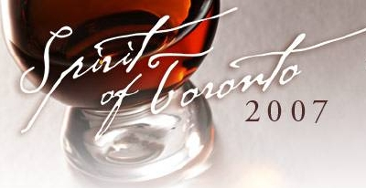

Spirit of Toronto – Saturday April 24, 2010
Spirit of Toronto is Toronto’s Annual Whisky Gala, a spectacular evening featuring more than 100 single malts and premium spirits, tutored tastings, live jazz, gourmet catering, food and whisky pairings, whisky cocktails and an outdoor cigar terrace on the lower level of Roy Thomson Hall.
Come and join KSMS as we travel to the gala event. Next year it will be occurring on Saturday April 24, 2010 at the Roy Thomson Hall in Toronto. I have made arrangements McCoy’s Bus Service to shuttle us there and back. The bus will depart Saturday April 24th, 2010 at 8 a.m. and return Sunday April 25th, 2010 at 2 a.m. The cost of the bus will be $40 per person and will be open to the first 27 people who express interest in the form of full payment.

----------------------------

Win Me !!

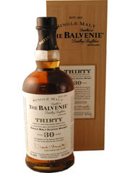

THE BALVENIE 30 YEAR OLD
SINGLE MALT WHISKY
VINTAGES 665091 | 700 mL bottle Price: $640.95
Spirits, Scotch Whisky, 47.3% Alcohol/Vol

Starting September 21st, 2009 tickets can be purchased for a chance to win this bottle. Tickets will be $3 each or two tickets for $5. Tickets will be on sale at each dinner until the January 25th, 2010 Robbie Burns dinner when the bottle will be raffled. The winner must successfully answer the skill testing question: What country does single malt come from?

----------------------------

Reservation policy
- Our contract with the Officer's Mess Kitchen requires that we provide seven (7) business days notice for them to guarantee accommodation for our requested numbers. Each month an invitation will be sent out to all members of the Society in the first week of the respective month in which the dinner will be held. To accommodate the Kitchen's needs and meet our contractual obligation with them; our members are requested to respond to the emailed invitation seven (7) business days prior to the respective dinner to guarantee a seat at the dinner. After that members will be placed on a waitlist.
- For these individuals the process will be as follows, using the September 21st dinner date as an example:
- Dinner invitations will be sent out Saturday August 30th, 2009. Please respond to me (rdifazio@cogeco.ca). I will then acknowledge that you have a seat. Please understand that if you do not receive a response you are not guaranteed a seat at the respective dinner. In such circumstances (e.g., computer glitches) please e-mail me again or call me at (613-634-0397).
- Accommodation at the dinner will be guaranteed for a member who responds by Wednesday September 9th, 2009 midnight.

Cancellation policy
- Using the same example as above, anyone who cancels anytime prior to Wednesday September 9th, 2009 midnight will be removed from the list.
- Anyone canceling between Wednesday September 9th, 2009 midnight and Monday September 21st, 2009 will be expected to pay for the cost of the dinner and scotch ($50). It is the responsibility of the member who cancels their reservation to find a replacement. If I can substitute an individual from the wait-list, then the member will not be asked to pay for their cancellation.
- Anyone who fails to attend the Monday September 21st, 2009 dinner without having cancelled and been successfully replaced will be expected to pay the full cost ($50). The member will be responsible for their guest's cancellation.
- If a member asks to be included at the dinner between Wednesday September 9th, 2009 midnight and Monday September 21st, 2009 , your name will be placed on a wait-list and be accommodated on a first-come first-serve basis.

----------------------------
Just a note because we care.

Please understand that for the purpose of each event you are advised to drink responsibly and refrain from excessive consumption. The dinners hosted by the Kingston Single Malt Society are sampling events. By agreeing to pay and thereby attend the dinner you agree to release from legal responsibility and hold harmless Kingston Single Malt Society, its President Roberto Di Fazio, and any other volunteers from liability or claims arising from these events.

----------------------------

If you have any questions or comments please free to contact me. Thank you for your understanding,
Roberto



