Antoinette Jackson

Insideout ministy  antoinette3@insideoutminisrty.net

INSIDE OUT MINISTRY

**NEWSLETTER 2020**

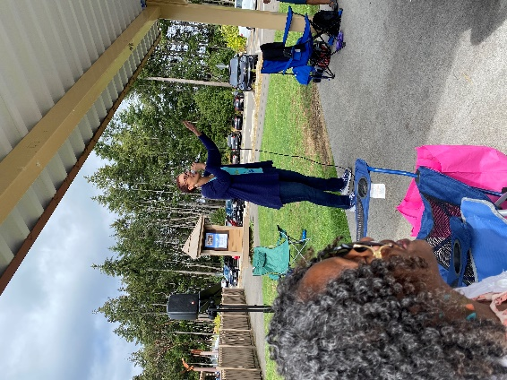 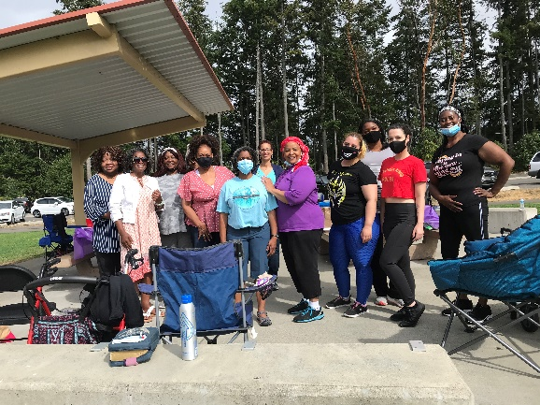

**Worship**

**Fellowship**

**Learning to live a new normal**

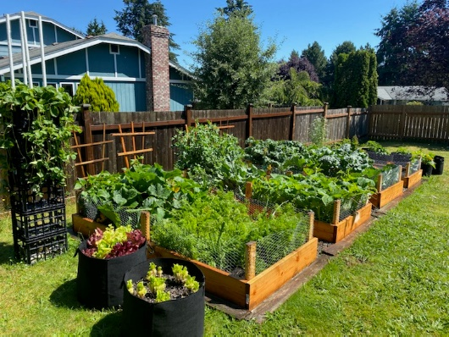 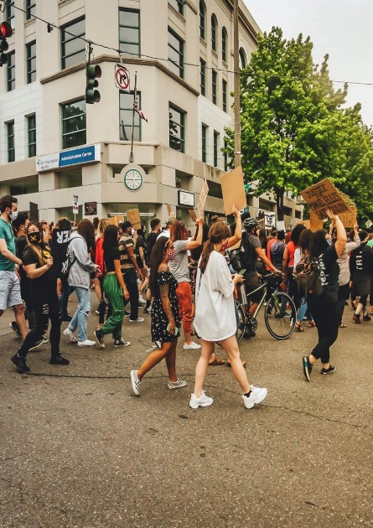

**Growing Food**

**Protest for CHANGE**

***Testimony of Maria Stennis***

2020 The year of uuuuhhhhh……

Flash back to Dec 31st 2019… Clock strikes 12:00 am, and I’m going into what would be “My best Year Ever!!”

You see, my husband and I made our “concrete” plans to change the World! We were going to be great and become Wealthy (still speaking that into Existence) Travel the world and continue to grow our business.

One of the biggest things that we planned this year was to leave the state of WA and travel to Texas to buy Real estate.

We decided to start our year with a mini vacation. We were able to travel In Early February to visit Texas and North Carolina, however it was in that vacation that we started to hear about a disease that was spreading like wildfire. We were told by some of our friends to wear a mask and stock up on food and supplies so we did. We were given odd looks in the airport and on the airplanes returning home because we had on our mask, but me being in the health care field knew to follow science and not people, So we wore our mask and when I returned to WA I started stock piling food, hand sanitizer, wipes etc… Whatever I felt like I needed to keep my family safe for a few months I did.

Fast forward to a few weeks later and all hell had broken loose. Seattle ended up being the first state to confirm this deadly virus and quickly others were also becoming sick and dying from it.

There was a feeling of Frustration, Fear and anxiety from people in the community, being told to stay home and social distance, but I remember just being. If that makes sense.

You see, I Have always been a pretty private person, I mean don’t get me wrong I had no issues teaching, Going out with my hubbie and few and I mean a few select friends, but that’s where it stopped. I don’t allow people into my home with the exception of family and few friends, so the social distancing and stay home orders did not affect me one bit at first.

Fast forward again to our current month July 2020 and I can honestly say that even I, the person who took pride in being alone, was suddenly craving people and interaction and the outdoors!!!. I had to think about what I have been told since I was a child. People are not meant to be alone. We need other people.

I see the effects of solidarity on my 5 year old who was used to going to school with his friends and is a bit of a socialite, become attached to his phone and game console because that really is the only other form of social activity he can receive. I have seen my husband who can start a conversation (lengthy ones) with anyone he meets have to turn to his podcast and other internet material to get the male comradery that he needs. And I’ve even seen myself break out of my shell of exile and start a women’s group so that I can 2 feel the warmth of another woman’s conversation.

This year has been an up and down rollercoaster, however one thing that me and my husband decided was that this world would not stop the plans that GOD had placed in our hearts in and our minds.

So, we **Moved** to Texas in the middle of the pandemic opting to drive instead of flying.

We have started 2 more small business not just one for a total of 3.

And we WILL be Wealthy by 2021.

I say all this to say that Just because the world around you changes, doesn’t mean that GOD does!

His word is TRUE.

And when he places something on your heart, react. Do it and trust him. I am blessed that Toni has allowed me to speak all of this to you, and I hope that someone who is reading this right now, that has placed their plans on hold because of what is going on right now, That keeps saying to themselves that this is not the “ PERFECT TIME” Realizes that There is no such thing.

Every day that YOU ARE AWOKEN is the ‘PERFECT” time!

Blessing

Maria Stennis