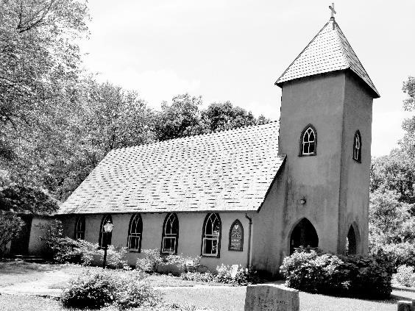

**Grace Episcopal Church**

**Grace Church Lane**

**Casanova, Virginia 20139**

**e-mail: gracechurchcasanova@gmail.com**

**website:** [**www.gracechurchcasanova.org**](http://www.gracechurchcasanova.org)

My brothers and sisters in Christ,

I bring you greetings in the name of the Father, and the Son, and ✠ Holy Spirit.

We are now in the season after Pentecost, the green season. I always have associated this with the growing season, green representing growth. The lessons we read or hear during this season instruct us how we as disciples (students) and apostles (proclaimers) grow in our faith. As we grow in our faith, we are strengthened in our faith. As our faith is strengthened, our faith also is being challenged. Sometimes we fall down and sin, that is we experience a break in our relationship with God. At times we simply ignore the fact we have sinned. We may even attempt to justify it. After all, my pledges are on target therefore the sin is not that bad.

***“If we say that we have no sin, we deceive ourselves, and the truth is not in us. If we confess our sins, he who is faithful and just will forgive us our sins and cleanse us from all unrighteousness. If we say that we have not sinned, we make him a liar, and his word is not in us.”1 John 1:8-10 NRSV***

One sin always before us is how we treat our brothers and sisters. If we are not loving them as God loves us, then we are sinning. Even though one has a right to have an opposing opinion, it does not give one the right to disrespect that sister or brother. Disrespect is seen in forms of abuse, mentally or physically and sometimes both. This is not love. Before we say, “I am not disrespectful,” to witness this and ignore it is a sin of omission It remains a sin.

In our liturgy we proclaim in part that we are one in Christ, and He is one in us. This means Jesus the Christ is in us, all of us. If I see a woman, I see Jesus. If I see a Hispanic, I see Jesus. If I see LGBTQIA+, I see Jesus. If I see a poor person, I see Jesus. If I see a rich person, I see Jesus. There is no room for disrespect because disrespect is not love and God is love. It is with great joy I witness Grace demonstrating this love. There is never an expression “look at what I am doing for you or how much better I am.” No, it is always an expression of God loves you and so do I. This is us growing in our faith.

The peace of the Lord is always with us, Fr. Michael B. Guy Sr., S.T.S.✠ 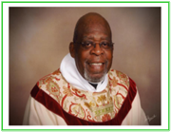

**SENIOR WARDEN’S NOTES**

Dear Grace Family,

Because there was not Vestry meeting for the months of June and July, I have only a few notes for you. Not having a meeting, as is our custom in the Summer, I must admit, was a welcome break!

Diocesan news includes:

* Happy news: The Rev. Canon Mark Stevenson was elected as the 14th Bishop Diocesan of the Diocese of Virginia

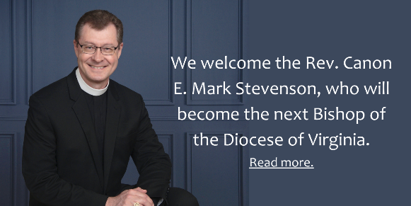

* Sad news: The Rt. Reverend Bishop Peter James Lee, 12th Bishop of the Diocese of Virginia, passed away in Chapel Hill, North Carolina on July 2, 2022. He was 84. Bishop Lee served for 25 years as Bishop of Virginia, from 1984 to 2009. Many of our Grace family remember him with great fondness. Grace sent condolences to the family and will be donating to the Peter James Lee Endowment for Small Church Revitalization fund. (You may remember that this fund granted Grace Church a generous amount in its successful quest to replace the slate roof of the church building.) To read Bishop Lee’s entire obituary, log onto the Diocese website: <https://www.thediocese.net/news/give-thanks-for-the-life-of-the-rt-rev-peter-james-lee/>



Blessings,

**We are now sending this newsletter via e-mail, please contact one of your Vestry members if you would like yours to be e-mailed.**

**Mary**

**TREASURER’S REPORT – MAY & JUNE 2022**

Income for the months of May and June was $17,104.63 (budget $16,928.00); expenditures totaled $19,343.98 (budget $16,928.00), resulting in a deficit for the 2 months of $2,239.35

The book value of our endowment fund is $62,847.24; market value as of June 30 is $61,620.15, a loss of   
$3,868.23 for the 2-month period.

Please continue to pray for Grace Church that it will grow spiritually, financially and numerically. If you have any questions about this report or any financial matter, please contact me.

**Judy Ball**,**,** Treasurer.

**Feed My Sheep (FMS)** 

***The Greatest of These is Love.***

We are in the ‘dog days’ of summer... A time to be lazy and lie in the shade with a cool drink.  Not so for our families. The kids are gearing up to return to school August 10! This means extra snacks in the backpacks and to have when kids arrive home. Not everyone qualifies for reduced or free breakfast/lunch.  I don’t need to remind anyone of what is happening to our grocery bills. So many of our clients depend entirely on social security or a ‘ fixed retirement.  Grace Church has always been generous in giving and supportive of this outreach. Now more than ever we need to help each other in these challenging times. Please be generous with donations as you feel able. Checks may be made out to Grace Church and mailed to PO Box 18, Casanova, VA 20139, or placed in an envelope and left in the collection plate.

God’s Peace, **Carol Grove** 🙏🏻❤️

We are now sending this newsletter via e-mail, please contact one of your Vestry members if you would like yours to be e-mailed.

**AUGUST BIRTHDAYS AND ANNIVERSARIES**

|  |  |
| --- | --- |
| **Travis Fields** | **3-Aug** |
| **Ancel & Melba Hendrix** | **3-Aug** |
| **Art and Sue Payne** | **7-Aug** |
| **Josh Warren** | **7-Aug** |
| **Jeannette Cerv** | **11-Aug** |
| **Emily Jacobs Johnson** | **13-Aug** |
| **Marilyn Ottevaere** | **14-Aug** |
| **Mary Neal** | **16-Aug** |
| **Jeff Shipe** | **17-Aug** |
| **Wesley Moline** | **18-Aug** |
| **Bob Brewer** | **20-Aug** |
| **Doris Pearson** | **20-Aug** |
| **Dale Cirillo** | **28-Aug** |
| **Nathan Butler** | **31-Aug** |
| **Ancel Hendrix** | **31-Aug** |

**We are now sending this newsletter via e-mail, please contact one of your Vestry members if you would like yours to be e-mailed.**

|  |  |  |  |  |  |
| --- | --- | --- | --- | --- | --- |
| **DAY** | **READINGS**  **\*** | **ALTAR/**  **FLOWERS** | **READER/ ACOLYTE** | **OFFERTORY PRESENTER** | **COFFEE HOST** |
| **August**  **7** Ninth Sunday after Pentecost | [Isaiah 1:1, 10-20](https://www.lectionarypage.net/YearC_RCL/Pentecost/CProp14_RCL.html#ot1) [Psalm 50:1-8, 23-24](https://www.lectionarypage.net/YearC_RCL/Pentecost/CProp14_RCL.html#ps1) [Hebrews 11:1-3, 8-16](https://www.lectionarypage.net/YearC_RCL/Pentecost/CProp14_RCL.html#nt1) [Luke 12:32-40](https://www.lectionarypage.net/YearC_RCL/Pentecost/CProp14_RCL.html#gsp1) | Pam Ruffner/ Diane Gulick | Betsy Anderson | Howard Charnock | Marilyn  Ottevaere |
| **August 14** Tenth Sunday after Pentecost | Isaiah 5:1-7  Psalm 80:1-2, 8-18  Hebrews 11:29-12:2  Luke 12:49-56 | Barbara Jacobs/ Mignonne Spellmeyer | Bryan Jacobs | Betsy Anderson | Sharon  Sweeney |
| **August 21** Eleventh Sunday after Pentecost | Jeremiah 1:4-10  Psalm 71:1-6  Hebrews 12:18-29  Luke 13:10-17 | Betsy Anderson/  Sharon Sweeney | Howard & Diana Charnock | Judy Ball | Mignonne  Spellmeyer |
| **August 28** Twelfth Sunday after Pentecost | Jeremiah 2:4-13  Psalm 81:1, 10-16  Hebrews 13:1-8, 15-16  Luke 14:1, 7-14 | Pam Ruffner/ Mignonne Spellmeyer | Judy Ball | Mignonne Spellmeyer | Sue Ballentine |

**If any dates do not fit your schedule, please arrange to trade with someone else.**

**\*https://www.lectionarypage.net/**

***We are now sending this newsletter via e-mail, please contact one of your Vestry members if you would like yours to be e-mailed.***

**AMAZON SMILE FOR GRACE CHURCH**

Don’t forget to sign up with Amazon Smile to have 0.5% of the purchase price of eligible items given to Grace Church at no cost to you! You can also go to the Grace Church website home page and click on the link there.

#### *******AmazonSmile Shopping App for Android Users Now Available******

You can now support Grace in the Amazon shopping app on your Android device! Simply follow these instructions to turn on AmazonSmile and start generating donations to Grace from your Android device.

* If you have the latest version of the Amazon Shopping App, open the App on your Android device.
* View Settings and select AmazonSmile.
* Follow the in-App instructions to complete the process.

We are now sending this newsletter via e-mail, please contact one of your Vestry members if you would like yours to be e-mailed.