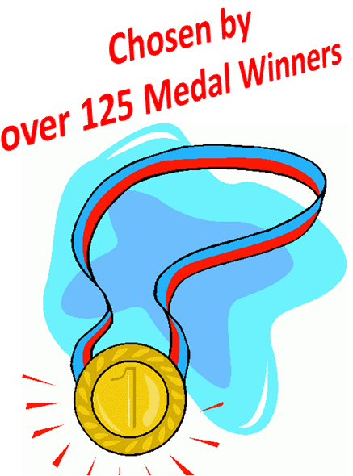
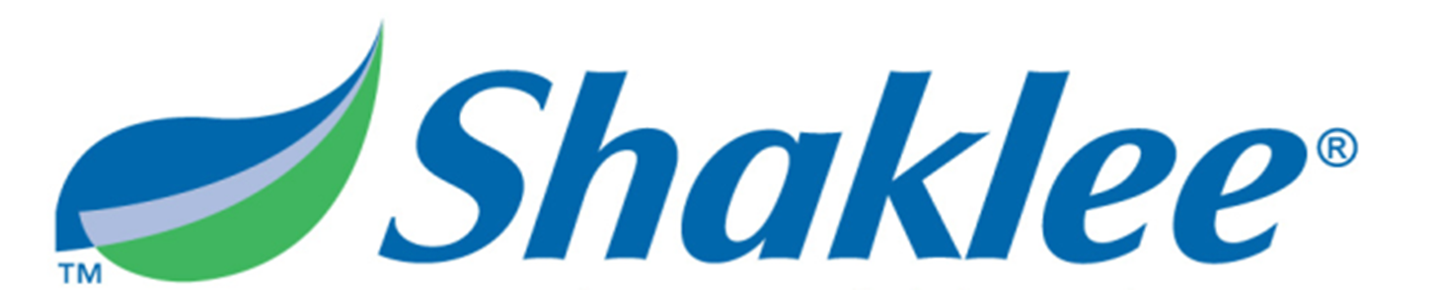
Sports Nutrition

Clinically Proven to help YOU
Train Longer ... Recover Faster ... Perform Better

Before Exercise During Exercise After Exercise

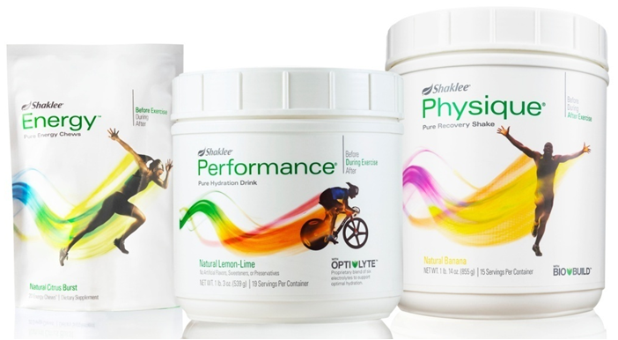

Pure Energy Chews Pure Hydration Drink Pure Recovery Shake

Natural products ... with no artificial flavours, sweeteners, or preservatives.
Everything you need ... Nothing you don’t ...
That’s PURE PERFORMANCE!

