Getting Started
on the Mountain Dulcimer

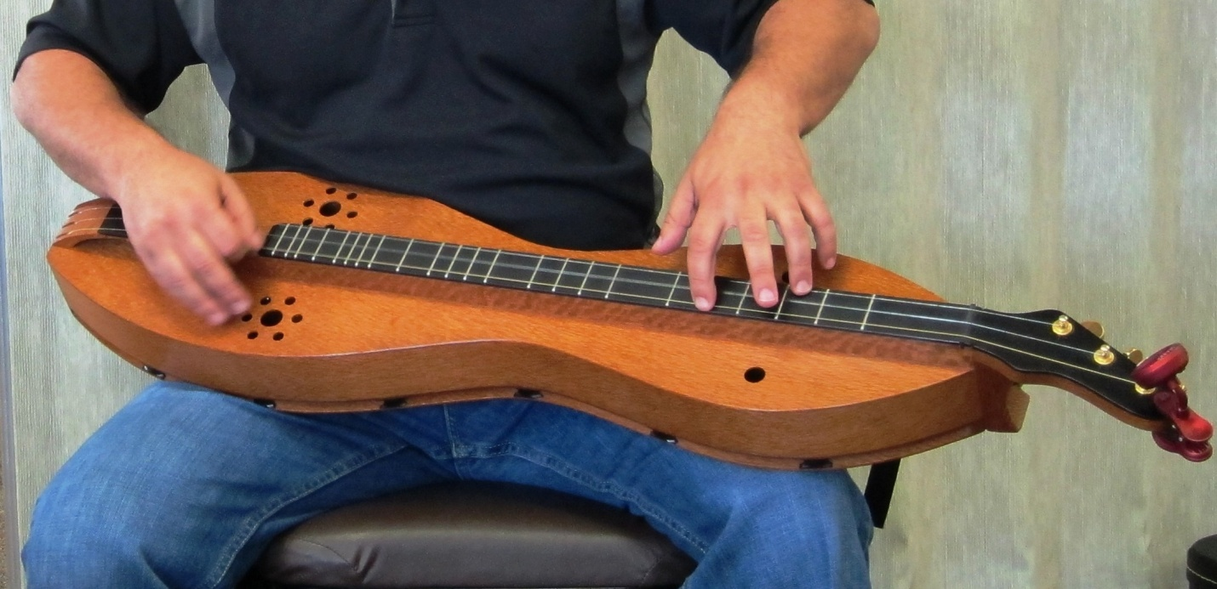

A Primer for the Absolute Beginner
prepared by Dusty Thorburn

Part I: The Parts of a Dulcimer
Although dulcimers come in many different shapes (hourglass, teardrop, elliptical, box, etc.), they all share the same main parts. This diagram depicts the main parts of every dulcimer.

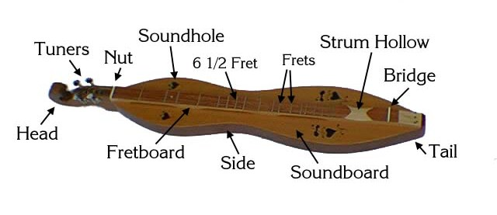

Part II: How to Hold a Dulcimer
Although some people put their dulcimer on a table or stand, the most common way to hold a dulcimer is to lay it on your lap. You need a low seat so that your lap creates a flat surface for your dulcimer, and sit with your knees apart. Position the dulcimer so that the head is to your left and the tail to your right, and the dulcimer should be angled, with the head sitting over or past your left knee and the lower end against your body. As you play, the dulcimer may have a tendency to move. To minimize such movement, you might lay sticky shelf liner (or carpet padding) on your lap. Another possibility is to use a strap that attaches to the tail and head of the dulcimer and goes around your lower back. A strap has the added advantage that the dulcimer can be angled up slightly, lifting the bottom off your lap a bit and allowing the back to vibrate more freely, creating more volume. (See the photo of the author on the cover of this document.)
Part III: How to Tune a Dulcimer
Traditionally, the dulcimer was played in a drone style, where the melody was played only on the (yes, you guessed it!) melody string and the bass and middle strings were allowed to drone. In traditional playing, different songs required different tunings. However, the addition of the 6-1/2 fret and the fact that most modern dulcimer players fret across all the strings mean that most songs can be played in a small number of tunings. By far the most common tuning for modern dulcimer players is a 1-5-8 tuning in the key of D, or D-A-d. The first note refers to the bass string, which should be tuned to the D below middle C on the piano (or the open 4th string of a guitar), the middle string should be tuned to the A below middle C on the piano (or the 4th fret on the bass string), and the melody string should be tuned to the D just above middle C on the piano (or the 7th fret on the bass string or the 3rd fret on the middle string).
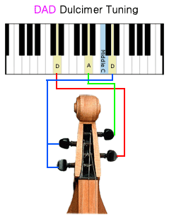
Some dulcimer players, especially those who fingerpick, tune their dulcimers to CGc. And other common tunings include DAA, DAC, and DAG. In our discussion here, however, we will assume our dulcimers are tuned DAd.

Part IV: How to Read Dulcimer Tablature

Little or no music theory is necessary to successfully play the dulcimer. Traditionally dulcimer players learned by watching and listening to other players. But nowadays, many of us learn songs by reading dulcimer tablature, which is simply a pictorial representation of where to play each note on the dulcimer fretboard.
With the dulcimer on your lap as described in Part II above, the bass string is furthest from you, then comes the middle string, and closest to you is the melody string, as in the picture below.

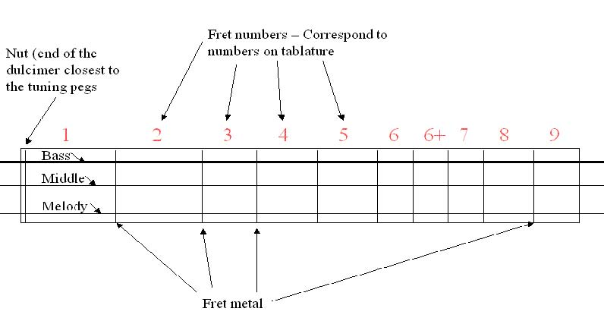

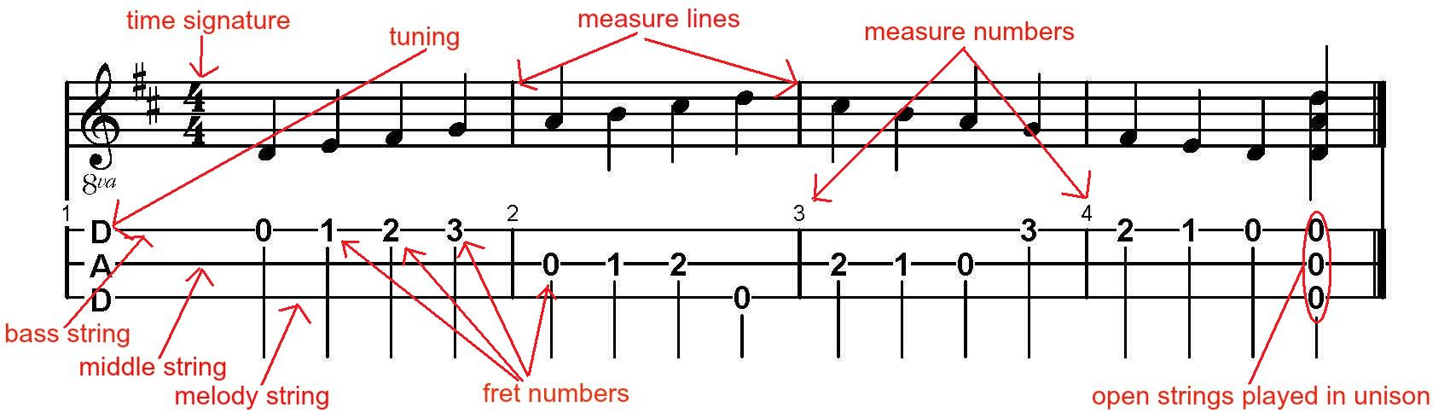
Just as in the diagram of the fretboard above, dulcimer tablature is written with three horizontal lines corresponding to the three strings of the dulcimer, with numbers indicating the fret where a note should be played. In most cases, standard music notation (SMN) will appear above the tablature, but one need not understand SMN to read tablature. In the example below, the tablature sits below SMN, and both show the D major scale ascending and descending followed by the open strings of the dulcimer played in unison.

One aspect of musical notation that is not so easy to depict in tablature is the duration of each note. For that reason, most people find it much easier to use tablature to learn how to play songs they already know. But to fully make use of tablature, a little bit of music theory will help. Different types of notes have different durations.

Whole Note | Half Notes | Quarter Notes | Eighth Notes | Sixteenth Notes

As the names would indicate, two half notes have the duration of one whole note; two quarter notes have the duration of one half note; two eighth notes have the duration of one quarter note, and two sixteenth notes have the duration of one eighth note. Some tablature does not indicate note duration at all. In the example above, note duration is indicated in the standard music notation above the tablature. In some cases, note duration might be indicated by the placement of a note in the measure, as in the example below.
Try to play this song based on the tablature below. You may want to glance at the standard musical notation to more easily identify note duration. Again, a half note has the duration of two quarter notes and a whole note has the duration of two half notes. The time signature 4/4 tells us that there are four beats in a measure and a quarter note gets one beat. So count 1-2-3-4 and let each quarter note last for one beat, each half note last for two beats, and a whole note last for four beats. Once you recognize the melody, you will know that you are reading the tablature correctly!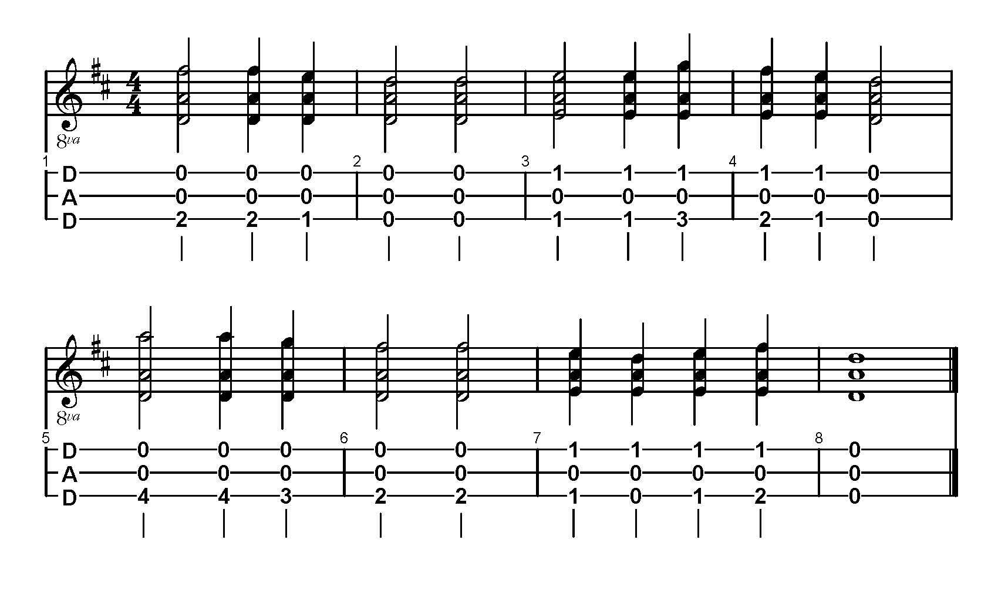Now you are ready to begin playing any tablature you can find!
Part V: Basic Chords
Now that you know how to read tablature, reading chord charts is easy. In general, chords are indicated with three numbers. The first number refers to the fret depressed on the bass string, the second refers to the fret depressed on the middle string, and the third refers to the fret depressed on the melody string.
Here are some basic chords to get you started:
D major = 0-0-2 G major = 3-1-0 A7 = 3-0-1
B minor = 2-1-0 E minor = 1-1-3 F# minor = 2-2-4

Three chord tricks:
First, keep in mind that because the dulcimer only has three strings, we often have to play "partial" chords. For example, a seventh chord by definition has four notes: the 1st, 3rd, 5th, and 7th notes of the major scale. But since we can only play three notes at a time, we have to skip one of the notes. In other cases, too, dulcimer players will play partial chords rather than including every note of a chord.
Second, because in DAd tuning the bass and melody strings are tuned to the same note, chords can also be reversed. So the D chord above is listed as 0-0-2, but 2-0-0 would also work! Similarly, F# minor is both 2-2-4 and 4-2-2. Easy, huh?
Third, a common chord in dulcimer music is the barre chord, meaning the three strings all played on the same fret, the most obvious of which is the open chord 0-0-0. Since that configuration involves the same note on the bass and melody string and the fifth on the middle string, it is not really a chord, since it only has two notes. (By definition a chord is a group of three notes played together.) What is missing is the third note of the scale. But dulcimer players can use this to our advantage. The difference between a major chord and a minor chord is the third (a major third in a major chord and a minor third in the minor chord). Since the third is missing in that barre chord, the chord functions as either a major or a minor chord, and the context will usually determine which. For example, a simple way to play an E or E minor is simply 1-1-1, and a simple way to play G or G minor is 3-3-3.

Part VI: Chord Shapes
The previous paragraph refers to a simple chord shape that can move up and down the fretboard: the barre chord. It is not the only chord shape in dulcimer playing, and there are only a few. The chart below shows the main chord shapes that can move around the fretboard.

chord shape | example
barre | 3-3-3
L | 3-3-5
slant | 2-3-4
extended slant | 1-2-4
Although there are a few other chord shapes, the four above are the most important and most common. Keep in mind that (with the exception of the barre chord for reasons explained above), as they move up and down the fretboard, they switch between major and minor chords. As you get more advanced and work with more dulcimer tablature and chord charts, notice how much is based on the five shapes above.

Part VII: Right Hand Techniques
So far, our discussion of how to play the dulcimer has concentrated on finding notes on the fretboard based on written tablature. But most of the actual making of music is done by the right hand. Whether we play loudly or softly, quickly or slowly, exactly on the beat or slightly ahead or behind it, and innumerable other nuances, are all determined by our right hand. The key to right-hand technique is timing, and you are strongly urged to practice with a metronome to develop a very steady rhythm. There are two broad approaches to right-hand technique: fingerpicking or flatpicking.
Fingerpicking involves using the fingertips (or picks attached to individual fingers) to pluck or strum the strings of the dulcimer. And again there are two basic approaches, though each involves individual fingers designated for playing certain strings. In one approach, the thumb anchors the hand against the near side of the fretboard and the index finger plays the melody string, the middle finger plays the middle string, and the ring finger plays the bass string. Another approach involves the ring and/or pinky finger anchoring the hand against the far side of the fretboard, and then the thumb plays the melody string, the index finger plays the middle string, and the middle finger plays the bass string. In both of these approaches, when all strings are played at once, the strings can be plucked in unison, the thumb might strum across the strings, or the index finger might strum across the strings.
Flatpicking involves the use of a flatpick or plectrum held between the thumb and index finger to strum and pluck the strings. The key to successful flatpicking is developing a steady back-and-forth strumming pattern. Start by counting slowly 1-2-3-4 and strum out on each beat. When you have that out strum steady, try to add an in-strum by counting 1 & 2 & 3 & 4 & and strumming out on the numbers and in on the &s. (Some dulcimer players reverse this pattern and strum in on the numbers and out on the &s. It doesn't matter which direction you start with so long as you are consistent and develop a steady beat.) Practice that back-and-forth strum not only by strumming across all the strings, but by picking individual strings as well. Once you have a steady back-and-forth strumming pattern, you can begin to vary it by stressing strums, skipping strums, muting strums, playing single notes instead of whole chords, and more.

VIII: Concluding Encouragement
It is often said that there is no wrong way to play the dulcimer. The idea behind such a statement is to encourage people to experiment and develop an individual style rather than thinking they have to copy exactly the way some other person plays. But that doesn't mean we should ignore approaches that musicians have developed over generations. And developing bad habits might impede your progress and discourage you from playing. The purpose of this document is to provide you the tools to begin playing the dulcimer on your own, to express your own musical ideas and emotions. If you find yourself getting lost in explanations here or anywhere else, remember that the music comes first. Tablature, standard music notation, and even descriptions here about how long to hold a note or how to strum with a flatpick, are merely attempts to describe what we hear when we listen to music so that we can attempt making that music ourselves. There is no better way to learn an instrument than to play it. Take that dulcimer out of the closet, tune it up, lay it across your lap, and play. If you like what you hear, do it again. If you don't, try playing differently. Remember that the goal is to have fun and enjoy yourself. We are all capable of making joyful noise. If these pages accomplish nothing other than encouraging you to do that, they have been successful.

There is a lot of information in print and on the internet to help you excel in your dulcimer journey. You might start with links on the "Resources" page at www.rivercitydulcimers.com.
Happy strumming!
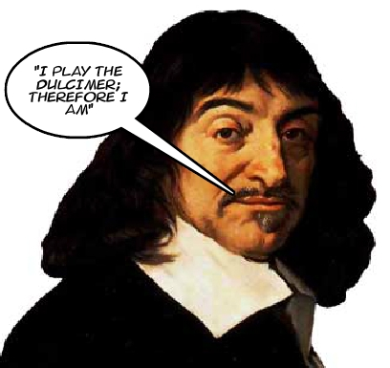

René Descartes

Once upon a time, wasn’t singing a part of everyday life as much as talking, physical exercise, and religion? Our distant ancestors, wherever they were in this world, sang while pounding grain, paddling canoes, or walking long journeys. Can we begin to make our lives once more all of a piece? Finding the right songs and singing them over and over is a way to start. And when one person taps out a beat, while another leads into the melody, or when three people discover a harmony they never knew existed, or a crowd joins in on a chorus as though to raise the ceiling a few feet higher, then they also know there is hope for the world.
-- Pete Seeger (1919-2014)

Image from "Dulcimer Buying Checklist" by C. A. Scheppner, available at http://bearmeadow.com/smi/checklst.htm.
Image taken from Get-Tuned.com and available at http://www.get-tuned.com/dulcimer.php.
From Bruce W. Ford, "How to Read Mountain Dulcimer Tablature" available at http://www.everythingdulcimer.com/articles/25/how_to_read_tablature.pdf.

