

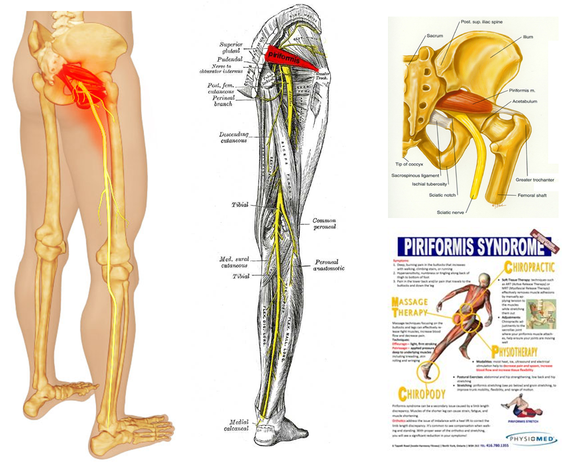

Supplements of Benefit:
- Soy Protein and/or Shaklee 180 Smoothees
- Vitalizer
- LOTS of Alfalfa (20 per meal)
- Vivix - double or triple label recommendation
- OmegaGuard - 2 to 4 with each meal
- Optimize Vitamin C
- Optimize Vitamin D3
Other Modalities of Benefit
- Massage
- Specific exercises as recommended by a physiotherapist
- Caster Oil Paks
Inflammation Food Guidelines

- Turmeric: Every day take one teaspoon of turmeric (just stir it into an ounce of tomato juice and swallow it quickly … the taste is not super great, but one ounce goes down in one swallow). It is very anti-inflammatory, and has been compared to potent drugs like hydrocortisone and Motrin. However, unlike the drugs which are associated with significant toxic effects (ulcer formation, decreased white blood cell count, intestinal bleeding, bone softening), turmeric produces NO TOXICITY OR SIDE EFFECTS

- Ground Flaxseed: Every day, consume 3 level tablespoons of ground flaxseed. It contains both Omega 3 and Omega 6 fatty acids that naturally lubricate the joints and reduce inflammation.

- Cinnamon: Have a teaspoon of cinnamon and a teaspoon of honey in warm water once or twice per day. It is very anti-inflammatory.

- Ginger: Ginger is another WONDERFUL natural anti-inflammatory remedy. At the end of the article you will see an excellent recipe for a ginger drink … it is a very wise choice!

- Diet:
- No red meat
- No sugar
- No coffee
- No white flour products
- Eat lots of greens
- Choose 75% alkaline foods / 25% acidic foods
- Get your allergies tested – remove offending foods
- NOTE: Many people have found that removing dairy products and gluten has made a significance in their inflammatory response. You may be reacting to gluten … experiment with removing it from your diet (especially wheat), to see if this makes a difference for you.

Several people have made up this vegetable broth recipe below and found it to be very helpful and drank if often …
VEGETABLE BROTH RECIPE:
- In a stainless steel pan add 1 ½ qts. water
- Add: 2 chopped potatoes, 1 cup each of shredded carrots & celery, + beet tops, turnips or onions
- Boil: turn down & simmer for 30 minutes
- Strain: drink broth warm or cooled. Can be refrigerated or rewarmed.
- Drink as much & as often as you like (reduces uric acid)

GINGER DRINK – this is great to drink first thing in the morning when you wake up
Make up a one week batch all at once and refrigerate.
- Add 2-4 tablespoons of finely grated ginger to 7 cups of purified water (simmer for 6 minutes – then drain)
- Optional: add 2 to 4 tablespoons of honey, maple syrup, or molasses for sweetening. (Molasses is an excellent choice, especially for people with blood sugar challenges.)
- Every morning take 1 cup of this liquid & add 2 tablespoons of lemon juice & a pinch of cayenne pepper.
- Drink chilled or warmed. (Make sure you add the lemon juice and cayenne to it fresh daily.)

