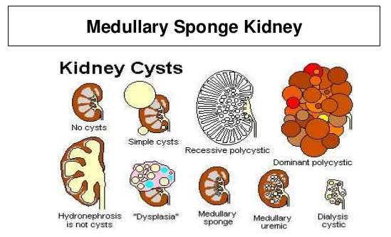
Medullary sponge kidney is a congenital disorder (meaning it is present at birth) of the kidneys characterized by cysts that develop in the urine-collecting ducts and tubules of one or both kidneys. Medullary sponge kidney belongs to a group of diseases known as 'cystic kidney disease'.
Individuals with medullary sponge kidney, as a result of the urine flow being blocked, are at increased risk for
- kidney stones
- urinary or kidney infections
- blood in the urine (haematuria).
SYMPTOMS: Although medullary sponge kidney is present from birth, symptoms do not usually occur until later in life. Symptoms and signs may include:
- pain in the back, lower abdomen or groin
- cloudy, dark or bloody urine
- burning or painful urination
- fever and chills
- vomiting
Traditional Medicine recommendations:
Medical treatment aims to manage the symptoms and reduce the risk of complications because there is no cure in traditional medicine.
- long-term, low-dose antibiotics to prevent urinary tract infections
- medication to discourage the formation of kidney stones
- avoiding non-steroidal anti-inflammatory drugs (NSAIDs), since these types of medication can worsen kidney function in people with kidney disease
- a short course of high-dose antibiotics to treat existing abscesses
- surgery to drain abscesses, if they are particularly large or do not respond to antibiotic therapy.
Natural Health Recommendations
- drinking plenty of water to discourage the formation of kidney stones
- dietary changes such as reducing salt, animal protein, cholesterol and caffeine
- Daily probiotics to reduce the risk of urinary tract infections
- NutriFeron to reduce the risk of urinary tract infections
- Vita D3 to reduce the risk of urinary tract infections
- VitalMag to discourage the formation of kidney stones
- Abundant use of Alfalfa tablets DAILY
- Do a Kidney Cleanse quarterly
- If an infection occurs, reach for Defend & Resist and Garlic (Garlic can be taken daily if desired as further defense ... Defend and Resist can be taken on a rotation basis all the time if desired ... 4 days on and 3 days off)

