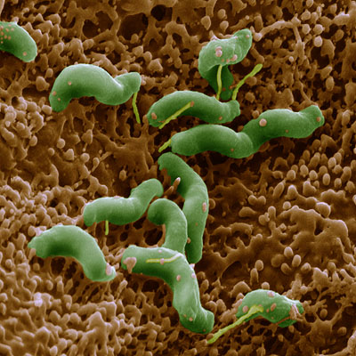
Helicobacter Pylori a helix-shaped

bacterium, about 3 micrometres long with a

diameter of about 0.5 micrometres.

Helicobacter Pylori bacterium
can cause the following:
- Inflammation of the stomach lining
- Nausea
- Upper abdominal pain
- Indigestion
- Uncomfortable digestive tract

What is the risk of long-term
Helicobacter Pylori left untreated?
- It is associated with 90% of duodenal ulcers
- It is associated with 70% of gastric ulcers
- It is suspected as frequently being the cause of stomach cancer

How to treat Helicobacter Pylori Bacterium Naturally
- Helicobacter Pylori can be killed by taking “bismuth hydrate”. Pepto-Bismol contains bismuth hydrate. Simply buy one bottle and take the whole bottle according to instructions on the label. If the Helicobacter Pylori is severe, you may need to take two bottles of Pepto-Bismol.

- Shaklee Garlic – 6 per day (2 - 3x a day) … more can be used if desired. If your skin starts to “stink” like garlic, you are taking more than you need and it is leeching out of your skin. (You can’t hurt yourself by taking too much garlic, but no one will want to sit beside you!!)

- Shaklee Optiflora – Normally a well person takes 1 per day. Take 2 a day until you have effectively eliminated the Helicobacter Pylori. Optiflora is a two-part system … make sure to take both parts of the system, but you will only need 1 teaspoon of the Prebiotic.
NOTE: When you are killing bad bacteria, you will have more gas! If the amount of gas
becomes a problem, reduce the prebiotic to ¼+ teaspoon per day.

- Shaklee DR
  - adult recommendations = 6 per day
  - take Monday through Thursday, then stop for Friday, Saturday & Sunday
  - continue this rotation until the helicobacter Pylori is gone

**************************************************************************************

- Shaklee NutriFeron – 2 per day

- Shaklee Vitalizer

- Take additional Shaklee Vitamin C (4 or 5 extra)
