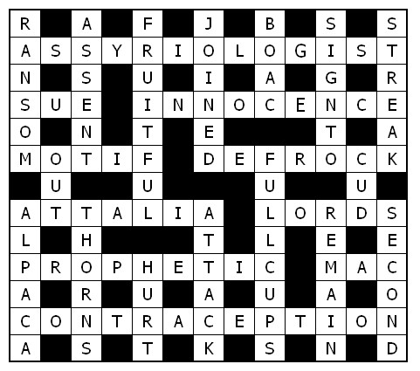

Service times at St Mary’s
Sunday: 10:30am Holy Communion
or Morning Prayer
Normally the first and third Sunday is Holy Communion with Morning on the second and fourth. Baptisms by arrangement with the Rector.
Tuesday: 10.00am Holy Communion
12.15pm Lunch-time Service

St Mary’s and the Nave Café is open – Tuesday, Thursday, Friday & Saturday from 9.00am – 3.00pm

Readers contributions to the magazine are always welcome. Hard copy (hand written if easier) to the Rectory address or by email: to : st.marysstockport@gmail.com
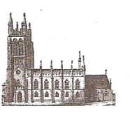
Editorial discretion with regard to content and space available will apply.
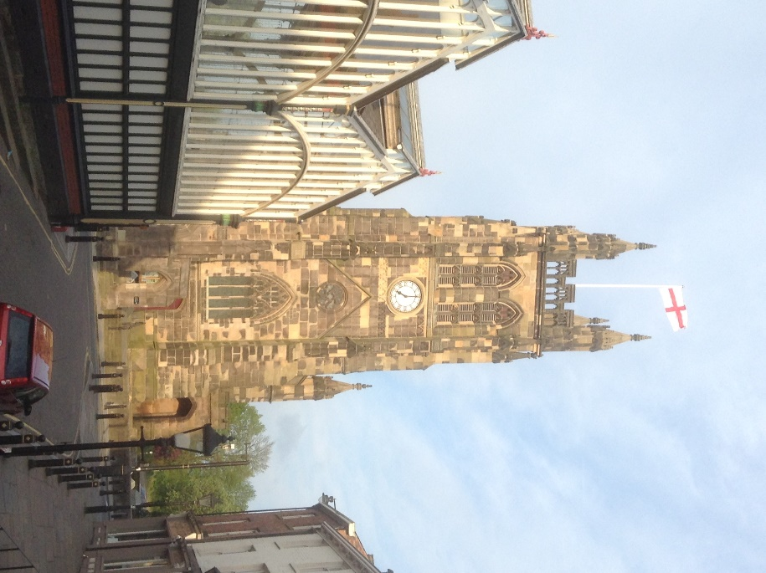
St Mary’s in the Marketplace
St Mary’s Rectory, 24 Gorsey Mount Street,
Stockport, SK1 4DU.
0161 429 6564
www.stmarysinthemarketplace.com.

St Mary’s in the Marketplace
Parish Magazine
July 2014

50p
+From the Rector’s “ i-Pad”
Dear Reader
It is hard for me to believe that on 2nd July it will be 15 years since my dear Father Tony Scoones died, peacefully in his sleep. Had he lived he would be 99 today, an extraordinary thought. Or perhaps not so extraordinary , since many people nowadays are seeing their parents living well into their 90s ; and one of our congregation , even into their 100s!
It is a great age, and we are always grateful when such great age is accompanied by health and happiness.
My father was born in 1915 when the war was just one year into what was to become a protracted 4 year struggle, with terrible suffering and loss of life on all sides. In St Mary's we possess two inscribed memorials to the fallen of that first year , which were presumable written down and framed in that same year , 1915, in the forlorn hope and expectation that the war would soon be over. I am very grateful to Graeme Storey of Britton and Storey, Shropshire, for his most generous donation regarding these two very special artistically outstanding Memorials, which are irreplaceable . I have commissioned him to carefully restore, reframe and remount for the church at this time, and he will return them to us free of charge, his donation to St. Mary's! The 100th Anniversary of the outbreak of the Great War, as it came to be known, on 4th August 2014 will be marked by State occasions and in many other ways at a local level, by churches and community groups across Great Britain.
Civic Service 15th June 2014
Our first formal welcome to St Mary’s for the new Mayoral Year.
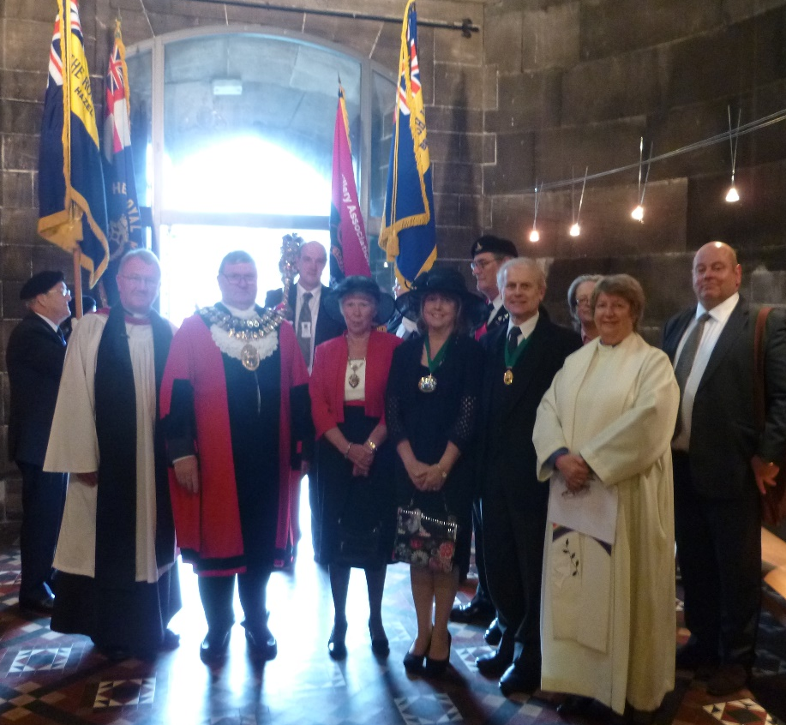
Included in the civic party – The Worshipful the Mayor of Stockport, Cllr Kevin Hogg; The Mayoress, Kathleen Hogg; Deputy Mayor, Cllr Linda Holt; Deputy Mayor’s Consort, Ken Holt; Leader of the Council, Cllr Sue Derbyshire; Chief Exective, Eamonn Boylan.
Mayor’s Chaplains: Rev Roger Scoones / Rev Margaret Tait
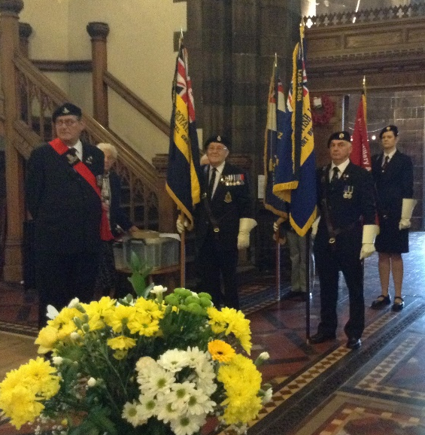

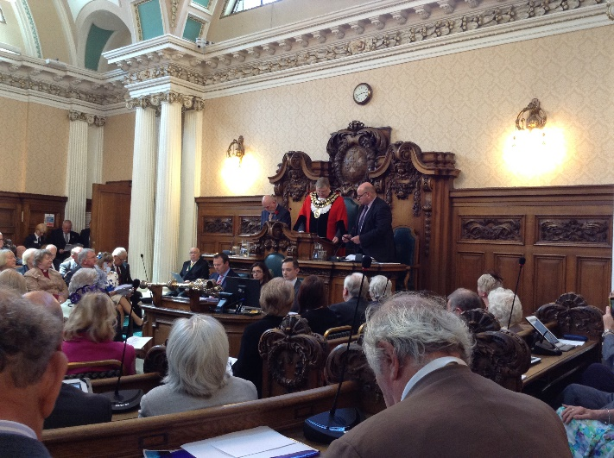
The Worshipful the Mayor of Stockport for 2014/15 Cllr Kevin Hogg, received his chain of office at Annual Council on the 10th June (Stockport Town Hall). A little late this year (because of the Euro Election timetable) Kevin has a slightly shorter Mayoral year than normal, but one that will be packed with events ceremonial occasions – some of which will be at St Mary’s.
If you look closely at the photograph below you will see both Roger and Margaret (Tait) watching the transfer of chains from Cllr Chris Murphy to Cllr Kevin Hogg. Roger and Margaret share the responsibilities as Mayors Chaplain for the next eleven months.
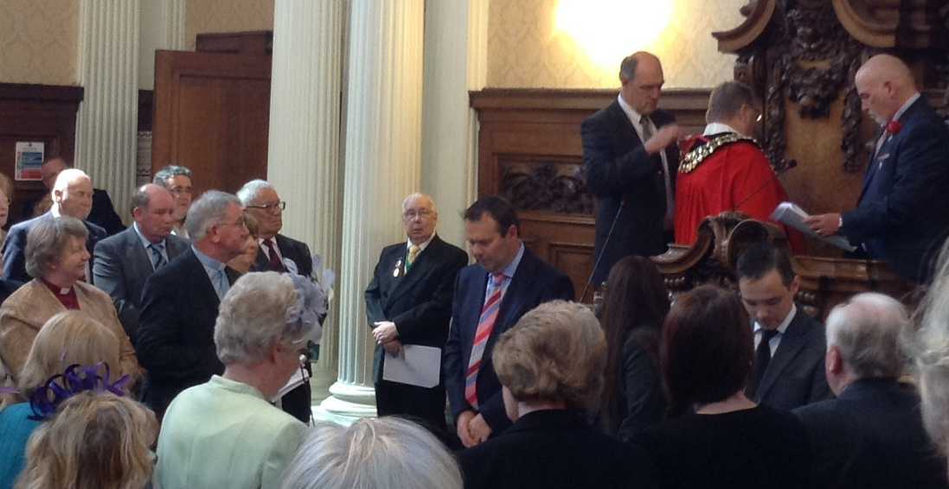

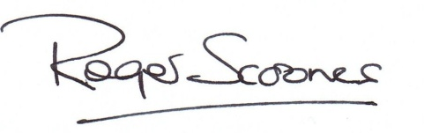

The Mayor of Stockport has initiated a special service which will be held on Sunday 3rd August to mark the beginning of this historic and poignant Anniversary . It will be a solemn occasion, without rejoicing. Having said that, there will continue to be good reason to remember and to give thanks for the lives of the many men who left this town to fight in the Great War, and who never returned.
I am very grateful to Jill Trumble, a member of the Stockport Heritage Trust , for taking the time and initiative to bring together all that is known about the War Memorials in St. Mary's . Her findings are to be published in a booklet, which is shortly going on sale in the Heritage Centre, cost £2 ( of which 50p will be donated to St. Mary's ) . Jill has done us all a great service in producing this booklet in time for the Anniversary, and I'm sure it will be of great interest to many people in the coming months and years. You may well wish to own your own copy!
In recent days we have lost two treasured members of our community, Audrey Nasarow and Jim Clare. These two people have between them made a very great impression on the life of the Parish Church, and they will long be warmly remembered by those who knew them, for the quality of their friendship and the extent of their commitment to the life of the Parish Church and to the wider community . They will be sorely missed. As the words of Remembrance ring out in the coming days, so we say also of those with whom we have shared our very busy lives in the environs of St. Mary's, in the Nave Cafe, at the Welcome Desk and in the Heritage Centre, and whom we see no longer..
WE WILL REMEMBER THEM Yours most sincerely.
St Mary’s 2014
Churchwardens:
Baker | Gabby
Clarkson | Isobel
Sidespeople:
Ashton | Barbara
Baker | Gabby
Bownas | Doreen
Clarkson | Isobel
Forster | Margaret
Hamnett | Frank
Hamnett | Irene
Heap | Susan
Hulme | Roger
Pinder | Adam
Smith | Catriona
Taylor | Carol
Parochial Church Council Membership:
Baker | Gabby
Clarkson | Isobel
Forster | Margaret | Electoral Roll Officer
Heap | Sue | Treasurer
Ingham | Yvonne
Pinder | Adam | Deanery Synod Rep/Dep Treasurer
Scoones | Roger | Chair
Smith | Catriona | Secretary
Taylor | Carol | Protection Officer
Waters | Rita | Deanery Synod Rep
West | Ann
Thank You to all on our regular reading list:

Barbara Ashton
Gaby Baker
Doreen Bownas
Isobel Clarkson
Margaret Forster
Frank Hamnett
Irene Hamnett
Sue Heap Roger Hulme
Adam Pinder Catriona Smith
Carol Taylor Ann West

This list is open to new readers throughout the year – our lists are prepared and produced quarterly by Isobel Clarkson.

If you are interested and would like to take a turn reading at our Sunday Services please have a word with the Rector or Churchwardens.

Don’t be put off if you haven’t done this sort of thing before, you are informed well in advance of “when” and “what”, giving you plenty of time to prepare in advance. It really isn’t as frightening as you might think, but indeed a rewarding experience.
We are of course happy to go through the procedure with you, where the reading fit into the service, where to stand etc., and will allow you to have a go on your own with the mic whilst the Church is quiet if that would help. We will also ensure you know the words to say before and after the readings.
Advice is simply - to speak relatively slowly and clearly and to definitely prepare in advance. One “fear” I suspect is knowing how to pronounce difficult words – well you only have to ask or if you have access to the internet you can always listen to your reading using an audio bible. http://www.biblegateway.com is a very helpful site, used by us regularly for downloading readings to service sheets etc.

Crossword

Across
8 Academic who studies history of one of Israel’s perennial enemies (13)
9 Take to court (Matthew 5:40) (3)
10 Absence of guilt (1 Kings 8:32) (9)
11 Of Tim (anag.) (5)
13 Deprive priest of ecclesiastical status (7)
16 Where Paul and Barnabas called en route from Perga to Antioch (Acts 14:25–26) (7)
19 ‘The earth is the — , and everything in it’ (Psalm 24:1) (5)
22 ‘Do not neglect your gift, which was given you through a —message when the body of elders laid their hands on you’ (1 Timothy 4:14) (9)
24 Raincoat (abbrev.) (3)
25 Issue relating to sexual ethics dealt with in the controversial Papal Encyclical Humanae Vitae in 1968(13)

Down
1 ‘The Son of Man did not come to be served, but to serve, and to give his life as a — for many’
(Matthew 20:28) (6)
2 Upward slope (Nehemiah 3:19) (6)
3 ‘God blessed them and said to them, “Be — and increase in number”’ (Genesis 1:28) (8)
4 ‘What God has — together, let man not separate’ (Matthew 19:6) (6)
5 One of the partners which, with BEA, formed British Airways (1,1,1,1)
6 ‘This will be a — — you. You will find a baby wrapped in cloths and lying in a manger’ (Luke 2:12) (4,2)
7 Takers (anag.) (6)
12 ‘But the things that come — of the mouth come from the heart, and these make a man “unclean”’
(Matthew 15:18) (3)
14 ‘Then I set bowls — of wine and some — before the men of the Recabite family’ (Jeremiah 35:5) (4,4)
15 Levitical eating laws were much concerned about animals ‘that chew the — ’ (Leviticus 11:3) (3)
16 Llama-like animal noted for its wool (6)
17 The seed which fell among these was choked by them as it grew (Luke 8:7) (6)
18 Launch an assault against (Genesis 14:15) (6)
20 ‘Neither can you bear fruit unless you — in me’ (John 15:4) (6)
21 John says of the healing of the royal official’s son, ‘This was the — miraculous sign that Jesus performed’ (John 4:54) (6)
23 Inflict pain on (Acts 7:26) (4)

James (Jim) Clare 1935 – 2014

Jim Clare An Appreciation from the Rector.
Taken from his address at Jim's funeral on 9th June
Jim was Born in Salford. His Father was a sheet metal worker.His Parents moved over to Stockport when Jim was a baby.Jim Grew up in Offerton with his siblings .The family Moved onto Hall Street when they were quite young.Malcolm ,Doris ,Mary ,Jim ,Grace ( they lost one sister, Agnes,tragically drowned in the river ,as a child )Marjorie and Ernie . The children all went to the Parish Church school.
After School Jim went straight into work. Firstly working in a garage in Holly street Jim was a good worker and would have made a good job of it but Jim didnt like being told to work dishonestly and so he left. This was an early sign of Jim's strength of character and determination to do things the right way in life.Jim went into a local engineering firm Coopers working as a paint sprayer .
After that he went "on the post" as they say around here. Jim was a postman for 27 years. He loved his work, and loved meeting people as postmen used to when times were more leisurely. But eventually Jim gave up the post. He got fed up with different shifts, and especially working inside. His job had been the Davenport Park round. Jim had done double shifts to get extra money. He was a good and loyal worker. But Jim went to work one morning (he had kept moaning about his work) and came back home and said to Margaret "I've handed my notice in and I'm never going back !"Imagine Margaret's reaction on that day!
After that Jim became a window cleaner! Quite a change in life for Jim.
But at last and at least he was happy.
Plant & “£” Stall
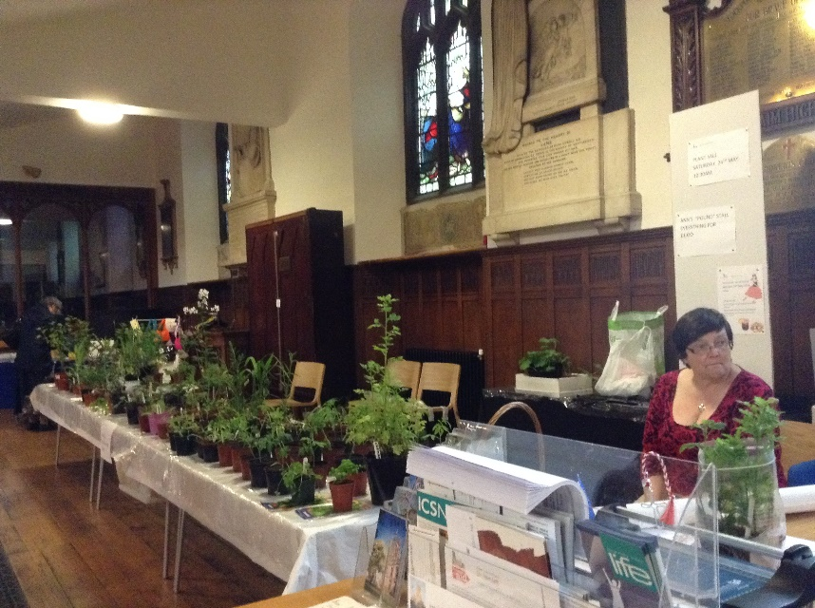
From little seeds…..
Well not all our plants were grown from seed but thanks to Rita Waters, our plant stall organiser, many were.
Thanks to all of you with “green fingers” who provided us with some lovely specimens of well established plants. It was amazing to see so many different plants for the garden as well tomatoes and herbs.

Thank you too for the supporting he “£” stall organised and run by Ann West. Wonderful idea Ann and a big thank you for all the work you put into your stall.
All these little initiatives help us to attained our goals as well as providing a “fun” day or two. In total the sum of £78.00 was collected towards “Project 2014”.

Archdeacons Visitation Service
It was indeed a wonderful evening with a packed church (we clocked in 235) and an absolutely magnificent sum collected for the chosen charity “Christians Against Poverty” of £976.00. Our guest organist for the evening was Peter Williamson

A note from the Rural Dean

Dear Roger

I just wanted you to know that I thought the Archdeacon's Visitation Service was wonderful.
Everything went without a hitch which is obviously down to excellent Team Work by your members.
Please thank them - they deserve much praise.
It was an absolute joy to see St. Mary's FULL to capacity.
The refurbishment is superb. I just love what you've done with the church - it is so much more user friendly and open.
I can only pay tribute to all that you and your congregation have achieved through dedication, hard work and love for God.
Congratulations on a lovely church and such dedicated people.
Every blessing

Diane

Jim met Margaret through friends, pen friends in Germany; its a lovely story which Margaret can tell you herself. They met one day in Mersey Square at the four telephone boxes ,a well known meeting place for young people in those days in Stockport! Very romantic .56 years later they are still together and the rest is history as they say! On the Anniversary of 50 years of marriage Jim and Margaret received a congratulatory card from Her Majesty the Queen which sits proudly in their home. They celebrated their Golden Wedding at the Davenport Tennis Club. A happy occasion for all concerned.
Jim and Margaret married on 26 October 1957 at St. Paul's Portwood
In due course they were blessed with a family. First came LINDA in 1959; then PETER came along in 1962; and then DAVID arrived a few years later in 1973. Jim and Margaret began married life in Star Street, near Newbridge Lane,were there were only 5 houses. They moved to Grenvillle Street in Edgeley, in 1969. Margaret has been linked with St. Matthews parish church ever since then, and continues to play an active part in its life .Jim was not a churchgoing person by inclination or conviction, but he loved singing carols, when the season came around , and he even joined our ad hoc Christmas Tuesday Choir here at St. Mary's in recent years which gave everyone pleasure to have him on board. According to Margaret, Jim always had a major project on the go. Planning, drawing , in the house or in the garden. A pond , a sandpit; all the children loved being in their garden in early years. There were terraces, and one must not forget the trellising for the roses! One of last projects was indeed a pond in their present home, which is magnificent, as is the whole garden, much of it created by Jim. His imagination skill and hard work all combined and intended to give Margaret a lovely garden for her plants ! Even if he sometimes did things without first getting Margaret's approval! Jim and Margaret moved from Grenville Road Cheadle Heath to Flowery Field. Then around the corner to Montrose Close 15 years ago, in order to downsize . A good and happy move for Jim and Margaret. The family remembers that at Grenville Road they had a Mini Countryman, white. It was nice car ,the first family car ; and then came a caravan kept in the front garden! Actually Jim had dug the garden out in order to keep it! That was Jim!
The family liked going to Cornwall even though in those days it was a long way without motorways . The family remembers one such journey, don't you? Jim got the children up really early at 3 am to make a good start! But much to the children's surprise " are we there yet?" The journey came to an early end, or so it may have seemed to sleepy young people. Jim had stopped at Macclesfield...for a two hour nap !because he was tired! Margaret was not a happy bunny! That was Jim ! After work at the post , finishing at lunchtime ,they would often go away for the weekend. Asby de la Zouch is recalled, but they particularly like going into Peak District, Ashford being a favourite spot .
Tragedy came into Jim's life again , in 1999,when they lost their youngest son David aged only 25. Jim was very close to David and his tragic death devastated the whole family. "What's the use of working" Jim conclude. As a result of this grievous blow he lost all interest in work. But the question was "What was he going to do with himself?" Fortunately Stockport Heritage Trust came to the rescue, just at the right time for Jim, and how grateful we all are for that. So Jim finished work. Jim went to a couple of the Parish Church School reunions .He got involved with Steve Cliffe , as we have heard , and again the rest is history, as they say. Since then Jim has got involved with the Cheshire Regiment Association. But it was in church that Jim met Eric Longson, who had gone into the Heritage Centre. "That's got to be Jim Clare! " He heard a familiar voice booming. They'd known each other since National Service in the Army . What a wonderful reunion that was. And it was helpful to Eric and Sheila too. Eric and Sheila together got involved in the Heritage and at one stage took it upon themselves to clean the War Memorial, for which we were very grateful.
Jim has really enjoyed much of life since then. He has always been enthusiastic about Stockport. And about the Parish Church. And about the Parish Church School. And about Richard de Vernon. In fact he was enthusiastic about everything that caught his interest. He has always liked doing odd jobs whether at home or at church, climbing up ladders, doing things. That's Jim, DOING THINGS. His garden is a testimony to his character !
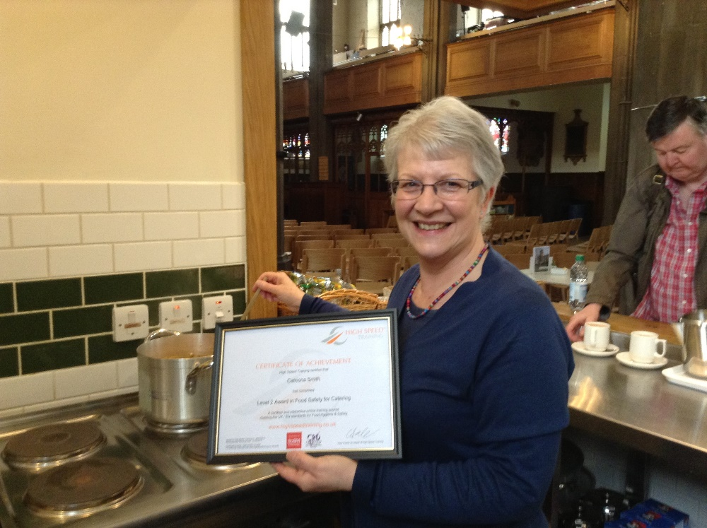
Congratulations and “thank you” to Catriona Smith for taking and passing her Level 2 Food Hygiene Certificate. Now fully fledged to act as a Duty Manager in our Nave Café kitchen – welcome aboard.

For Sale!
Have a look in the Stockport Heritage Trust area and view our range of “goodies” for sale at more than reasonable prices for our “designer” St Mary label. Buy something for a loved one, a friend or even for yourself.
Clotted Cream Shortbread £3.25 Chocolate Chip & Cherry Cookies £3.25
Vintage Marmalade £2.95 Farmhouse Pickle £2.95
Sweet Red Onion Chutney £2.95 Milk Chocolate Cider Crunch £2.99
Milk Chocolate Rocky Road £2.99 Dark Chocolate Raspberry Swirl £2.99
Clotted Cream Handmade Fudge £2.25 Chocolate Handmade Fudge £2.25
Mint Imperials £1.99 Fruit Jellies £1.99
Toffee Bonbons £1.99 Liquorice Allsorts £1.99
Midget Gums £1.99
Welcome to our guest organist
R P Williamson

We have been delighted to welcome to St Mary’s guest organist Peter Williamson who has now played for us at the Archdeacon’s Visitation, two funerals (Peter Atkinson and Jim Clare) and the first Civic Service (as shown above) of the new Mayoral year.

Peter is a freelance organist, based in Marple Bridge, is a highly qualified and experienced musician and is available for performances as well as tuition & theory.

We will see Peter again at our service on the 3rd August – if not before!

And Jim has valued the Family too. Over the years Jim has kept in touch with the family ...Wherever they have been. LINDA and STEVE and their children JOE 24 who now lives in Singapore and has flown back specially to be with the family ,and LIAM 23 and AIDAN 14.Jim has been very close to them all. Jim did a lot with them when they were young. They loved him because he was always doing things with them, taking them to play golf and to the park. Many happy memories of Jim, GRANDAD. And there was PETER and JANE too with their son THOMAS 11 WHO IS VERY CLOSE to GRANDAD too.
Following National Service Jim signed on for an extra year, so he did 3 and half years altogether including serving in Suez. In fact he was recalled for Suez Crisis!
Jim was blessed in so many ways by God and we have been blessed in being part of Jim's life and his positive view of life even in the face of great personal adversity and grief. His artistic skills which he possessed as a boy, but which have literally blossomed in recent years, have left us with a unique legacy of Jim's talent, which will be remembered warmly for many years to come.
Jim made no bones about the fact that he was not a churchgoer. So to some the presence of a number of clergy at his church funeral, which he specifically requested, might come as a surprise . The privilege of kneeling to pray with Jim by his bedside as he moved towards the end of his life, was to me a clear indication that Jim's faith was in his heart and mind where you and I were not privileged to go. On one occasion ,and maybe only once Jim received Holy Communion with Margaret. Jesus blessed countless people young and old, as he went about in his earthly ministry. Only God , moving in Jim's heart could have brought him to the altar of faith on that day, and I believe that God loved Jim and created Jim for special service on the life of his church and in this community. Famously St. James said Show me your faith without deeds and I will show you my faith by what I do!
Jim has spent more time in this church in the last dozen years of his life than most members of the regular congregation. He has done more good in this church and in this community in his service here than many who call themselves Christians or at least appear that way by being churchgoers.
Jim didn't need to go to church on Sunday ! He heard sermons on Tuesdays and he shared in the comings and goings of the unusual life of this parish church in a wonderful way , a way which endeared him to all who came to know him. He was simply and in every way the best of friends. When he came into St. Mary's a light seemed to come on. He made people happy, he made them laugh. He made sense of our all being here together as a community of faith and action . It made sense to him. And he took the good news of St. Mary's and the Stockport Heritage Trust out into the community. He was evangelical in his enthusiasm for all that was good in HIS community. He loved Stockport and he wanted to give something back to the town.
God loves a cheerful giver, the Bible says. And that was Jim, a cheerful giver. His remarkable courage and stoicism in the face of prolonged illness showed us all what a Christian life should be , one of faith AND deeds. In the marriage service we hear the words God KNOWS ALL THE SECRETS OF OUR HEARTS. That was Jim .
There were some things, like his faith, which were not given to know. But we were privileged to see the man, and his deeds, his love, his loyalty, his commitment, his integrity ,his charity , his friendliness and his sense of humour. All God given gifts, to ONE unique and much loved man, whom we commend to God's mercy TODAY confident in God's promises to Jim and to all present, that "God so loved the world that he gave his one and only Son, that WHOEVER believes in me, shall not perish but have eternal life".
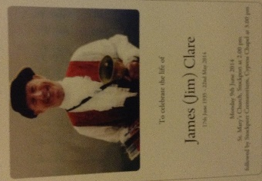
THAT'S JIM
Audrey Nasarow 1932-2014
Taken from thoughts composed by Audrey's sister- in-law, Ann Russell
"Audrey was born on 3 April 1932 in Manchester. She was the only daughter of George and Edith Russell. Audrey had two brothers, George, who died in infancy, and her surviving and much loved brother Les. Audrey had a happy childhood despite the failure of her parents' marriage. She had a special and loving mother who made sure that her children were happy and content. When Audrey went on holiday to Wales with her lifelong friend at the age of 16, she met a handsome Polish soldier, Alex Nazarow, whom she married when she was 21. They enjoyed dancing and socialising with friends. Holidays were spent abroad, following the sun. Later on they bought a caravan in Wales, where they enjoyed meeting lots of new friends, with some of whom Audrey kept in contact over the years. Unfortunately Audrey and Alex didn't have any children, but they loved Peter, Audrey's nephew, who lived nearby. When Peter met Catherine and they in turn had two lovely children, Evan and Amelia, it made the family complete. The family meant the world to Audrey. When Alex was taken ill towards the end of his life, it was a very hard time for Audrey , and at that desperate time she found great comfort at St. Mary's Church in the Marketplace. Audrey had gone into the church one Market day to pray and she met Roger, the Rector, and so he became a special friend and a great comfort to her. She spent a lot of time at church and loved meeting and greeting people for a chat. On Thursdays she went to the Triangle in Reddish." Roger Scoones - Rector
Remembering With Appreciation
Audrey Nasarow
A Service of Thanksgiving
Tuesday, 1st July 2014 12.15
St Mary’s in the Marketplace, Stockport

