Grace Episcopal Church
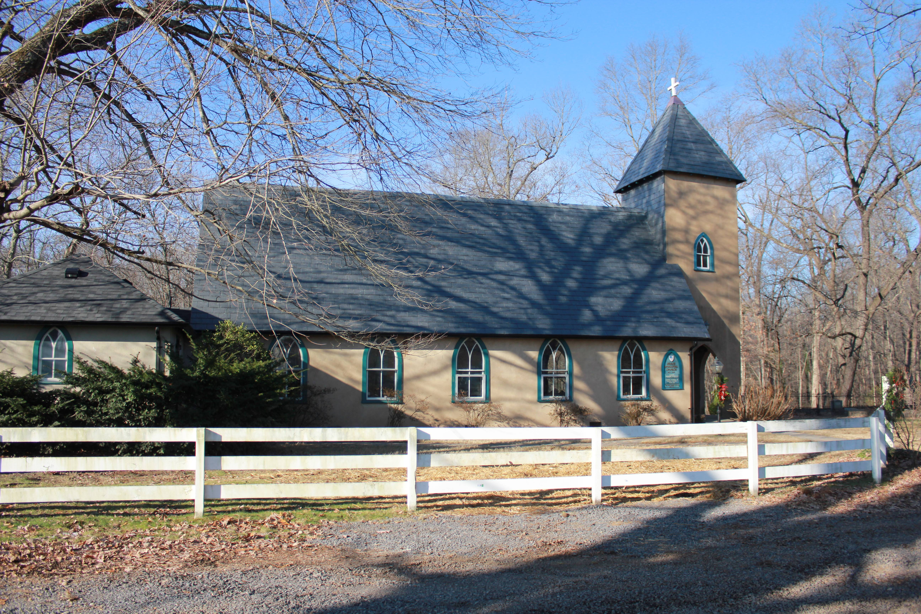
5096 Grace Church Lane
Casanova, Virginia 20139
e-mail: gracechurchcasanova@gmail.com website: www.gracechurchcasanova.org
My brothers and sisters,
I bring you greetings in the name of the Father, and of the Son, and of the Holy Spirit.

In the spring of the year, the time when kings go out to battle, David sent Joab with his officers and all Israel with him; they ravaged the Ammonites, and besieged Rabbah. But David remained at Jerusalem II Samuel 11:1 NRSV
We remember this biblical account because of what occurs next. He takes notice of this beautiful married women named Bathsheba. In the spring of the year the time when kings go out to battle, David remained in Jerusalem. How would this account read if David had done what kings did in the spring of the year?
Before we savagely beat up David, we need to question ourselves. Have our decisions and actions been in concert with the appropriate requirements of our vocational or occupational positions? David at this time abandoned his responsibility. Have we abandoned our responsibility?
David was given the duty to govern Israel and to oversee the proper worship of Israel. In this case he did not accomplish his task. He did not go out to protect his citizens and he committed murder. I would submit to you my brothers and sisters that we too have erred. We have not loved our neighbors as ourselves. We cannot say that we love and worship God if we do not love our neighbor.
Nathan confronts David. David does not make any excuses for his sins but immediately acknowledge his sins. Please read Psalm 51 for this is David’s reply to God for his sins.
If we say that we have no sin, we deceive ourselves, and the truth is not in us. If we confess our sins, he who is faithful and just will forgive us our sins and cleanse us from unrighteousness. I John 1:8-9 NRSV
When we consider the actions or inactions to our brothers and sisters which we know to be in contradiction to God’s law and we do nothing, how do we justify this? Did we stay in Jerusalem?
Grace, you have taken the lead to continue the work to become the “beloved community.” This is hard work. However, this is what God calls us to do. We are called not only to proclaim with our lips but to demonstrate by our actions.
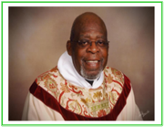
The peace of the Lord is always with us,

Fr. Michael B. Guy Sr., S.T.S.
SR WARDEN’S NOTES
Dear Grace Family,

Vacations are still in full swing, resulting in no Vestry meeting again in August. But there are nevertheless a few things to report.

Fr. Michael needed to be away on August 14th, so Grace and St. Luke’s merged services in order to accommodate the one fill-in minister that could be scheduled. The two congregations worshipped together at St. Luke’s in Remington at 11:00 AM. It was a lovely service. (I would include the name of the minister; however, I am not sure how to spell her last name.) In any case, she was excellent! Twice more (once in September and again in October) Fr. Michael will need to be away, in which case, Bishop Ted will be filling in. Services for those two Sundays will be held as normally scheduled (9:00 AM at Grace.)

We are now entering the last quarter of calendar year 2022 and yes, I am saying “where did the time go?” Do you agree? This means that change is on the horizon. Thanksgiving and Christmas will be on our doorstep before we know it. After these two glorious Holidays, we will usher in the new year and hence, two new Vestry members. Some of us have served on the Vestry repeatedly throughout many years with only small breaks in between. Will you step up and help us by volunteering to serve? Please consider it and notify one of the Vestry members if you would be willing to do so.

I have surely been enjoying my Summer and I hope you have too! Meanwhile, our Junior Warden and her “assistant” have been hard at work. Look at the list of things they have accomplished for our buildings and grounds!
- Dug a grave for ashes
- Cemented loose stones in church sidewalk
- Cleared weeds from labyrinth stones
- Arranged for H & H Heating to fix Family Center AC (Damaged in lightning strike.)
Second AC Unit was installed and cooling Tuesday, August 16th. Work done included:
- Replacing interior AC unit coils
- Replacing both exterior AC units
- Installing two new thermostats
Furnaces did not need replacing, saving us substantial additional expense.

Be sure to thank them for their hard work when you see them! And remember, coffee hour has resumed!

Hopefully, a pleasant Autumn season is in our future!

Blessings,
Mary
Sr. Warden

TREASURER’S REPORT –JULY 2022
Income for the months of July was $10,865.31 (budget $8,464.00); expenditures totaled $8,934.04 (budget $8,464.00), resulting in income for the month of $1,931.27.
The book value of our endowment fund is $62,847.24; market value as of June 30 is $61,620.15.
Please continue to pray for Grace Church that it will grow spiritually, financially and numerically. If you have any questions about this report or any financial matter, please contact me.

Judy Ball, Treasurer

FEED MY SHEEP

Please don’t forget that children returning to school now may not have a breakfast, lunch, or dinner. “Feed My Sheep” can help! Donations may be placed in the offering plate or mailed to the Church’s PO Box (address shown in footer.) Checks should be made payable to Grace Church with the notation “FMS.” Thank you!

Blessings for a healthy remainder of the Summer,
Carol Grove

SEPTEMBER SCHEDULE

If any dates do not fit your schedule, please arrange to trade with someone else.
DAY | READINGS  * | ALTAR/  FLOWERS | READER/ ACOLYTE | OFFERTORY PRESENTER | COFFEE HOST
September  4  Thirteenth Sunday after Pentecost | Jeremiah 18:1-11  Psalm 139:1-5, 12-17  Philemon 1-21  Luke 14:25-33 | Mary Neal/ Diane Gulick | Mary Neal | Susan Payne | Barbara Eanes
September 11  Fourteenth Sunday after Pentecost | Jeremiah 4:11-12, 22-28  Psalm 14  1 Timothy 1:12-17  Luke 15:1-10 | Barbara Jacobs/ Sharon Sweeney | Betsy Anderson | Mary Neal | Judy Ball
September 18  Fifteenth Sunday after Pentecost | Jeremiah 8:18-9:1  Psalm 79:1-9  1 Timothy 2:1-7  Luke 16:1-13 | Betsy Anderson/  Mignonne Spellmeyer | Bryan Jacobs | Barbara Jacobs | Marilyn Ottevaere
September 25  Sixteenth Sunday after Pentecost | Jeremiah 32:1-3a, 6-15  Psalm 91:1-6, 14-16  1 Timothy 6:6-19  Luke 16:19-31 | Carol Cordell/ Sharon Sweeney | Howard & Diana Charnock | Betsy Anderson | Mary Neal
*https://www.lectionarypage.net/

AMAZON SMILE FOR GRACE CHURCH
Don’t forget to sign up with Amazon Smile to have 0.5% of the purchase price of eligible items given to Grace Church at no cost to you! You can also go to the Grace Church website home page and click on the link there.

*******AmazonSmile Shopping App for Android Users Now Available******

You can now support Grace in the Amazon shopping app on your Android device! Simply follow these instructions to turn on AmazonSmile and start generating donations to Grace from your Android device.
- If you have the latest version of the Amazon Shopping App, open the App on your Android device.
- View Settings and select AmazonSmile.
- Follow the in-App instructions to complete the process.
AmazonSmile is not currently available for IOS users – we’ll let you know when it becomes available.

Shelly Shipe | 2-Sep
Amy Fields | 5-Sep
Jimmy & Karen Walton | 11-Sep
Diane Gulick | 13-Sep
Bennett Warren | 16-Sep
Nathan Moline | 17-Sep
Melanie Lemmel McKee | 18-Sep
Michael Calhoun | 19-Sep
Jimmy Walton | 20-Sep
Andy Butler | 26-Sep
Birthdays and Anniversaries for September

He prostrated himself at Jesus’ feet and thanked him. And he was a Samaritan. Then Jesus asked, “Were not ten made clean? But the other nine, where are they? Was none of them found to return and give praise to God except this foreigner?” Then he said to him, “Get up and go on your way; your faith has made you well.” Luke 17:16-19

In human history, foreigners have been too often met with suspicion, contempt, persecution, and violence. Some things never change.
In typical fashion, Jesus singles out the “foreigner” and makes it clear that this person, in particular, deserves honor for his gratitude. Jesus, the master teacher, shows us that the seemingly most unlikely member of a group, a “foreigner,” is worthy of not only acceptance but also praise. It reminds me of being in a classroom setting when a teacher sees a hand shoot up and hears a thoughtful answer from a student that everyone else has ignored or debased.
In the unspeakable love of God, no one is other, no one is unimportant, and no one is a foreigner.
Author: Nia McKenney
from Forward Day by Day
