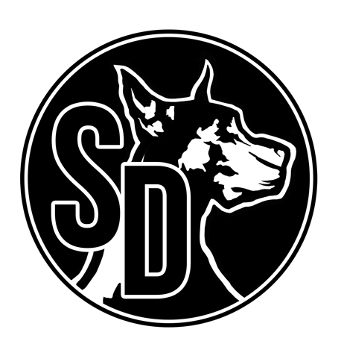
BEER MENU
ROTATIONALS ABV $
Down East-Original Cider 5.1% 7
Lakefront – Imperial Pumpkin 13% 8
Bells-Two Hearted 7% 7
Laguanitas- IPA 4% 6.5
3 Floyds-Lazer Snake 7% 7
New Holland-Dragon’s Milk 11% 8
War Pigs – Foggy Geezer IPA 6.8% 7.5
21st Amendment-Blood Orange IPA 7% 7
Ology – Red Giant Berliner 8% 8
Destihl-Raspberry Berliner 4.2% 7
MN BEER
Wild State Cider – Semi Dry 6.7% 6.5
Excelsior-Rip Rap PB Stout 5.6% 6.5
Surly-Hell 5% 4
Surly-Furious 6.7% 6.5
Modist-Dreamsicle Sour IPA 6.5% 8
Utepils-Skolsch 4.9% 6.5
Fulton-Standard Larger 4.5% 6.5
Indeed-Mexican Honey Light 5.2% 6.5
Bent Paddle-Venture Pils 5.7% 6
Lupulin IPA -Fashion Mullet 6.5% 6.5
Blacklist-Raspberry Wit 5.5% 6.5
Castle Danger-George Hunter Stout 8% 7
Bad Weather Brewing-Hopcromancer 7% 6.5
Lift Bridge-Imperial Pumpkin Porter 11.5% 8
COCKTAILS
Cask-aged Manhattan 10
Mules-Lime or Cherry 9

WINE- ASK SERVER
BEER IN A CAN
White Claw-Black Cherry/Mango/Grapefruit 5
Fair State-Roselle 5
Gray Duck-Tangerine Seltzer 5
Sociable Cider Werks-Pinchflat/Rusty Chain/Blueberry 6
Seattle-Basil Mint 6
Pryes-Course Correct 6
BauHaus-Wonderstuff 5
Montucky-Cold Snack 4
PBR 4
Not Your Father’s Root Beer 6
BauHaus – Short Pants Lemon Shandy 5
Coors Light 4
Miller Light 4
Budweiser 4
Grainbelt Premium 5
Grainbelt Nordeast 5
Stiegl-Radler 6
Guiness 6
IMPORTS
Kwak 10
Delerium Tremens 10
Sunner Kolsch 7
Barbe Ruby 7
Duchese Cherry 7
Chimay 10
Duvel 8
St. Bernardus 9
La Trappe Quad 10
Paulaner Oktoberfest 8

