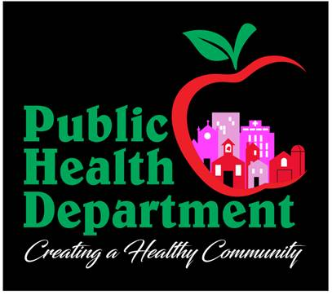

**Immediate Opening!**

SEK Multi-County Health Department

**Woodson County (Yates Center)**

**Position: Public Health Nurse**

This is a full-time position, 7am-5:30pm, Monday-Thursday. Benefits include but are not limited to: 12 paid holidays, Accrual of 10 hours vacation time monthly, Accrual of 10 hours sick time monthly, health/dental/vision insurance, KPERS retirement and a set schedule!

Seeking an independently motivated individual with excellent communication, leadership, and organizational skills.

Required: Active Kansas Registered Nurse License.

Applications may be picked up at any of our offices or downloaded from our website: [www.sekmchd.com](http://www.sekmchd.com) under the contact tab. (<https://www.sekmchd.com/contact>) Please email completed application and a current resume to Becky Johnson at [becky@sekmchd.com](mailto:becky@sekmchd.com) or fax to (620)223-1686.