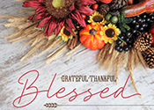
Trinity Times TimTimes
Volume 10, Issue 11
November 2022

My Ministry

Pastor King Duncan once asked his audience if they remembered Gracie Allen, who played the scatterbrained wife in a comedy team with her husband George Burns? Duncan recalls that once, Gracie called in a repairman to fix her electric clock. The repairman fiddled with it for a while and then said, "There's nothing wrong with the clock; you didn't have it plugged in." Gracie replied, "I don't want to waste electricity, so I only plug it in when I want to know what time it is."
Duncan then pointed out “That's an apt description of many of us. We save our religion for a rainy day. We go about unplugged and wonder why our lives are so devoid of power. How sad. Christian faith is not something to be plugged in when it is convenient or when it is necessary. The Christian life is lived daily. There is a cost involved.”
Our challenge here at Trinity is a similar one, and that is to live our religion every day. And to not pull out the plug of faith every time there is a cost involved. Let us challenge one another to this end. Let us always be aware of what time it is in our lives.

In Christ,

Pastor Doug

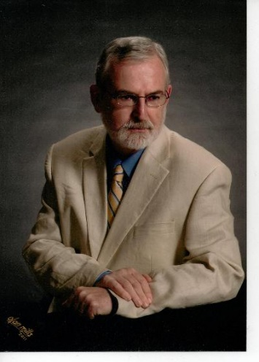
Pastor Douglas Benton

Trinity United Methodist Church
1160 Trinity Church Road
Newberry, SC 29108
803-276-1245 Office
803-543-0082 Pastor Cell
dobenton@umcsc.net
www.trinityumcnewberry.net
PLEASE VISIT OUR WEBSITE
AS OFTEN AS YOU CAN!

Peggy Bogart, Church Secretary
Head Usher: Harry Longshore
Choir Director: Open
Organist: Eddie Welborn
Substitute Organist: Phyllis Sanders
Video Board: Josh Pitts, Foster Senn, Bryan Waldrop
Acolytes/Crucifers Coordinator: Open
Newsletter Editor: Harriet Stevenson

Sunday Worship:
Worship Service: 11:00 a.m.

We are a nurturing and open church to all who enter into our Sanctuary. We base our ministry on the Word of God and a caring spirit. Jesus invites us to share our ministry to all that come into our church.
We are a caring and loving church and we want to share your concerns. Let us know if you or someone you know would like to share a prayer request with us. We will be happy to pray for you. Contact Harriet Stevenson, Peggy Bogart, Church Secretary, or Pastor Doug to add or remove names from the Prayer List.
Recent Hospitalizations and/or Surgeries:
Known Hospitalizations:
Continued Prayers: Shirley Berry, Boyd Hendrix, Robert Pollard, Jeannette Poag, Pastor Doug & Carrie, Faye Senn, Wade & Francis Pitts, Frieda Kesler, Bridget Pitts, Allison Hawkins, Jim Waldrop, Alice Longshore
Family and Friends of Trinity: Kinsley Bouknight, Woody & Connie Kreuzinger (Carrie’s parents), Brittany Hawkins, Ann Coker, Rick Coker, Freddie Bundrick, Doris Mohler, Harriet Connelly, Charles Melvin “Doc” Pitts, Faith Benton (Pastor’s niece ), Keith Rankin, Kathy Buchanan (White Oak), Cade Roberts, The Mayer Family, Dr. Jim Rainey
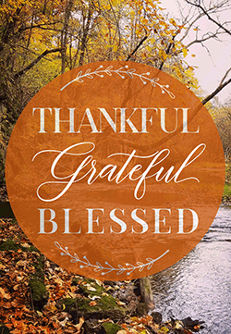

If you would like to place flowers in the church, please sign the flower chart located in the hallway outside the pastor’s study. Record your name on the Sunday you wish to place flowers in the church. Please complete and return an Altar Flower Sheet form to the desk of Peggy Bogart, Church Secretary, with the wording for the bulletin.

Nov. 6 Jane Woodward
Nov. 13 Betty Way
Nov. 20 Joan Morris
Nov. 27 Phyllis Sanders

Nov. 6 Josh Pitts
Nov. 13 Harry Longshore
Nov. 20 Sylvia Holmes
Nov. 27 Lynn Mohler
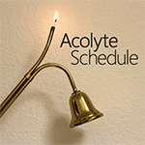

Nov. 6 Wyatt Pitts
Nov. 13 Harriet Stevenson
Nov. 20 Taylor Bouknight
Nov. 27 Noah Bouknight

3 – Jane Woodward
8 – Michael Bouknight
11 – Jim Waldrop
18 – Myrtle Longshore
19 – Crystal Waldrop
21 – Doug Benton
27 – Jeannette Poag
27 – Noah Waldrop
30 – Kruz Bouknight

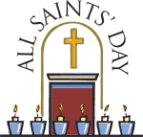

All Saints (November 1 or the first Sunday in November) is a day of remembrance for the saints. We celebrate the communion of saints as we remember those from Trinity who have passed since the last All Saints Day. These individuals were a part of the body of Trinity. On Nov. 6, we celebrate the communion of the following saints:

- Kim Eubanks
- James Poag
- Gloria Brehmer
- Gerry Johnson
- Paula Jane Spicer
- Rebecca Bundrick

ARE YOU READY FOR SOME
ADULT SUNDAY SCHOOL?

We are combining the two adult Sunday School classes into one and will begin an
Advent Bible Study on
Sunday, Nov. 20 at 10:00 a.m.

Please let Harriet know if you are interested in this class. Depending on the number of people, we will either meet in the Sunday School room downstairs if we have a small number or the Sunday School room upstairs if a larger number.
We will begin with an Advent Bible Study on the Book of Luke.
Rather than have one teacher, those who are willing will share in the teaching.

IT IS TIME FOR US ADULTS
TO GET BACK TO SUNDAY SCHOOL!
WE WILL FELLOWSHIP
AND
STUDY GOD’S WORD!

PLEASE PRAYERFULLY
CONSIDER JOINING US!

When you go to bed on Saturday evening, November 5, be sure to set your clocks back an hour. Daylight Savings Time ends at 2:00 a.m. on November 6.
2022

Sunday | Monday | Tuesday | Wednesday | Thursday | Friday | Saturday
 |  | 1 | 2 | 3 | 4 | 5
 | . |  | Trinity Men’s Club  7:30 p.m.. |  |  | Set Clocks Back before you go to bed!
6 | 7 | 8 | 9 | 10 | 11 | 12
Birthday and Anniversary Recognitions  all Saints sunday  Daylight Savings tIME ENDS  cOMMUNION | Trinity Women’s Club Meeting  5:00 p.m.  Trinity/New Chapel  Charge  Conference  7:30 p.m.  Trinity UMC |  | Silver and Gold  11:30 a.m.  Joanna Grill  110 N. Main Street  Joanna | .  . | Veteran’s Day  Thank a Veteran! | Trinity Men’s Club  Road Cleanup on Trinity Church Road  Meet at church at 8:00 a.m.
13 | 14 | 15 | 16 | 17 | 18 | 19
MYF  Ice Skating at The Plex in Irmo. Leaving after church service. | .Administrative  Council  6:30 p.m. |  |  | . |  | .
20 17 13 14 15 16 17 18 | 21 14 15 16 17 18 | 22 14 15 16 17 18 | 23 23 14 15 16 17 18 | 24 14 15 16 17 18  Thanksgiving Day  Be Grateful | 25 14 15 16 17 18 | 26 14 15 16 17 18  MYF decorating church for Christmas  Noon – 2:00 p.m.
27  Advent  Begins | 28 | 29 | 30
Invite a friend to come to church with you! All are welcome!
With YOUR help, we can grow our membership at Trinity! We
miss those who have not returned to church yet! Please consider joining us! The time is now! Trinity needs you!

Organizations and Opportunities to Serve:

Trinity  Women’s  Club  1st Monday  5:00 p.m. | 2022 Leadership Committee: Harriet Stevenson, Susan Longshore, Dixie Waldrop  The Women’s Club meets on Monday, November 7, at 5:00 p.m. at the church. Barbara Rogers will have devotions which will be followed by a business meeting. We will discuss our November and December mission projects, whether we will have a meeting or a Christmas party in December, and what we will give our shut-ins for Christmas.  The Women’s Club wishes everyone at Trinity a Happy Thanksgiving!

Silver  And  Gold  2nd  Wednesday  11:30 p.m.  ___________  Men’s Club  1st Wednesday  7:30 p.m. | The Silver and Gold enjoyed devotions by Phyllis Sanders, a delicious covered-dish meal, and a few games of bingo at their October meeting. June Pitts provided the prizes. Our November outing will be at the Joanna Grill, Main Street, Joanna on Nov. 9 at 11:30 a.m. We would like to welcome Gary Holmes to our group. He will provide the prizes for November. All seniors, 55+, male or female, are invited and encouraged to attend our meetings. You do not have to be a member of Trinity to attend.  NEXT MEETING: DEC. 14, 11:30 a.m. - MEAL AND CRAFT IN FELLOWSHIP HALL.  __________________________________________________________________________________  Officers: President- Johnnie Pitts; Vice President-Ashley Wilson; Sec/Treas-Wilson Senn; Program Coordinator-Foster Senn.  The Men’s Club will meet on Nov. 2 at 7:30 p.m. for their regular meeting and a meal.  The Men’s Club will be picking up trash on Trinity Church Road on Saturday, Nov. 12 at 8:00 a.m. Meet at the church.  All men are encouraged to attend our meetings. You do not have to be a member of Trinity to participate in the Men’s Club. We would love to have you join us for some good food and fellowship.  Christmas Gathering: Blue Ocean
We observed Pastor Appreciation on Oct. 16. The Pastor and Carrie were presented with gifts to show our appreciation for all they do for Trinity. A luncheon took place after the service.
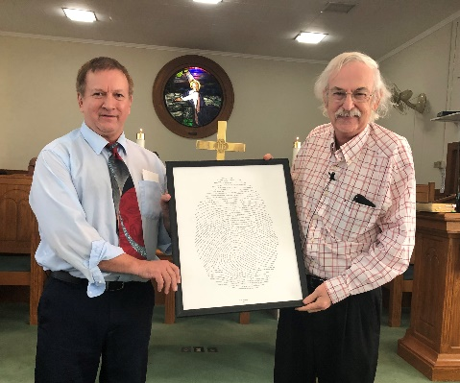

- The Silver and Gold packed Janna’s Blessing Bags for the homeless and needy which were presented to Newberry County Law Enforcement to carry in their cruisers. Joint project of Trinity and Royal Life Insurance Company.
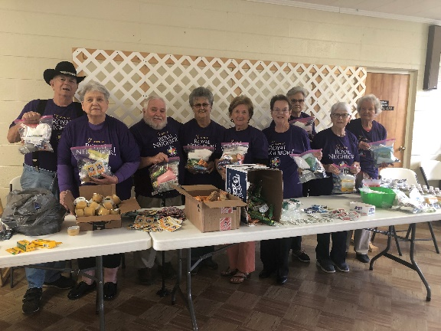
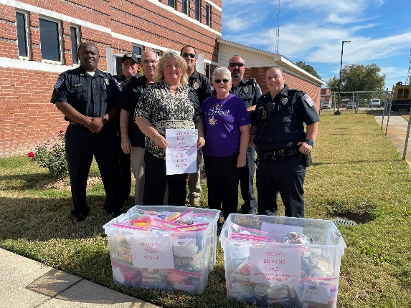
- Silver and Gold Prize Winners at the September meeting were: Phyllis Sanders, Harriet Stevenson, Mamye Enlow and JunePitts.
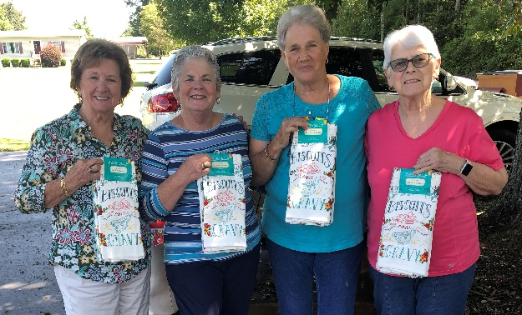

- We observed Breast Cancer Awareness Month on October 16 by wearing pink. We were delighted to have Travis Gilliam, a breast cancer survivor, speak to us on the subject. 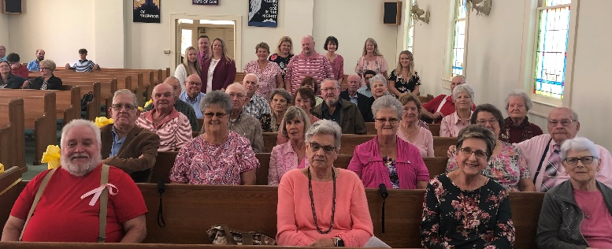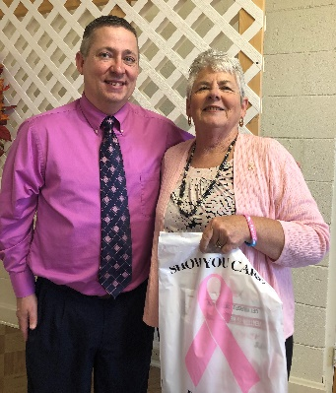
- Our Golden Agers were honored on Oct. 16 with a luncheon after the service.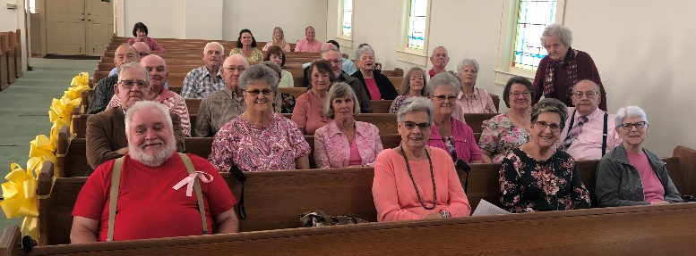
The wonderful entertainment for the Golden Agers was a performance by Trinity’s newest musical group, JJC.
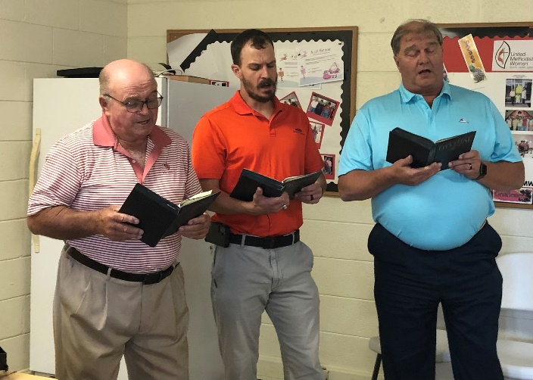
Johnny Pitts, Josh Pitts, and Craig Kesler

Methodist Youth Fellowship (MYF) – Josh and Erin Pitts, Leaders;

The MYF would like to thank everyone who participated and/or helped with their spaghetti lunch fundraiser in October. Your support helps fund our activities.

Upcoming Events:
Nov. 13 – MYF goes skating at The Plex in Irmo. Leaving after the church service.

Nov. 26 – The MYF will be decorating the church for Christmas from 12 -2:00 pm.

Help Us Make Christingles

We will be making Christingles on December 14 at our Silver and Gold meeting. Come join us for lunch and help us make Christingles for the church. Let Harriet Stevenson or Joan Morris know if you will be able to attend. This will be a fun event that has never been done before. All of the supplies will be provided. All we have to do is enjoy some good fellowship together and make Christingles together.

What is a CHRSITINGLE?
A Christingle is something that many folks have never heard of and do not know how it relates to Christmas.
The word comes from Germany and means “Little Christ Child” and is an object that is made that is used to celebrate Jesus Christ as the “Light of the World”. A Christingle is used during Advent, Christmas, and/or Epiphany.
It is made with an orange, aluminum foil (to catch the wax ), a white candle, red ribbon, four cocktail sticks that poke out in all directions, and soft candy. Each of these items has a specific meaning behind it.
- Orange: because of its shape it represents the world.
- Candle: A candle is placed straight up and it represents the light of the world or a light in the dark.
- Red Ribbon: It is wrapped around the orange which symbolizes the blood of Jesus and how he saved the world from their sins.
- Four Sticks: These four sticks (toothpicks) represent one of two things depending on who is making the Christingle. They can represent North, South, East, and West or all the seasons.
- Fruits and Nuts: These symbolize the fruits of the earth or God’s bounty that he grows by sunlight and rain.

Trinity United Methodist Church
1060 Trinity Church Road
Newberry, SC 29108

