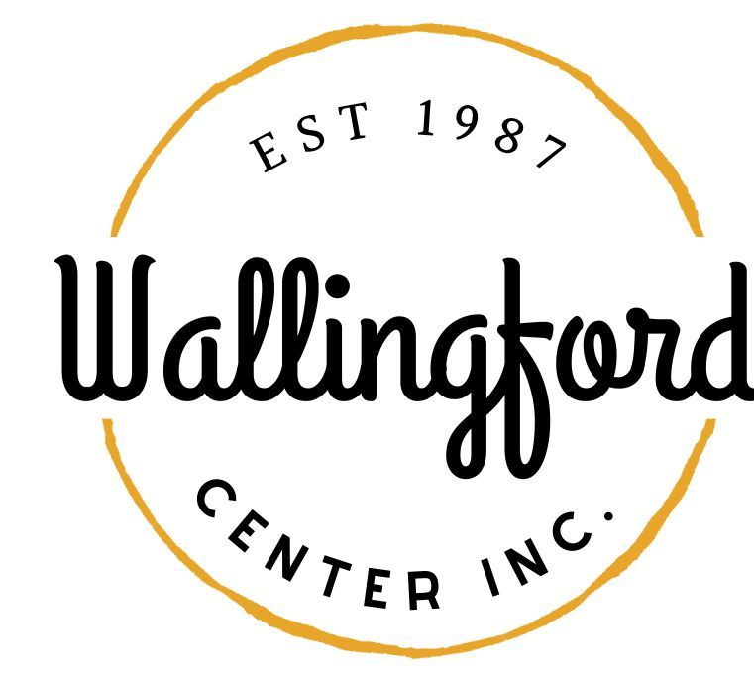

**Regular Meeting**

**Tuesday September 6, 2022**

**Wallingford HubCap**

**128 Center Street Wallingford, Ct 06492**

**5:00pm in person**

1. **Call to Order**
   1. Appointment of Alternates
2. **Approval of minutes**
   1. Special Meeting June 15, 2022
3. **Welcome New Members**
4. **Treasurer’s Report**
5. **New Business**
   1. Celebrate Wallingford 2022 event
      1. discussion of logistics for 2022 event
      2. sign for volunteers
      3. outstanding tasks related to event
      4. spin off events related to Celebrate 2022
      5. public safety protocols required for 2022 event
      6. beer tasting
      7. entertainment
      8. merchandise for event
   2. Holiday Stroll
      1. confirming date for event
      2. discussion of merchandise
   3. Game Night
      1. volunteer sign up for future events
6. **Communications**
   1. Executive Director Report
   2. Report from other subcommittees
      1. HUBCAP
      2. Downtown Collaborative
7. **Public Comment**
8. **Executive Session pursuant to CGS 1-200 6a ; purpose of session is discussion of annual review of staff**
9. **Adjournment**