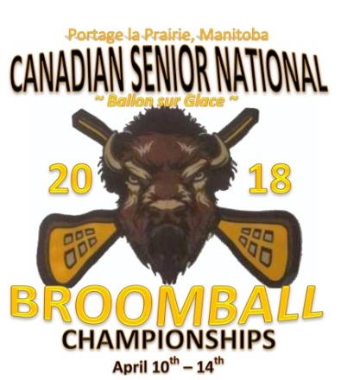

2018 Canadian Senior National SOUVENIR INFORMATION

We are pleased to present the 2018 Souvenir Items. The attached Flyer lists all available items; in various sizes and colors.

- Fill out the attached order form.
- Advance Orders DUE by Tuesday, March 6th, 2018
- There will be LIMITED Souvenir Options at the EVENT; please order early.
- FULL Payment on any customized orders MUST be received with all orders (NO EXCEPTIONS).
- No Refunds, Changes or Cancellations after the March 6th Deadline.
- Souvenirs will be available for pick up at the Event.

Accepted Payment Options: E-transfer, Money Order, Cheque

For More Information or to place an order:
CONTACT: Tina 1-204-278-3515 Fax: 1-204-925-5792
Or by EMAIL: broomball2018@outlook.com

Mailing address:

Manitoba Amateur Broomball Association
145 Pacific Avenue
Winnipeg, MB R3B 2Z6

