Preparing for the upcoming season
Wrestling is a demanding sport. It is important as you approach the upcoming season that you take your preparation with some thought. Wrestling is not only physically demanding, but a very mental sport as well. I have put together a list of a few items that will help you become the best you can be.
Stretching (Daily) warm-up prior to stretching (example running in place, stationary bike, light 10 minute jog, elliptical, etc...)
- Hamstrings
- Quads
- Achilles
- Lower back
- Torso
- Shoulders
Running for distance (every other day) this will help with endurance and stamina
- First week run 2 miles
- Add a mile each week
High Intensity Interval Training BPM150 (every other day) to help with your “wind”, combine 2 of these items for a workout
- Core Exercises: 3 sets of 10 star jumps / 20 sit-ups / 20 leg lifts (from 6” to 90° / 20 cycles (1,2,3-1) / 30 second planks / 30 air squats)
- Running hills (10 sets) every other hill alternate 15 push-ups and 15 sit-ups
- 30 minute running stairs at a stadium
- 30 minute elliptical training and add in sprinting for 30 seconds every 5 minutes
- 30 minute riding stationary bike or riding a bike (try to sprint for 30 seconds every 5 minutes)
Learning
- Watch collegiate wrestling on internet, You Tube or Big 10 channel
- Watch new techniques on the internet (i.e., takedowns, bottom wrestling, top wrestling, etc.)
- Motivational videos
Diet
To prepare for the upcoming season, you can start by paying a little closer attention to what you put in your body every day. Here are some ideas to get you going in the right direction:
- Only Drink Water
- Try to eat every 2.5-3 hours throughout the day 5-6 small meals
- Prep ahead meals so it is easy to consume multiple meals throughout the day
- Eat high protein foods
- Minimize fruit intake
- Maximize vegetable intake
- Minimize dairy intake
- Try not to eat fake/processed foods (i.e., cookies, chips, soft drinks, cake, candy, all items located in the middle of a grocery store)
Mental Toughness
Mental toughness is the ability to resist, manage and overcome doubts, worries, concerns and circumstances that prevent you from succeeding, or excelling at a task or towards an objective or a performance outcome that you set out to achieve.
Goal
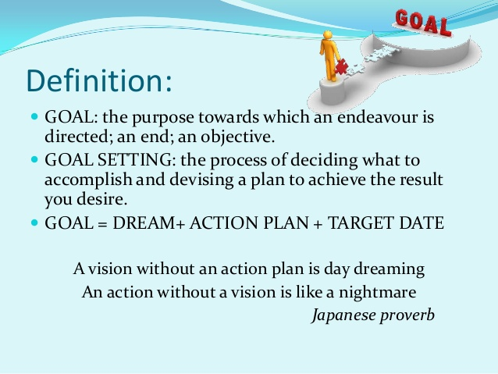
Goal Setting
