elimu

learning center
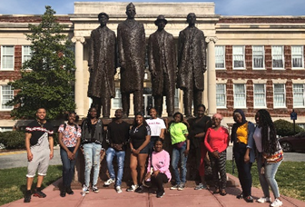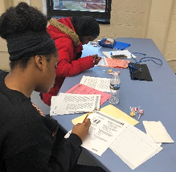  Bridging the Gap is a students’ Guide to get through the high school years. Bridging the Gap guides individuals who are in high school and are preparing to attend a college or university. It can also assist individuals who are in the process or eager to find out what they are passionate about and focus on how to get to their goals.  Weekly Workshops  During these weekly workshops the students are able to gain insight on the college admissions process, the importance of financial aid, essay-writing, as well as have one-on-one checkpoint sessions with the program director to ensure that no one is left behind and that everyone has the tools to achieve their goals academically.  College Visits  During the school year, Bridging the Gap strives to take its students on college visits once every month. Ranging from small private institutions to large public institutions, we strive to expose our students to different types of college environments so that when it is their turn to start the college selection process, their college selection process will be diverse. | Program Coordinator  Taylor Rolfe  501-352-5764  elimuempowerment@gmail.com  Meetings and times  Wednesdays 5:00 pm – 6:30 pm  North Carolina A&T University  Hines Hall Room #324  1601 E. Market St.  Greensboro, NC 27411  Community Involvement  The students of Bridging the Gap are required to complete 10 hours of community service per semester. Aside from the required outside service hours, the students participate as a collective in numerous community service events in the Greensboro Community.  ACT/SAT Workshops  Every year, Bridging the Gap offers a FREE ACT/SAT Prep Academy where we prepare our students for both the SAT and ACT college entrance exam. During the prep academies the students will understand the importance of the SAT and ACT as well as familiarize themselves with the composition of each exam. We also focus on the strategies for each exam as well as the scores they need to get accepted into their college/university of their choice.

