Wrestling Practice Gear/Equipment Guideline
Wrestling practices are physically and mentally tough. It is important that your student athlete is prepared with the appropriate gear and hydration.
Required Practice Items:
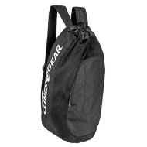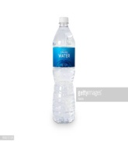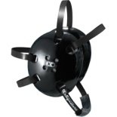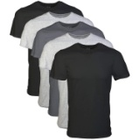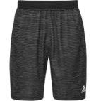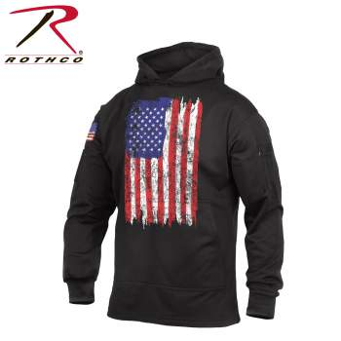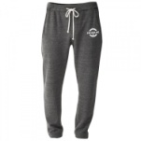
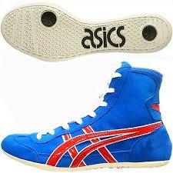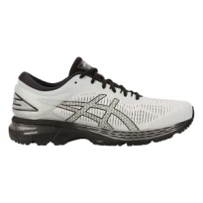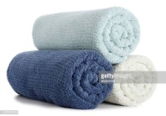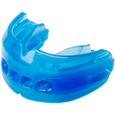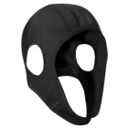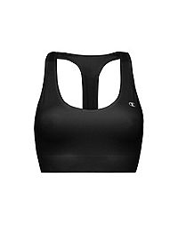
(1) Gear/Back-Pack
(1) Water bottle
(1) Wrestling Head Gear
(3) T-shirts
(1) Shorts
(1) Sweatshirt
(1) Sweat Pant
(1) Wrestling Shoes
(1) Running Shoes
(1) Towel

*Mouth Guard- WIAA requires any athlete that has braces, to wear an approved mouth guard. If you have upper and lower braces you are required by the WIAA to wear a top and bottom mouth guard.
*Any Athlete that has long hair will be required by the WIAA to wear an approved hair cover either attached to their head gear or like the example on the page.
*Girls are required by the WIAA to wear a sports bra.

Optional items you might want or need:

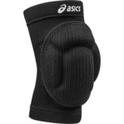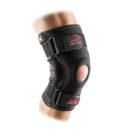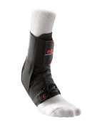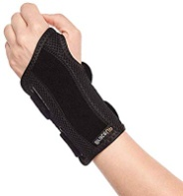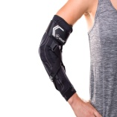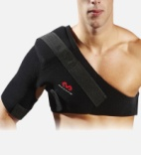
Wrestling Knee pad or pads
Different types of braces if you have previous injuries (example: knee, ankle, wrist, elbow or shoulder brace)

