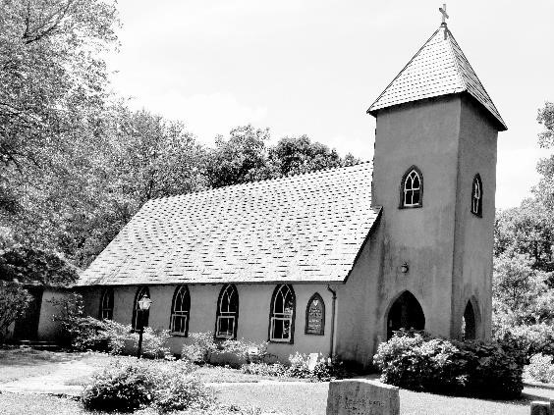
Grace Episcopal Church
Casanova
Grace Church Lane
Midland, Virginia 22728
e-mail: gracechurchcasanova@gmail.com
website: www.gracechurchcasanova.org

My brothers and sisters in Christ,
I bring you greetings in the name of the Father, and the Son, and Holy Spirit.

“But about that day and hour no one knows, neither the angels of heaven, nor the Son, but only the Father.” St. Matthew 24:36 NRSV

When catastrophic events occur, some people are quick to declare the end is near. Some say God is punishing us for our sins. Others will list the sins in detail. These same people include punishment as one of the signs the world is coming to an end. Some even go as far to give a date. Do they not see or understand God’s love is for all of us?

We are in the great fifty days of Easter. Easter, the day that Jesus was raised from the dead. Three days before, in obedience to his Father, Jesus died for our sins. Sin separates us from God and God does not desire us to be separated from Him. Dying for our sins, Jesus established a pathway in which we are reconciled to God. All one needs to do is sincerely ask for forgiveness and it is given. God does not punish. God Loves. God is Love. Only God knows about that day and hour.

I am happy to say that I have not seen many of those signs or heard the statements of
“why is God doing this to us?” or “where is God now?” I am excited by what I do see. People are more respectful to and show concern for each other. During one of the food distributions, a gentleman waited in line to give us a check for $500.00 for the food bank. He did not see himself as being more important than those being served simply because he was offering money. He showed love and respect for others. This is what I see, God’s Love is for all of us. We are sharing God’s Love and it is being recognized.

Christ is risen and we continue to demonstrate His love every day.
He is risen indeed, Alleluia.

The peace of the Lord is always with us.
Fr. Michael B. Guy, Sr. S.T.S. 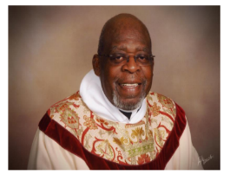
SR WARDEN’S NOTES
Dear Grace Family,

Thank you to all who participated in “Operation Soup” in April. Again, it was a roaring success! In fact, Holy Week itself was a very memorable and moving event. Thank you to Fr. Michael for the lovely, inspirational services. The Vigil on Easter eve was particularly moving as three churches (St. James, St. Luke’s, and Grace) joined together in celebration of the risen Lord. Next year, you all must come; you will be so happy you did!

The Vestry has agreed to resume an abbreviated version of “Coffee Hour” in June. By “abbreviated,” we were thinking… coffee cake and coffee or iced tea and cookies. Keep it simple. We are in the process of deciding where we should hold this after-church gathering each Sunday, i.e., inside or outside. That said, who would be willing to be a coffee hour host? With the abbreviated version, do you still think a partner arrangement is necessary or could you host alone? Please talk to a Vestry member and discuss your “druthers.” We will decide based upon the majority’s choice.

Blessings,
Mary

TREASURER’S REPORT – MARCH 2022
Income for the month of March was $7,412.36 (budget $8,464.00); expenditures totaled $10,371.32 (budget $8,464.00), resulting in loss for the month of $2,958.96.
The book value of our endowment fund is $62,847.24; market value as of March 31 is $69,185.88.
Please continue to pray for Grace Church that it will grow spiritually, financially and numerically. If you have any questions about this report or any financial matter, please contact me.
Judy Ball, Treasurer
FEED MY SHEEP
Proverbs 19:17: “The one who is gracious to the poor lends to the Lord, and the Lord will repay him for his good deed.”
Please keep the “Feed My Sheep” (FMS) ministry in your prayers. Checks may be made out to Grace Church with a notation to FMS and mailed to Grace Church at the address shown in the footer of this document. Cash or checks can also be put in an envelope and left in the collection plate.
Carol Grove

ARCHITECTURAL REVIEW BOARD HISTORIC PRESERVATION AWARD

Grace Church has been awarded the 2022 W.H. Irwin Fleming Award for preservation or rehabilitation of historic architecture for the work to replace the church roof.

The presentation will take place at our regular service on May 15, 2022. Please join us for this very special event!

Birthdays and Anniversaries - may

Stephanie Myers | 3-May
Donna Shipe | 4-May
Dave Coates | 7-May
Emelia Warren | 9-May
Sue Ballentine | 10-May
Rick Anderson | 12-May
Carol Payne | 14-May
Adam Rhoads | 14-May
Betsy Anderson | 15-May
Bob & Julie Brewer | 15-May
Bryan & Barbara Jacobs | 15-May
Nellie Warren Escorcia | 19-May
Bobbie Gouldthorpe | 21-May
Karen Walton | 21-May
Debbie Meador | 25-May
Flavia Escorcia | 26-May

May serving schedule

Day | Readings | Altar/  Flowers | Reader/ Acolyte | Offertory Presenter
May 1st  Third Sunday of Easter | Acts 9:1-6, (7-20)  Revelation 5:11-14  John 21:1-19  Psalm 30 | Barbara Jacobs/ Diane Gulick | Bryan Jacobs | Susan Payne
May 8th  Fourth Sunday of Easter | Acts 9:36-43  Revelation 7:9-17  John 10:22-30  Psalm 23 | Betsy Anderson/ Mignonne Spellmeyer | Diana & Howard Charnock | Barbara Jacobs
May 15th  Fifth Sunday of Easter | Acts 11:1-18  Revelation 21:1-6  John 13:31-35  Psalm 148 | Carol Cordell/ Sharon Sweeney | Judy Ball | Betsy Anderson
May 22nd  Sixth Sunday of Easter | Acts 16:9-15  Revelation 21:10, 22-22:5  John 14:23-29  or John 5:1-9  Psalm 67 | Mary Neal/ Diane Gulick | Mary Neal | Howard Charnock
May 29th  Seventh Sunday of Easter | Acts 16:16-34  Revelation 22:12-14,16-17,20-21  John 17:20-26  Psalm 97 | Pam Ruffner/ Mignonne Spellmeyer | Betsy Anderson | Judy Ball
If any dates do not fit your schedule, please arrange to trade with someone else.

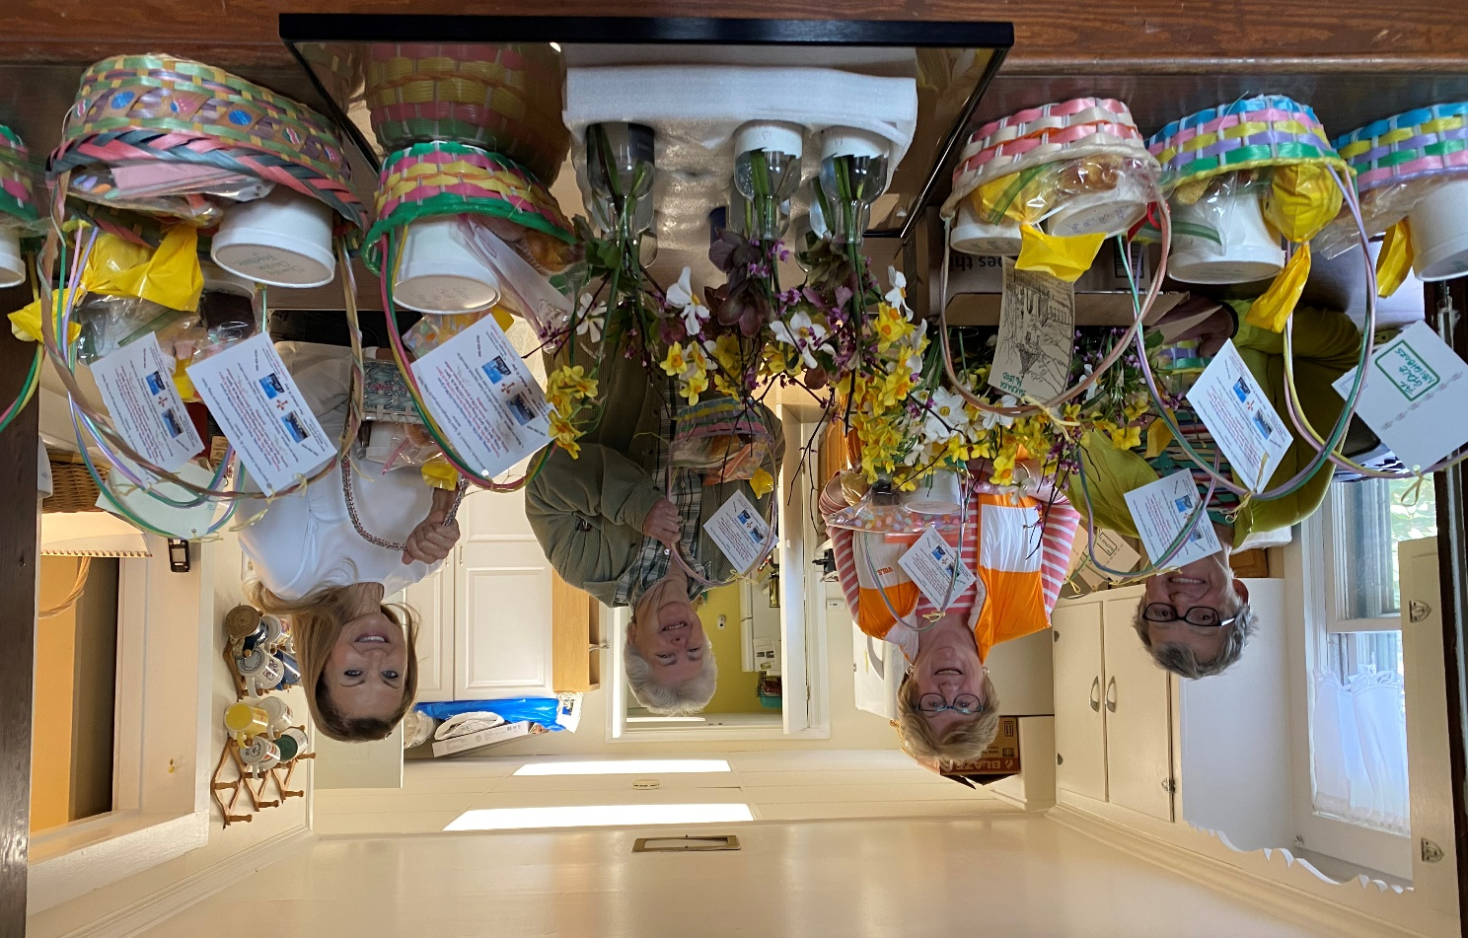
Operation Soup!! April 2022
Photo by Diane Gulick

AMAZON SMILE FOR GRACE CHURCH
Don’t forget to sign up with Amazon Smile to have 0.5% of the purchase price of eligible items given to Grace Church at no cost to you! You can also go to the Grace Church website home page and click on the link there.

*******AmazonSmile Shopping App for Android Users Now Available******

You can now support Grace in the Amazon shopping app on your Android device! Simply follow these instructions to turn on AmazonSmile and start generating donations to Grace from your Android device.
- If you have the latest version of the Amazon Shopping App, open the App on your Android device.
- View Settings and select AmazonSmile.
- Follow the in-App instructions to complete the process.

events to remember

May 7th – “Sew What” quilting, crocheting, embroidering, knitting, etc. – Grace Parish Hall at 9:30AM until … you wish to depart.
This Photo by Unknown Author is licensed under CC BY-SA-NC
May 15th – Presentation of the 2022 W.H. Irwin Fleming Award for preservation or rehabilitation of historic architecture for the work to replace the church roof - Grace Church at regular 9AM service.

Luke 24:30-32 NIV When he was at the table with them, he took bread, gave thanks, broke it and began to give it to them. Then their eyes were opened and they recognized him, and he disappeared from their sight. They asked each other, “Were not our hearts burning within us while he talked with us on the road and opened the Scriptures to us?”

Perhaps you can relate?

Some weeks, after I take communion, pray, and leave the church building, it’s almost like Jesus vanishes from my life. I hear the Bible readings. The Sermon speaks of the good news of the gospels. Often, I am inspired by these words. My heart is burning as the scriptures are being opened to me. But Monday comes. During the week, my spiritual eyes close. I cannot see Jesus when he is the person right in front of me… the man on the sidewalk asking for spare change, the chatty old lady who wants company, the family member who needs my full attention.

But there are other weeks when all I see is Jesus. During those times, I give thanks for the life-giving encounters with strangers, friends, and family who each remind me of Jesus.

Lord, help us to keep our hearts burning with the flame of scripture throughout this month.

Excerpt from Forward Day By Day, writing by Patrick Kangrga, a lay minister serving as director of youth ministries at St. James Episcopal Church in Jackson, Mississippi

