INTRODUCTION

One Step Strip Style AFP Test is a rapid direct binding test for the detection of Alpha Fetoprotein in serum as an aid in the diagnosis of primary hepatocellular carcinomas, testicular teratocarcinomas and neural tube defects. The test is based on the principle of sandwich immunoassay for determination of AFP in serum. Monoclonal and polyclonal antibodies are employed to identity AFP specifically. This one step test is very sensitive and only takes about 10-20 minutes. The sensitivity of the test can reach to 25ng/mL.

SPECIMEN COLLECTION

For serum, collect blood into a container without anticoagulant. Allow the blood to clot and separate the serum from the clot. Use the serum for testing.

If the specimen cannot be tested on the day of collection, store the serum specimen in a refrigerator or freezer. Bring the specimens to room temperature before testing. Do not freeze and thaw the specimen repeatedly.
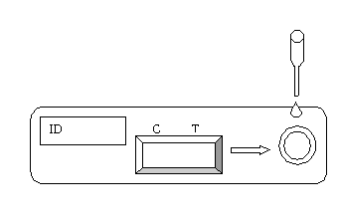
TEST PROCEDURE

- When you are ready to begin testing, open the sealed pouch by tearing along the notch. Remove the test from the pouch.

- Draw 0.2ml (about 4 drops) sample into the pipette, and dispense it into the sample well on the cassette.

- Wait 10-20 minutes and read results. Do not read results after 30 minutes.

INTERPRETATION OF RESULTS

- 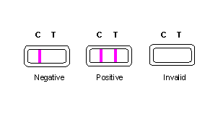Negative: Only one colored band appears on the control (C) region. No apparent band on the test (T) region.

- Positive: In addition to a pink colored control (C) band, a distinct pink colored band will also appear in the test (T) region. This indicates an AFP concentration of more than 25ng/mL. If the test band is equal to or darker than the control band, it indicates that the AFP concentration of specimen has reached to or is greater than 400ng/mL. Please consult your physician to perform a much more detailed exam.

- Invalid: A total absence of color in both regions is an indication of procedure error and/or that the test reagent has deteriorated.

STORAGE AND STABILITY

The test kits can be stored at room temperature (18 to 30°C) in the sealed pouch to the date of expiration. The test kits should be kept away from direct sunlight, moisture and heat.

PRECAUTION

- For in vitro diagnostic use only.
- Do not use test kit beyond the expiry date.
- The test device should not be reused.

Latest revision 09.05.2011

ATLAS LINK, INC USA Headquarters:
No. 811 Zeyang Plaza, No.166 Fushi Road 10758-A Ambassador Drive
Shijingshan Dist., Beijing 100043, China MANASSAS, VA 20109 USA
Tel: 86-10-88909112 Fax: 86-10-88909115 Tel: 703-3663851


CIRIANO GLOBAL S.L. (UNILATEX GROUP)
CIF: B50927532 C/Blancas 4-6, 1 B Oficina 1
50001 Zaragoza Spain
Tel: 34-976910399

