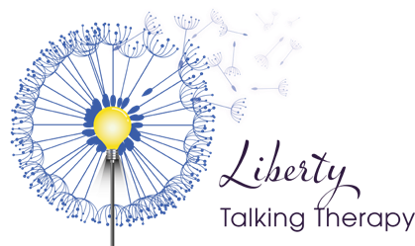

Course Participant Registration form
Please complete and return this form as soon as possible along with your payment to enquiries@libertytalkingtherapy.com

Course Name: | Advanced Specialist: Working with Children and Young People
Date of course: | 18th September 2023
Name:
Email:
Telephone:
Emergency contact: | Name:  Mobile number:
Previous training:
Please include Level 4 or equivalent training with dates

Relevant practice experience
Permission for details to be retained for further  opportunities with Training by Liberty | Yes/No

Payment by |  | Reference
BACS | Liberty Talking Therapy Limited Account: 28102309  Sort Code: 60-83-71 | Your name + ASCYP
Course cost: £895 (interest free payment terms available)
For further information please email enquiries@libertytalkingtherapy.com or call Catherine on 07906584643
