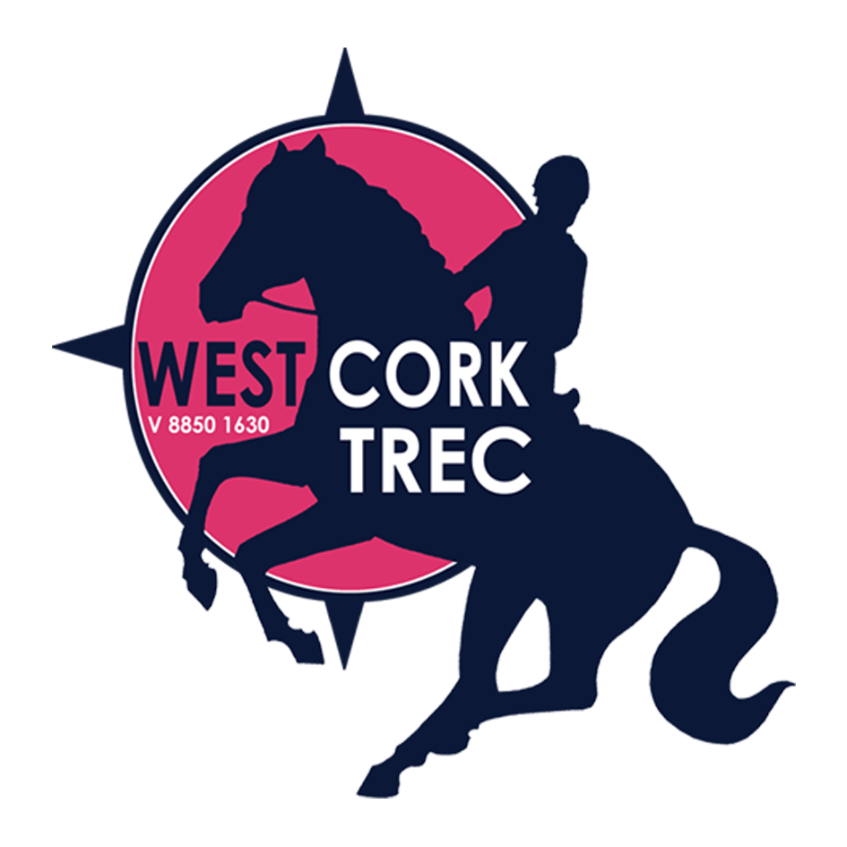
West Cork TREC
Results - Midsummer 2017 Competition

Level 2a Individual
1st 374 points Fionnuala Solomon (Chester)
2nd 349 points Lorea O’Sullivan (Templebready Poppy)
3rd 341 points Kate Ryan Brouwer (Dáithí)
4th 277 points Vicky McMullan (Garangree Duke)
5th 276 points Sandra Schmid (Henry)
6th 268 points Millie O’Sullivan (Casey)

Level 2a Pairs
1st 727 points Jenni Andrew (Hector) and Martha Norton (Cornflake)
2nd 626 points Karen Nicholson (Ebony) and Maunza Heidtke (Penny)
3rd 611 points Caoimhe Duggan (Hugo Boss) and Kate Sheehan (Bantry Bluebell)

Level 2 Individual
1st 340 points Patrick Byrne (Amber Sky)
2nd 338 points Emma O’Regan (Borrowaddy)
3rd 336 points Sheila Winters (Ballyclough Nugget)
4th 308 points Liz Burbage (General’s Daughter)
5th 278 points Margaret Buckley (Kavanagh)
6th 257 points Siobhan Wolf (Paris II)

Level 2 Pairs
1st 635 points Suzanne O’Rourke (Apache) and Natasha O’Rourke (Rio)
2nd 532 points Lucy Murphy (Shady) and Jane Capener (Gladys)
3rd 430 points Samantha Payne Murphy (Winston) and Jane Finch (Morrigan)

Level 1 Pairs
1st 741 points Margaret Manning (Apachi) and Shirley Squire (Comanche)
2nd 674 points Frances Whooley (Ballyphilip Gold) and Elaine Dolan Crowley (Molly)
3rd 638 points Marlina Posthuma Quirke (Faerietale Dreams) and Tanja Khosrawi (Teko)
4th 501 points Siobhan Ovington (Coolhenry Hanna) and Bobbie Ovington (Piccolo Boy)

Best POR
1st 235 points Patrick Byrne (Amber Sky)

Best MA
1st 53 points Sheila Winters (Ballyclough Nugget)

Best PTV
1st 140 points Suzanne O’Rourke (Apache)

Best Under 16 (Overall)
1st 323 point Marlina Posthuma Quirke (Fairietale Dreams)

Best Newcomer (MA/PTV)
1st 131 points Marlina Posthuma Quirke (Fairietale Dreams)

West Cork TREC would like to thank the following people

- Lee Valley Equestrian Centre – Karen and Ger and their helpers (Mike for cutting hedges and grass!)– for allowing us to use their venue for the competition
- The landowners Sean Lally, Conor Buckley, and the O'Riordan family – for allowing us access through their lands
- Our sponsors ( Bantry Pet & Equine Shop, Drinagh Eurospar Skibbereen, Fields Supervalu Skibbereen, Brosnans Centra Schull, Brunner Art Schull)
Berry for her sandwiches, rolls and cake, and to all who brought in food to share
- The treccies – Bastian (Technical Delegate), Adèle Connor and Ian Squire (Traceurs), Annie O’Neill (Chef de Piste), competitors, helpers and parents

