Professional Massage - Client Information Release Form

Name___________________________________________________________________

Age______ D.O.B. __________ Sex______

Address_________________________________city_____________________________

State _______ zip________________

Phone no._____-____-______ cell no._____-_____-_____ e-mail _________________

Have you had massage before? ______. If yes how often? _________________________

Are you pregnant? _______.

Please list any medications you are currently taking:

________________________________________________________________________

Please list any existing injuries______________________________________________

Please list any surgeries ___________________________________________

_______________________________________________________________________

Do you have a major complaint or condition you want to improve today?

If so, when did this condition first appear? _________________________________________

What activity were you doing when you first noticed it? __________________________

Has your condition worsened? _______________________________________________

Has your condition “spread” to other areas of your body? _________________________

Are there any activities in which you can no longer participate because they cause pain or weakness? ______________________________________________________________

Does the pain lessen or intensify while standing, sitting, sleeping, or walking? ________________________________________________________________________
Have you visited other health care professionals for treatment of this condition? If so, when? What types of evaluations and treatments were performed (MRI, CT scan, X-ray, surgery, physical therapy, spinal adjustments, etc.)? ______________________________
________________________________________________________________________

What do you hope to achieve at today’s session?_________________________________

________________________________________________________________________

What do you do for exercise? ______________________________________________

How did you hear about this business?_________________________________________

There is a 24 hr cancellation policy that is to be respected by all parties involved. If you fail to adhere to this policy you will have to pay the full cost of a session. You must agree to this policy by signing your name here. ______________________________________

Please identify current problem areas in your body by circling or shading in the appropriate areas on the diagrams below.

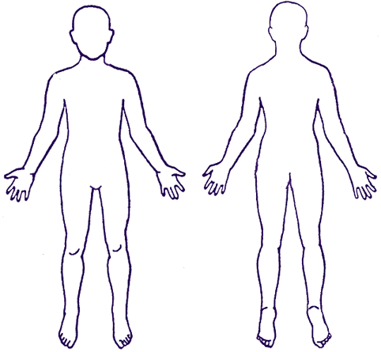

Comments_____________________________________________________________________

Thank you.

Client’s signature_______________________________ date___________________

