Commercialism Policy
2015+

Board of Management Scoil Bhríde Nurney
2015+
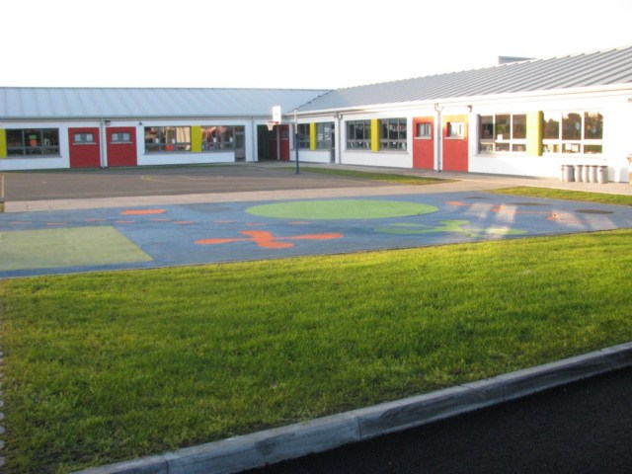

Scoil Bhríde

Commercialism Policy

Introduction:
The following policy is proposed in response to the growing number of commercial schemes aimed at teachers, pupils and their families.

This policy is the result of a process of collaboration between staff, support teachers, Board of Management, pupils and parents. The Policy was originally drafted in November 2014.

Rationale:
The school has chosen to adopt a commercialism policy in the light of;

- The Department of Education and Science has requested that school authorities “consider carefully the implications of allowing any situation to develop which would result in parents being put under undue pressure to purchase a particular commercial product.” (Circular 7/87)
- The recommendation of the Irish Primary Principals’ Network is that schools “should not facilitate outside agencies, commercial bodies, etc. to promote their products and services through children” (2002)
- The Social Personal and Health Curriculum which states that children should be enabled to “become aware of the different forms of advertising, its purpose and the messages it promotes”
- The dangers associated with allowing commercial marketing within primary schools including: advertising to a captive audience of minors, marketing of unwholesome food, commercial pressure on parents and abuse of teachers’ influence

Relationship to School Ethos:
Scoil Bhríde is committed to the full and rounded education of each child and the effective delivery of the Revised Primary Curriculum. This includes fostering the child's capacity to question and enquiry critically about their world.

Aims/Objectives:

- To provide a commercial-free environment in school for teachers, pupils and parents
- To filter out exploitative, pressurising or commercially-biased schemes which seek to market products to pupils or their families
- To support the implementation of the Media Education element of the SPHE curriculum
- To promote philanthropic involvement by the business community in a way that is commercially unbiased, child-centred and enhances teaching and learning within the school

Policy Content:
The school will endeavour to be free from;

- Commercial presentations aimed at children - e.g. Banks, Summer Camps
- Incentive schemes or competitions that require them to influence children’s commercial purchases or those of their families - e.g. voucher/token collection
- Sponsored curriculum material carrying an overt or prominent advertising message - e.g. advertisements, logos, slogans, product-orientated activities
- The school will promote media literacy as part of the Media Education element of the SPHE curriculum. We will seek to make pupils aware of marketing messages and their influence on our consumer decisions
- The school will continue to support business partnerships which are commercially neutral and which are free from the kinds of marketing strategies listed above. Appropriate adult recognition may be given by teachers and school management for donations/benefits received from companies - e.g. letters of thanks, photographs

Success Criteria:

- A typically commercial-free environment within the school and classrooms
- Increased levels of media awareness among pupils
- Support for the school’s position from teachers, parents and pupils.
- Positive business relationships which support the school and do not compromise the above policy

Ratification of Commercialism Policy

This policy was adopted by the Board of Management on _________________

Signed: _________________________ Signed: __________________________
Chairperson of Board of Management Principal

Date: __________________________ Date: __________________________

Date of next review: __________________

