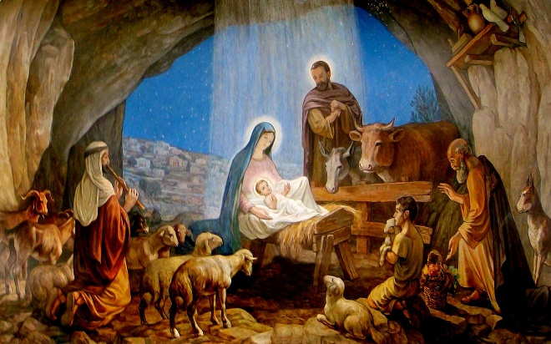
Chosen By God
December 24, 2017
Luke 1:26-38

Grace and peace to you from God our Father and from the Son of God and the Fruit of Mary’s womb, Jesus Christ, Our Lord, amen.
I’ve been doing an awful lot of reading and thinking about Mary this past several days. Our Wednesday Advent service this past week focused on this same Gospel text. We thought about doubt. Mary’s and ours. Mary had a brief moment of hesitation where she asked the angel Gabriel how this whole virgin birth thing could be possible, but a heartbeat later proclaimed, “Here am I, the servant of the Lord; let it be with me according to your word.” We pondered how Mary’s momentary uncertainty changed to committed resolve in the blink of an eye. Mary didn’t ask for a sign or some proof. She didn’t make any objection about how this was going to interrupt her life and her plans. Mary simply answered God’s call with three little words, “Here am I…”
A long time before Jesus, there was another great man of the Jewish faith by the name of Moses. When Moses was born, the evil Pharaoh declared all male children were to be killed and Moses was sent down the river in a water tight basket by his mom in order to save him. God chose Pharaoh’s daughter. She fished Moses out of the bulrushes, she raised him and taught him life’s lessons and values. We don’t know much about Pharaoh’s daughter, but from the history of the Egyptian culture we can certainly assume she was very privileged. Moses had the best of everything the Egyptian civilization had to offer. Not so this time abound. Mary was a young teenage lower-class, unwed, soon to be mother, with not much going for her. This latest development might just make an already pretty hard life much worse.
Mary isn’t all that unique. In fact, she sort of represents the typical pattern of God’s interaction with humans. I mean, it wasn’t Mary’s goodness or innocence or beauty or even her willingness to serve God that was the basis for her to have found favor with God. Mary is blessed and worthy of our honor and respect because of the plain and simple fact that God chose Mary to bear his only begotten son. It was God’s grace and not Mary’s worth that raised her up to the forefront of all Christianity. That fact, is not simply plain and simple, but also surprising, perhaps even shocking and scandalous. God didn’t choose a royal princess or holy priestess, or another Pharaoh’s daughter, but a plain and, at least to the world’s eyes, utterly insignificant young girl. God chose her. God elected her. God addressed her and honored her and elevated her.
Nobody would have expected this. Which is why Mary is loved and honored though out all these years. Mary, you see, stands for all of us, all of us who have no right to expect God’s attention much less, God’s favor and yet are surprised to discover God has chosen, elected, called, and honored each of us.
When you think about it, this surprising choice of God isn’t limited to Mary, but it’s kind of a theme of the whole of Luke’s story of the nativity. No one would have imagined shepherds would have been the chosen audience of the angels, either. We tend to romanticize shepherds, but most folks in the first century would have found nothing redeeming about them. At the bottom of the socio-economic ladder, dirty and smelly from their work, with no social standing to speak of, shepherds were just a rung above outcasts. Yet the angels don’t appear to those at the Temple in Jerusalem or to the well-to-do of Bethlehem, but to the shepherds, out in the fields, sleeping with the sheep. If sheep smell anything like alpacas, these were the last people anyone would have expected to be graced by God...
Matthew’s account – though we don’t read it this year – is no different. Matthew has the Magi from the East. Why foreign kings and astrologers and not the scholars of Israel? For that matter, why a poor carpenter and his pregnant, teenage fiancé? Why any of the people who figure so significantly in God’s story?
Of course, once we’ve gone this far, we realize this is the paradigm for most of the biblical story. Why the Jewish nation and not one with greater armies or territory? Why the strange assortment of characters that become prophets? Why the old and childless Abraham and Sarah? Why mischievous if not downright crooked Jacob? Why adulterous King David? Why…?
Well, the list goes right on down, all the way until you get to us. You are here today because God has chosen you. I’m here because God, for some unknown reason chose me. Well, in my case it’s pretty easy to see God must like well spoken, intelligent, handsome, elderly-er I mean mature men… Well, perhaps I fit the Biblical mold better than I sometimes like to think I do… My point is, God has his eye on you and me and has given each of us a gift and a task. The only question that remains is how will you answer God’s call on your life.
This morning we have two young ladies who are ready to make a great response to God’s invitation in their lives. Belle and Layni, today when you receive your First Holy Communion you will be replying to God’s invitation with the same sort of answer given by another young woman many years ago. Here am I, servant of the Lord. This act of receiving the body and blood of Jesus is a very public way of opening yourself to everything God has for you. His grace and mercy will forgive you your sins and his claim on you will open the way for you to everlasting life. All of this is God’s free gift to you, which you don’t have to do anything to earn. You can’t earn a free gift after all…
In my lifetime Mary has gotten a sort of bad rap. In the ongoing Lutheran-Catholic squabble the Lutherans in my life have accused our Catholic brothers and sisters of “Worshiping” Mary. The truth is, many Catholics may not even know or understand what their own beliefs are when it comes to Mary. Martin Luther, I think it’s safe to say, loved her. Although Luther loved and honored Mary for her faithfulness, he opposed Christians looking to Mary as an intercessor or go between for us to God. Lutherans are strong believers that Jesus Christ is our one and only intercessor before God. That’s why we pray in the name of Jesus Christ Our Lord. Now, sometimes we ask other people to pray for us and for our issues or problems or for those of our family and friends. There is great power in many people praying and asking God for his intervention. Officially, that’s what Catholics do when they pray to Mary. Our concern is that when we pray to the saints we diminish Christ’s role in our salvation and give the impression that the greatness of the saints could be added to the work of Jesus Christ to save humanity. As Saint Paul reminded his young friend Timothy, “For there is one God; there is also one mediator between God and humankind, Christ Jesus, himself human” (1 Timothy 2:5). We confess Jesus is our only savior, our only high priest, our only advocate, and intercessor before God.
So, our take home for today is that we should not shy away from Mary, but honor and respect her, hold her in high esteem, and even love her for her faithful response to what must have been an overwhelmingly fearful, confusing, life altering miracle God placed quite literally in her lap.
May we find that we also have faith like Mary when life deals us situations we don’t particularly care for and certainly would have never chosen for ourselves. May we understand God’s election upon our lives is an incredible gift. God wants to use each one of us to make a difference for the better in this world. May you, like Mary and like Belle and Layni today, answer the messenger from God with those same three words, “Here am I!” Amen.

