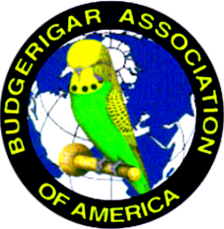
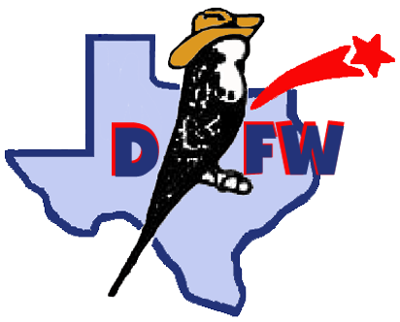
SOUTHWEST HONORARY MEMORIAL CLUB SHOW

August 11th, 2018

Ables Springs Volunteer Fire Department
30000 FM429 N
Terrell, TX 75161

Hosted by: DFW Budgie Club
Affiliated with: Budgerigar Association of America
All Divisions – Rare, Junior, Novice, Intermediate, Champion
BAA Panel Judge Holger Moeller
Entry - $3/bird, $30 max

Schedule of Events:
SATURDAY 7:00 AM Show Hall Opens –Set up - All help is appreciated. Registration of Entries
9:00 AM Bird check in and entry complete. Staging of entries.
10:00 AM Judging Begins
12:00 PM Lunch – Club will provide main meal. Please bring desserts and sides.
1:00 PM Budgie Auction – All donations are appreciated!
6:00 PM Show Hall Closes – Awards, wrap up, and clean up. All help is appreciated.

Show Chairman: Joshua Anthony – 225-907-9376 joshda12101984@gmail.com
Show Hall Contact: Julie Willis – 469-524-9700 juliebelle57@gmail.com

Sales Division
Budgie Auction

***Pre-register electronic entry to Julie Willis – juliebelle57@gmail.com ***

Local hotels – La Quinta, Best Western, Holiday Inn Express

