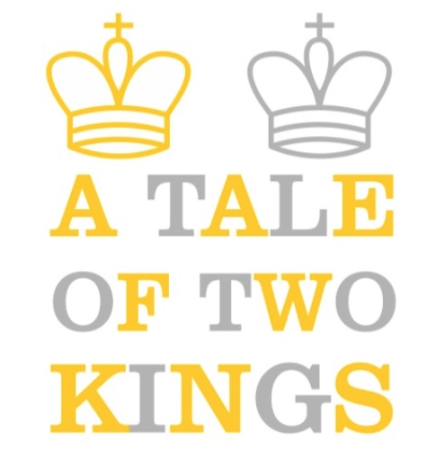
Saturday, February 11
Show Me The Money Tournament
Coy’s Camps and Classes
In the Tucson Mall
Upper Level

Open Event: All Ages and Levels

4 Rounds G45;d5

Round Times: 11:15, 1:15, 3:15, 5:15

All ½ point bye requests (including removals) must made be before Round 2.

Entry Fee: $25

Prizes: First Place: 30%, Second Place: 20%, Top U1000: 10%.
Unrated players can only win First and Second. We use the current month’s published ratings for pairing and prize purposes. Current Month’s Official Rating used. Players must actually win at least half a point in a game to be eligible for a prize.

Register: Send USCF ID/ Name to molly@coyscampsandclasses.com or text to 520-349-7580/ events4chess.com.

USCF Rated Event/ Bring set and clock/ Limited amount available/Mask Optional

US Chess membership required. Get a membership at uschess.org

***It is the player’s responsibility to have a correctly set clock, even if borrowed.

Register Online by February 10, 2023 at 7:00pm. After that, contact us directly.

