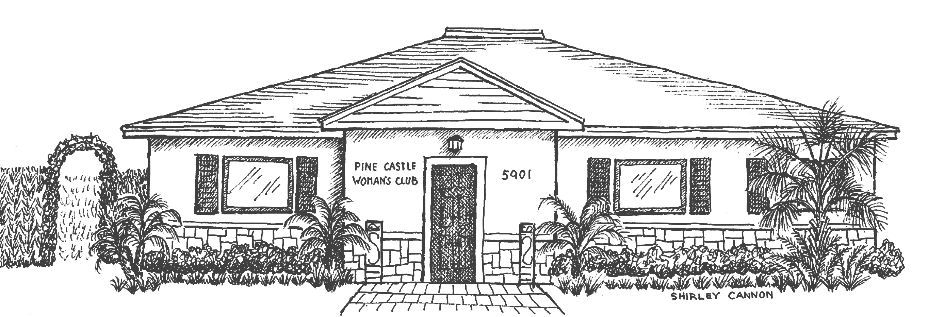
PINE CASTLE WOMAN’S CLUB
“The Heart of the Community since 1940”
Member of GFWC FL Federation and General Federation of Women’s Club
5901 South Orange Avenue, Orlando, FL 32809 *407/494-9118
pcwc1940@gmail.com www.pinecastlewomansclub.com

MISSION STATEMENT: To serve the philanthropic and cultural needs of the greater Pine Castle community and collect and preserve its unique history.

DATE SUBMITTED _______________
ACTIVE MEMBERSHIP $50.00_______Paid by check # _________ OR Date Paid by Credit Card ____/___/____
ASSOCIATE MEMBERSHIP $55.00_____________________
NOTE: Does not require attendance at meetings, no voting privileges, no holding office.
NEW MEMBERS WHO JOIN IN JANUARY OR FEBRUARY WILL PAY A PARTIAL YEARLY FEE OF $22.OO.
THOSE JOINING IN MARCH AND APRIL WILL BE WELCOMED AS GUESTS. FULL DUES FOR THE NEXT CLUB YEAR WILL BE PAID BETWEEN MAY 1 AND THE GENERAL MEETING IN SEPTEMBER.

FULL NAME ________________________________________ BIRTHDAY (MO/DAY) ________________
OCCUPATION (current or retired) _________________________________________________________
SPOUSE/PARTNER __________________________________
EMERGENCY CONTACT ______________________________ PHONE ____________________________
HOME PHONE_________________ CELL PHONE_________________WORK PHONE_________________
E-MAIL ___________________________________________
ADDRESS _________________________________________
CITY ______________________ STATE _________ ZIP ____________
NUMBER OF CHILDREN ________ NUMBER OF GRANDCHILDREN ________
I WAS INVITED TO VISIT AND/OR JOIN PCWC BY: _________________________________________________

MONTHLY SUPPORT: The Russell Home for Atypical Children, Servant’s Heart Ministry, The Foundation for Life Ministries and other local charities.

COMMITTEE (OR COMMITTEES) you would like to volunteer for:
_____ Annual Game Day (usually held in March)
_____ Flossie’s Garden/Grounds
_____ Hospitality
_____ Member Book (included)
_____ Membership
_____ Neighborhood Fun n’ Games (monthly)
_____ Newsletter/Publicity
_____ Scrapbook/Photography

_____ Black History Month (held in February)
_____ Brick Sales (brochure included)
_____ Bylaws (included)
_____ Community Events
_____ Corner Rose Tea Room (brochure included)
_____ Devotions/Pledge
_____ Fifth Grade Essay Contest (held in April)

Membership Chairman Signature: Date Dues Submitted to Treasurer:
____________________________ _____________________________

