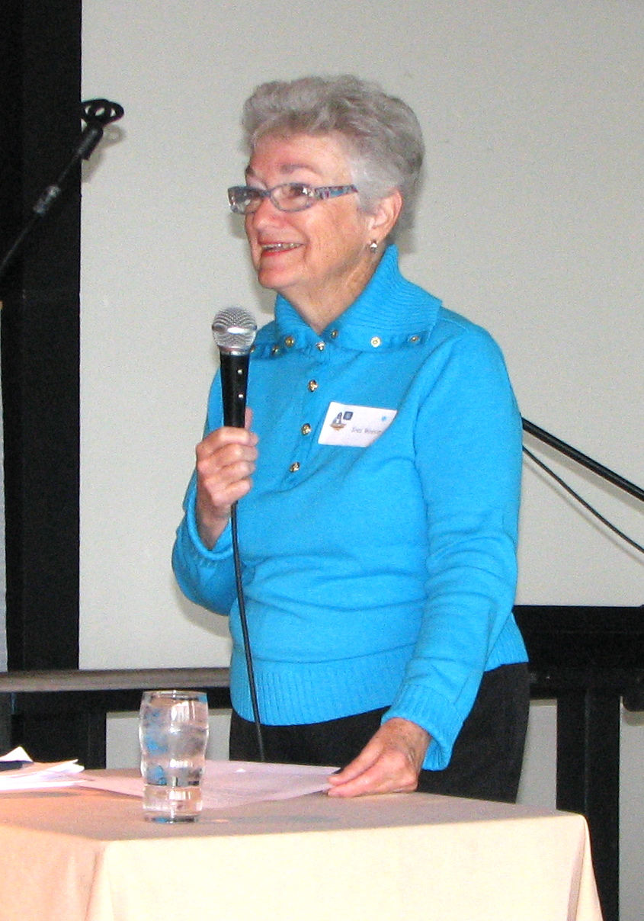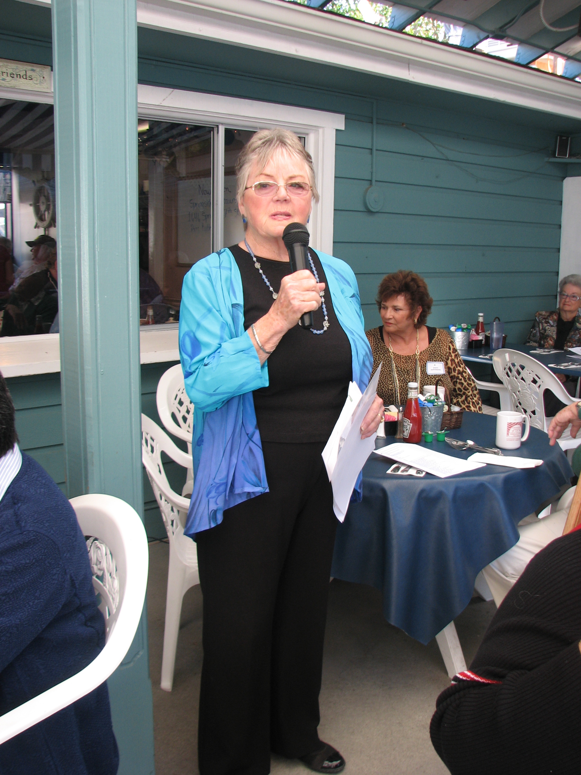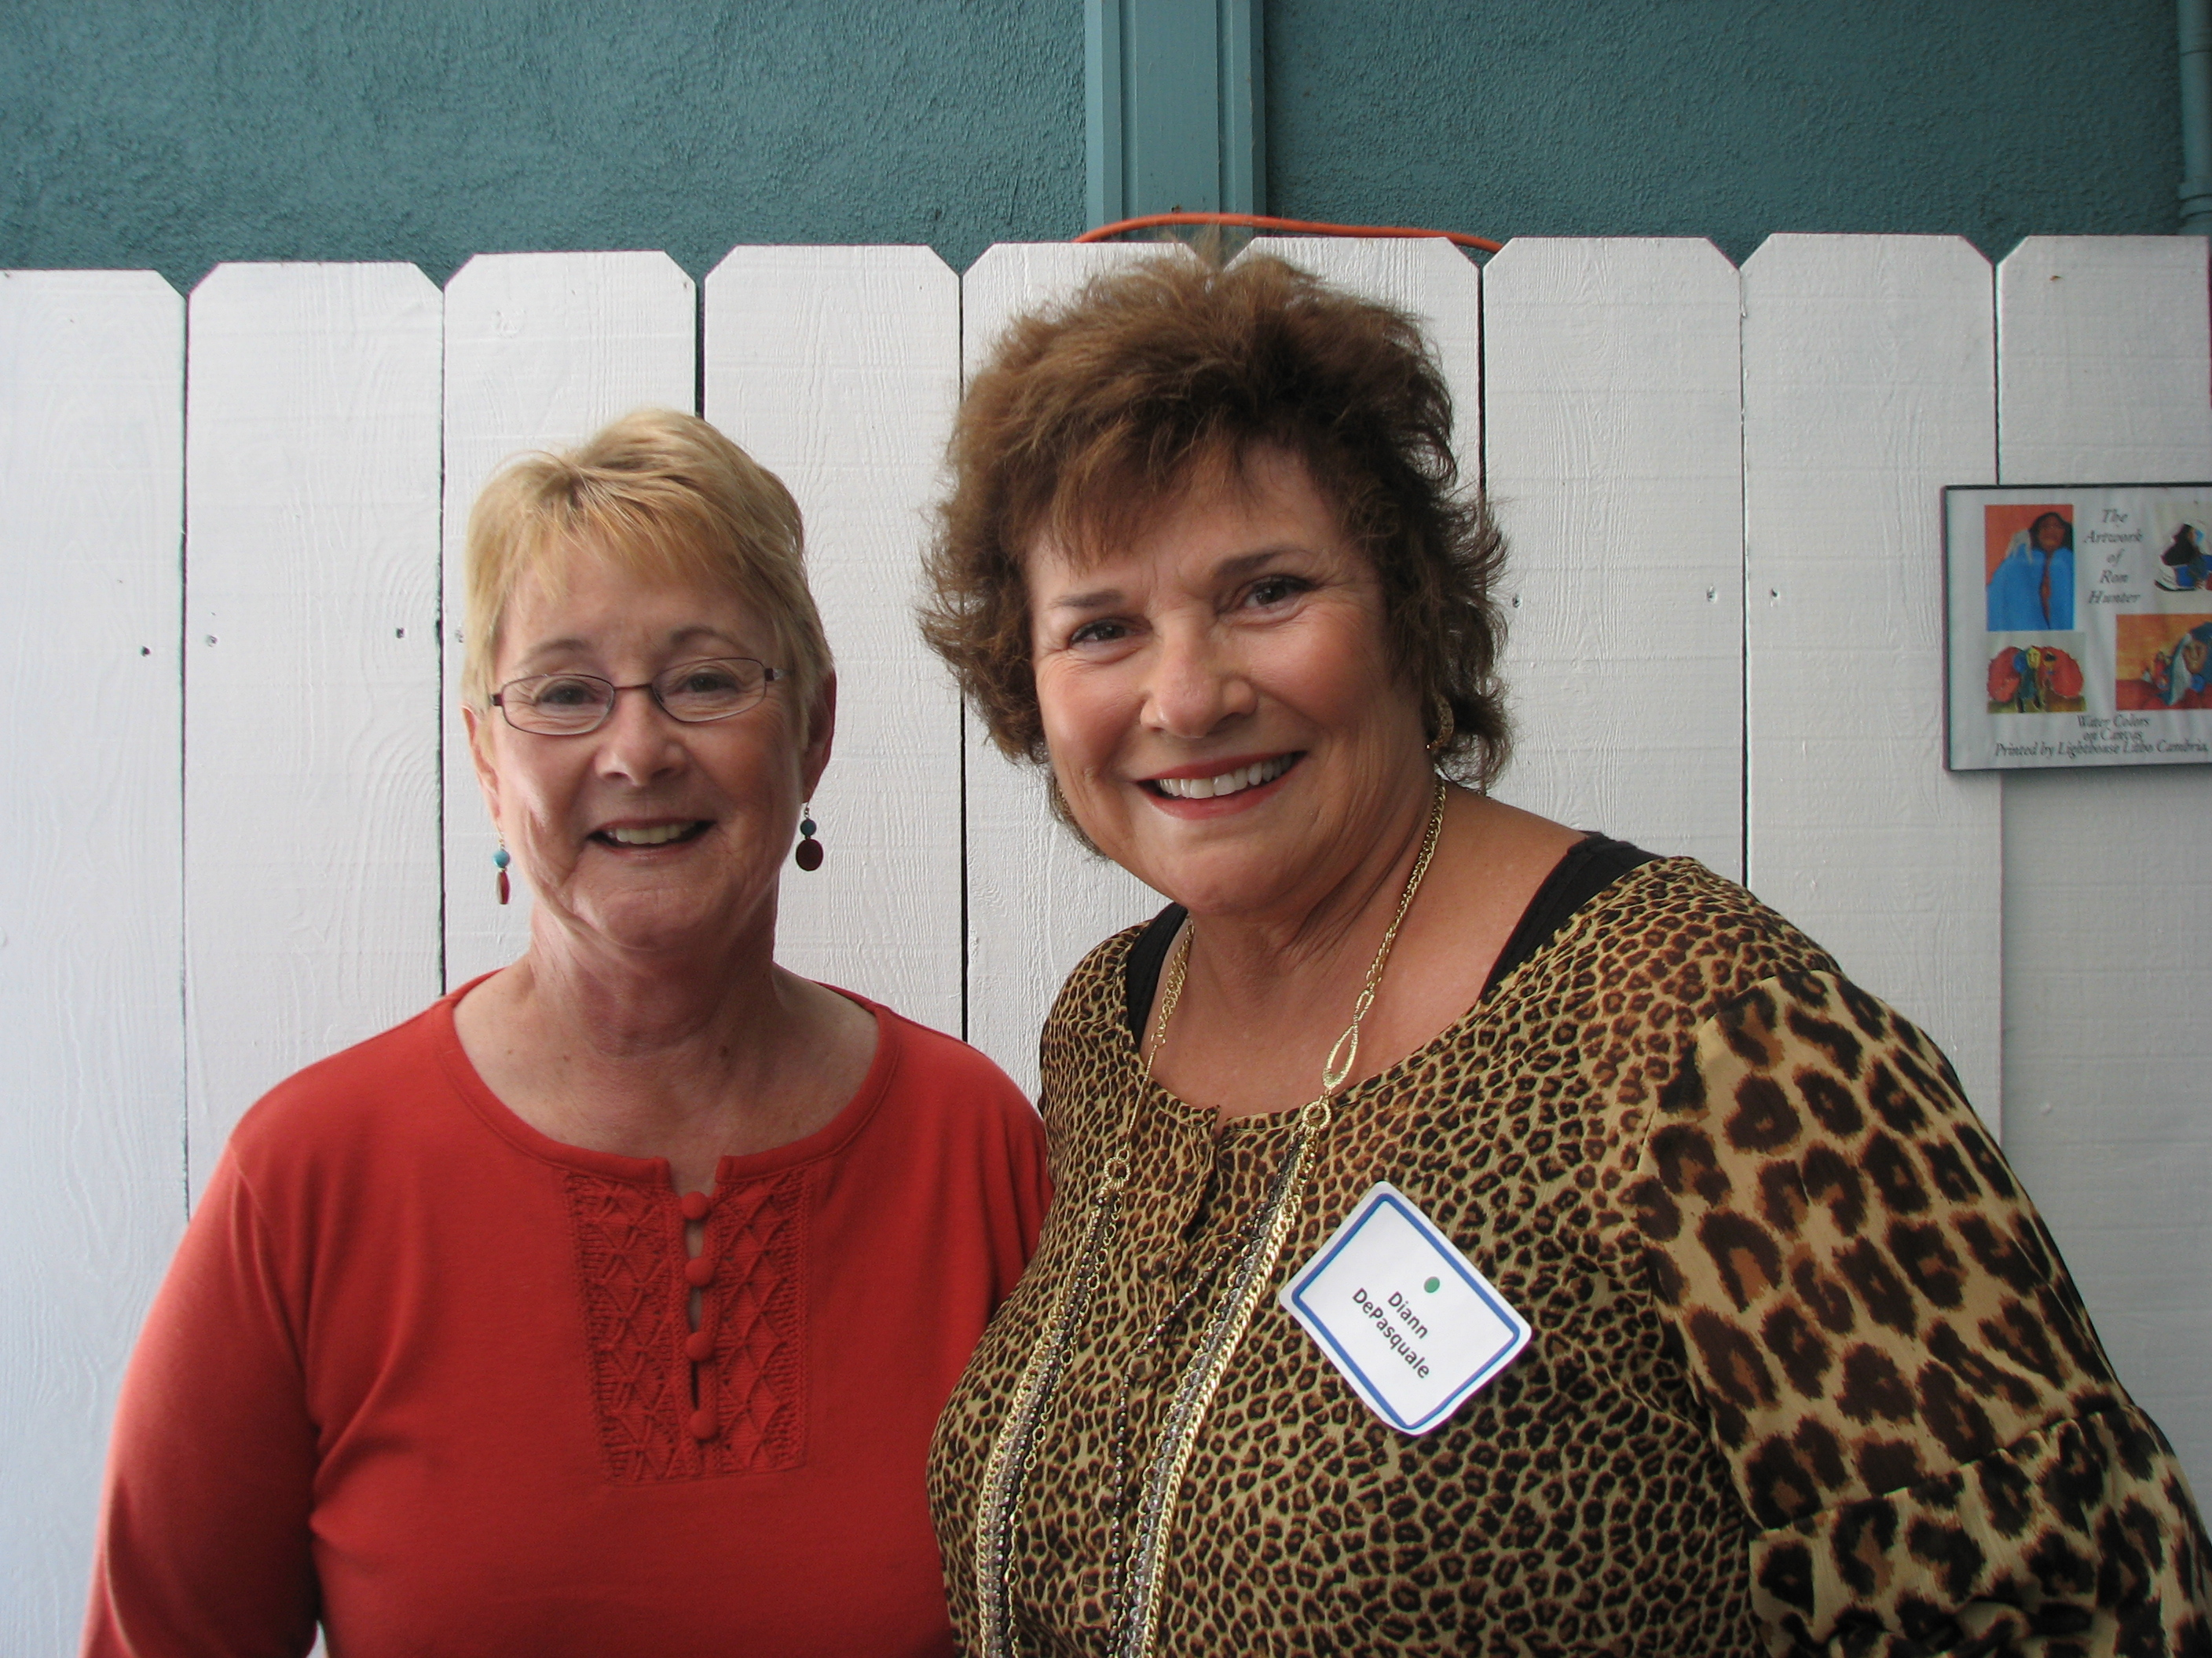

**Presidents, University Women of Cambria**

**Toni Weaver, 2007**

**Jean Chinnici, 2009**

**Kristi Jenkins, Current**

**Diann DePasquale, 2011**