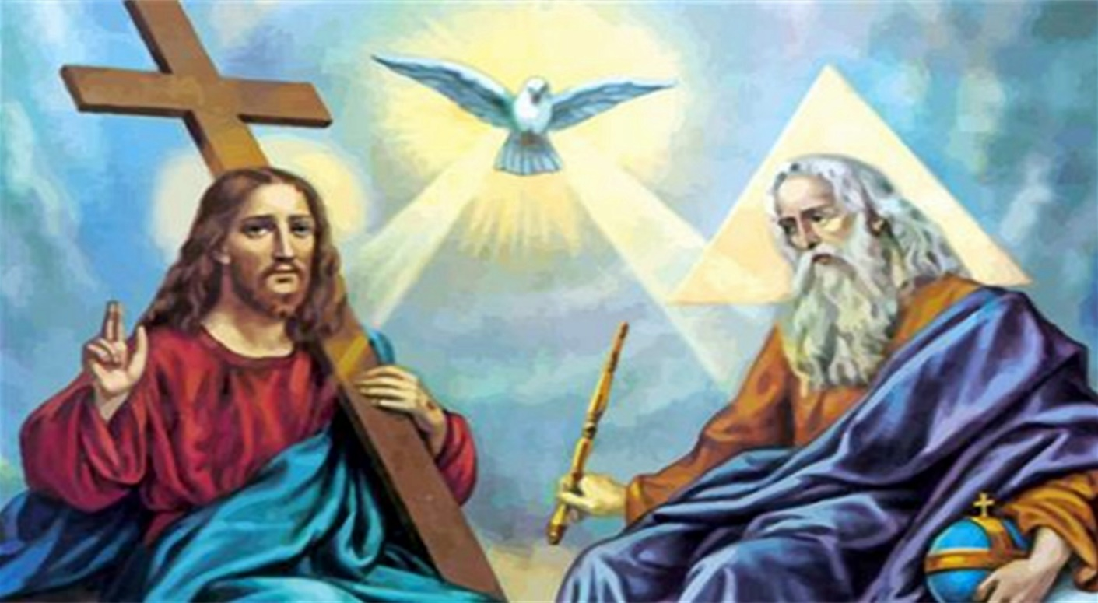
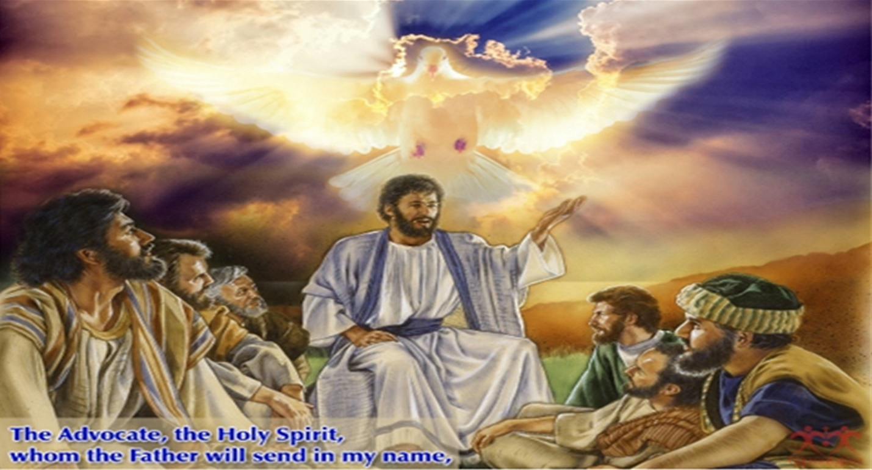
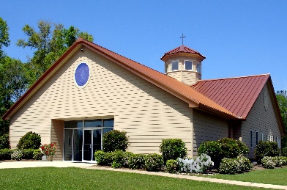
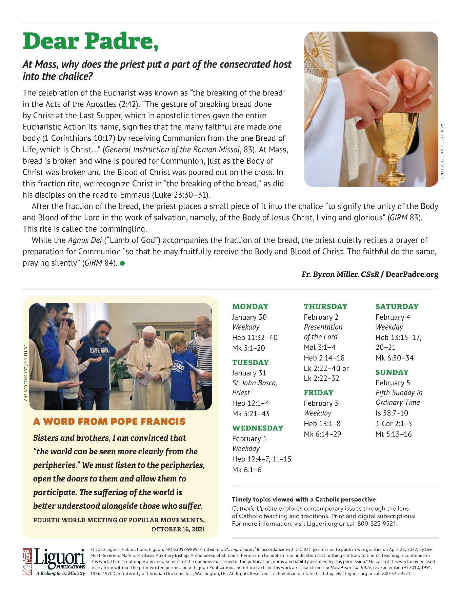
Holy Spirit Mass Schedule & Intentions

Week of January 28 – February 3

Sat 6:00 pm Parishioners Living & Deceased
Sun 11:00 am †Laura Hamilton
Sun 4:00 pm †Souls in Purgatory
Mon 8:00 am NO MASS
Tue 8:00 am †Leona Renadette
Wed 8:00 am †Pete Dacri
Thr 8:00 am Special Intention
Fri 8:00 am †Margaret (McCann) Dunfield

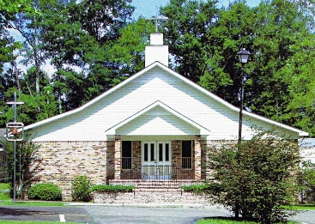
4th Sunday in
Ordinary Time

January 29, 2023

Holy Spirit Catholic Parish & Christ the King Mission
Reverend Peter Kmiecik, Pastor
Deacon John E. Jennings † Deacon Norbert Lloyd, Jr.
Parish Secretary – Grace LeBlanc
Parish Office 283-5252 – Fr. Peter’s Office 233-0947 - Fax 283-5255
holyspiritcc@bellsouth.net – www.holyspiritcc.com
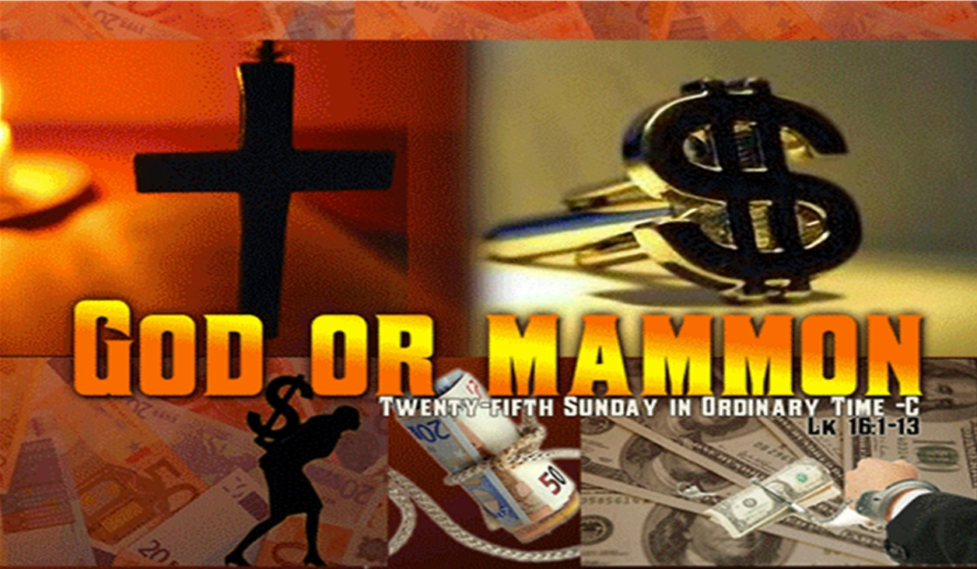
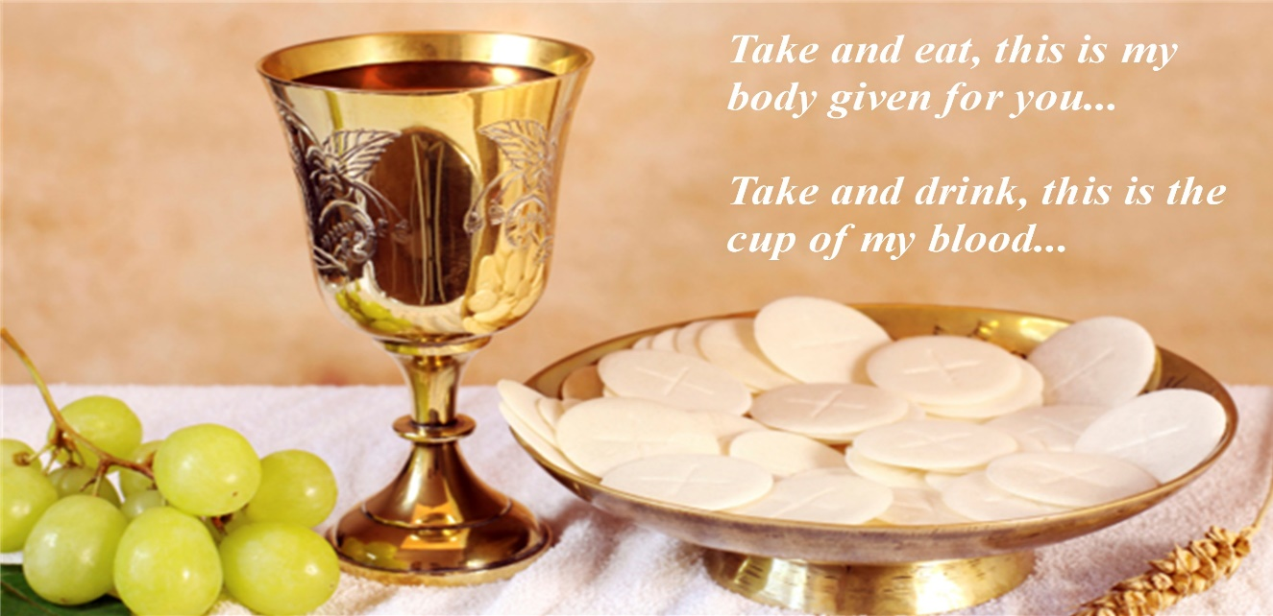
Office Hours: Mon-Thur-8:00 a.m.–3:00 p.m. Fr. Peter is off on Mondays
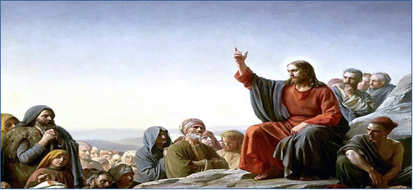
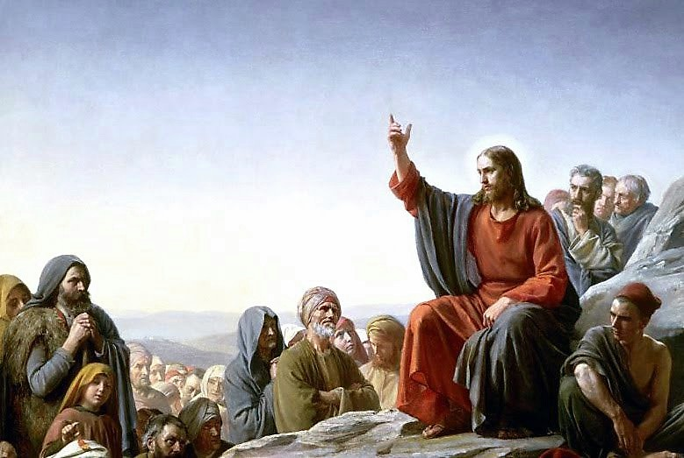
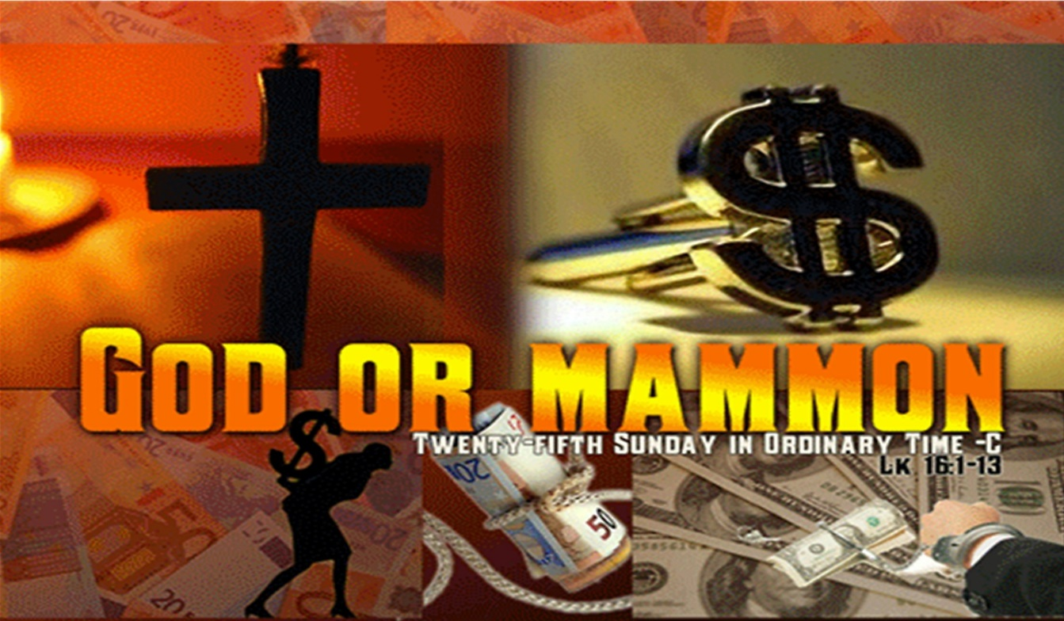
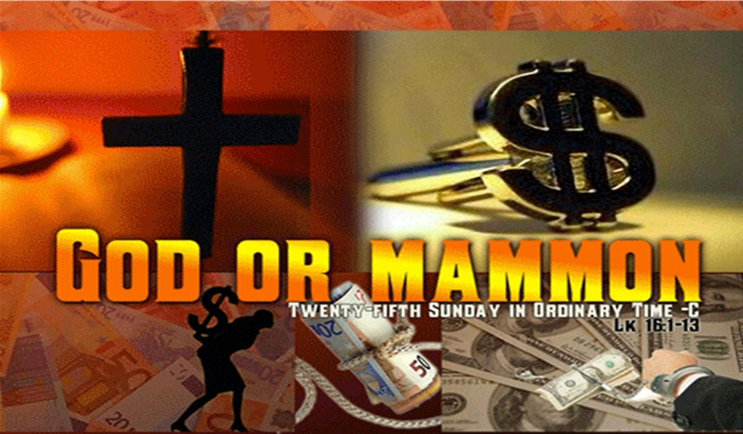
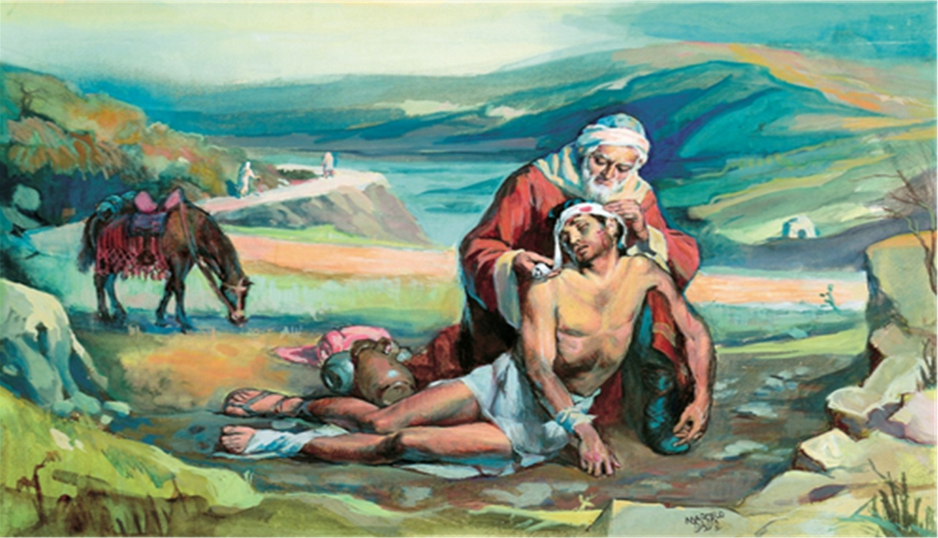
Christ the King Mass Schedule & Intentions

Week of January 14– January 20

Sat 4:00 pm †James & Thelma Higginbotham
Sun 9:15 am †Parishioners Living & Deceased
      
Tue 4:00 pm †Ann Newman

SACRAMENT OF RECONCILIATION
Before and after daily Mass, and by Appointment
1st Friday Adoration – 8:30am- 4:00pm at Holy Spirit
Adoration at Christ the King – Tuesday 3:30pm-4pm

